Southside Property Management   
Database System

User Manual

Version Release 20  
Bringing together User Manual Release 19 and subsequent release notifications

Vickers Projects

November 2014

Contents

Contents 1

Introduction 11

Getting into the system 12

Management information 13

Statement Summary by Landlord 14

Summary of Monthly Fees by Property Manager: 14

Monthly fees by Property Manager: 15

Rent Arrears 15

Unprocessed Cost Summary: 15

Maintenance activity: summary of current contractor instructions 16

Property Update Summary 16

Properties taken back by Landlord 17

Vacant Properties 17

NTQs On-Going 18

Letting Activities 18

Landlords and Properties 19

The Landlord screen 19

Landlord Referral 23

Landlord Details 23

Landlord bank details 23

Contact with Landlord 23

Multiple Landlords on MRS 24

Property Summary window 27

Double Clicking 30

New Properties 31

Expiry Tab 32

Property Tab 33

Interest now at Property Level 34

Property Accounts 35

Move property to new landlord 37

Bank accounts 37

Rent 37

Property data 38

Guaranteed rent 38

Minimum fee 38

Property Commission 39

Monthly Commission Amount 39

Editing of cost data on Property Form 39

Access to/ Creation of Maintenance / Service Information 39

Summary Details of Leases 40

Action Log 41

Recording Actions 43

Automatic Action Logging 43

Recording User name for Actions completed 44

Pop-ups 44

Leases 44

Leases and tenants Selection 46

Leases, Rents and Tenants 48

Leases In Force 48

Use of Leases in Force form 48

Rent Increases 49

Catering for Rent Increases 49

Meter readings 50

Rent changes 50

Arrears 51

Arrears accumulator: 51

Arrears form: 51

Arrears Additions 53

Leases not completed 53

Deposit protection 53

Leases 53

End of tenancy statement 53

Tenants 54

Lead Tenant 55

Properties and Maintenance 55

Property Details 56

Property data 56

Display of property data 57

Property details 57

Tenants Preferred 57

Identification of Property Manager 57

Advertising Description 58

Warranties 58

Job Restriction 58

Property Type and Status 58

Neighbour details 59

Property specific conditions 59

Property Lost 60

Emailing information on New Properties 60

Property Maintenance 63

Maintenance / Service Records – Contractor comms stored 64

Maintenance / Service Record Changes 64

*Emailing* 65

Format of the emails 65

Email Types 66

Job sheets 67

Contractor 68

Landlord 68

Tenant 68

Landlord email on Job completion 69

Entering Request for Quotations 69

Actions on Costings 72

Maintenance / Service Records – Contractor comms stored 73

Preparation of Statement Summary 74

Costs 75

Overall process 75

Cost switchboard 75

Cost input 75

Direct input of non-jobsheet costs 76

Cost type: 78

Tenant liability: 78

Jobsheet costs 78

Input payments to Southside 79

Tenant liability: 79

Regular charges 80

Input of regular charges 80

Landlord projects 82

Cost and payment recovery scheduling 82

Reschedule scheduled costs 84

Costs summary 84

Other cost reports 84

Remembering Costs without setting Lease in Force 85

Tax allowances 86

Yearly report to Landlords of Tax Allowances by Category 87

Review Property Management provides Three buttons: 88

Review Property management 91

Maintenance Costs 92

Maintenance Status 94

Expiries 98

Review Expiry Dates 98

Applicable for Property 100

EPC Rating 100

HMO expiry 100

Expiry Dates by Property Manager 101

Updating Inspection Dates – 102

Expiry Type – Period between Inspections 102

NTQ (Notice To Quit) 104

Set Up Actions 104

Overview of NTQ Actions 107

Review NTQ’s 108

New NTQ Considerations 110

Internal notification email 111

AT6 text 115

Producing an AT6 letter 115

Meter readings 116

Concurrent NTQs 116

List of Actions and Action Templates 117

Setting and resetting Available and Vacant Status 117

Tenant Liabilities and End of Tenancy Statement 117

Tenant Liabilities for a Lease 117

Letting and Property Availability 118

Checking vacant and Available properties 118

Vacant Properties 119

Available Properties 119

Reviewing vacancies and inconsistencies 120

Letting and Leasing 124

Key Notes 128

Tenancy Application Accepted 129

Marketing actions 133

Lease agreement actions 135

Meter readings 135

Groups and prospective tenants 135

Properties and interested groups 135

Tenant Guarantor (Check whether still available) 136

Signing Lease 136

Informing Council and Informing Utilities 136

Proposed Tenancy Application 136

Proposed Tenancy Application 137

Lease pack 137

Letting basic actions and action templates 139

Managing potential Tenants 142

Preamble 142

Managing Prospective Tenants 142

Creating and managing Groups 144

Groups and their Members 146

Application of Groups 146

Tenants selected for Letting 148

Monthly Statement Review &Creation 150

Load rents from bank statement 151

To load a spreadsheet: 152

Review monthly MRS 155

Interest 157

More than 10 costs in a month 157

Reverse MRS 158

Review monthly summary 159

Monthly Summary Statement of approved MRS’s 161

Report view of approved MRS’s 162

List of properties eligible for MRS, and processed status 163

List of all documents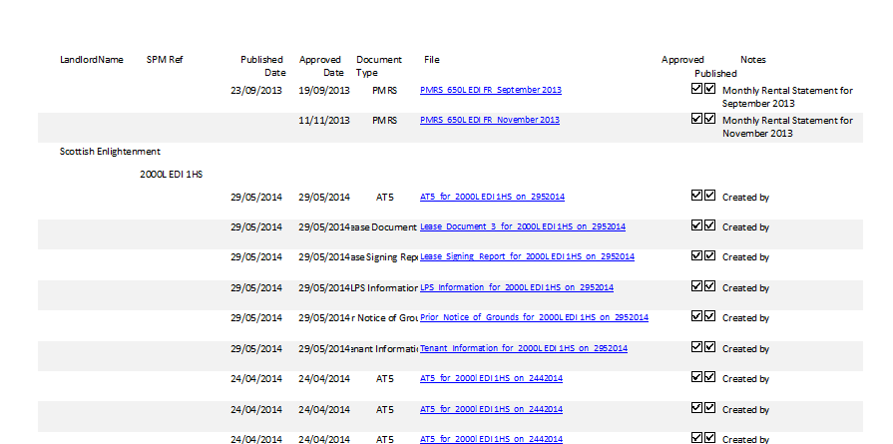 164

Quick look views 165

Draft Property Summary 166

Review Monthly MRS 166

Landlord year end processing 167

Non-standard year end reports 167

To set a non-standard year end: 167

**To unset:** 168

To change year end date: 169

Reporting 169

Tax statement: 171

Tax statement: 173

Tax year end: 173

Review non-standard tax year ends: 173

Important Note 174

Lost Commission 174

Documents and Invoices 176

Document Library 176

Attaching invoices and other documents to the Document library 178

Landlord emailing 178

Documents screen 179

Attaching invoices in bulk 180

Handling Keys 182

Keys Functions 183

General Loan 185

Lend Key using Job Sheet 185

Returning a key 186

Staff and Contractor cards 187

Loaning keys where the lender has no Key Fob 187

Keys On Loan and Keys Overdue forms 188

Key History 189

Reports for Keys on Loan and Key History 189

Key Management 189

SAGE transfer 192

Standing data in SID and Sage 192

Location of transfer files in SID 193

Import mapping in Sage 193

Running the Sage interface 194

Search by Address 199

Email Selection & Mailing 200

The emailing program 204

System Set Up 205

Database choice 205

Standing Data 207

Maintenance / Service Types 208

Contractors for Expiries 208

Staff Information 209

Example of Contractor Standing Data 210

Database Setup 212

Audit Records 213

Standing Data Banks and Tax 213

Banks and Tax 213

Landlord Year End 214

Purpose 214

Distribution Lists 214

Appendix I Sample MRS 215

Appendix II Database design 217

Main and JD databases 217

Appendix III Common buttons and conventions 219

Filtering records 220

Appendix IV Technology 222

Appendix V Audit Records 223

Appendix VI Email and Letter templates 224

Templates 224

Data Items Used in Emails and Mail Merges 226

Annendix VII - Landlord tax year end processing 228

Purpose 228

Environment 228

The process 228

Annenx VIII - Installing Front End Application on PCs 232

# Introduction

The purpose of the SouthSide Management system is to assist SouthSide Property Management with the effective and efficient management and administration of their property business.

Functions include:

* Maintaining records of Landlords and their Properties
* Tracking Leases contracted with Tenants
* Processing Rental Payments
* Maintaining Maintenance and Service Records for Properties
* Processing Costs and Payments
* Processing Property Costs
* Handling Notices to Quit
* Marketing and Property Letting
* Acquiring prospective Tenants
* Creating Monthly Rental Statements (MRS’s) for Landlords
* Maintaining a Document Register
* Emailing MRS’s to Landlords

# Getting into the system

Click the desktop shortcut Southside Management to open the system, and choose which database you want to work with (Main or JD Properties[1])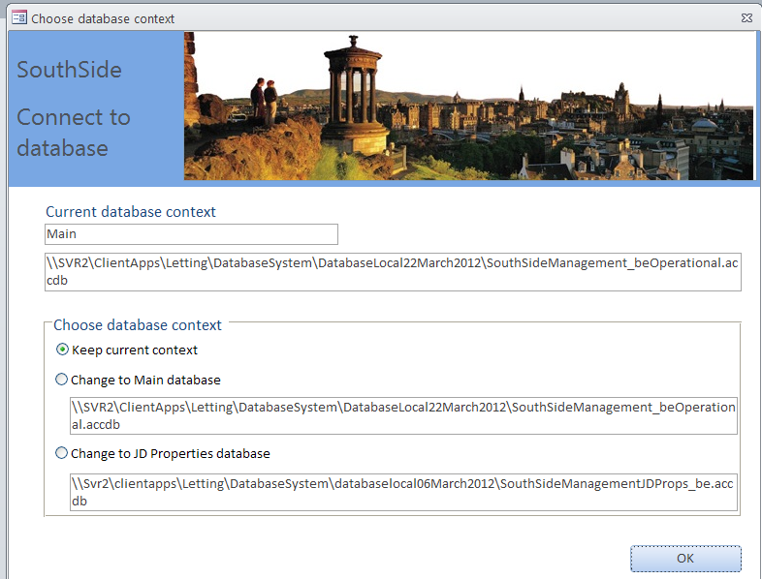

The next, multi-layered, switchboard gives access to the functions of the system.

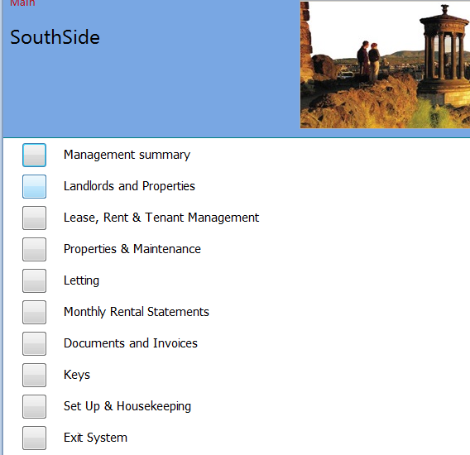

# Management information

Clicking the first item on the switchboard ‘Management Summary’

opens a form offering quick view of summary information:

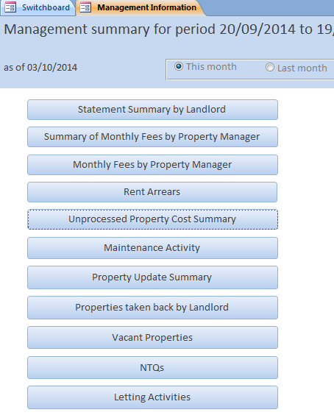

## Statement Summary by Landlord

Statement Summary by Landlord is per the spreadsheet currently prepared by property managers:

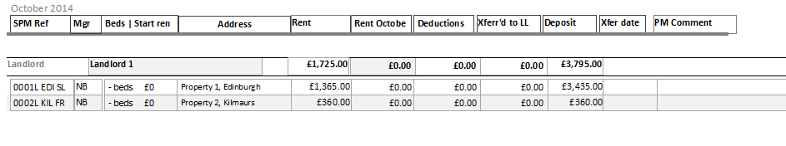

### Summary of Monthly Fees by Property Manager:

summary of management fees

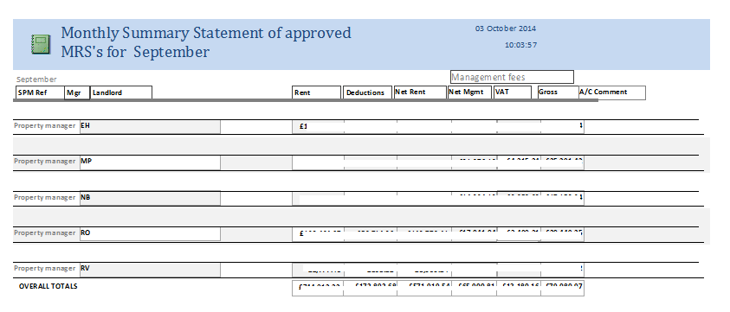

### Monthly fees by Property Manager:

detail of management fees

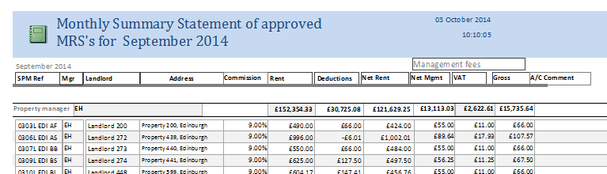

### Rent Arrears

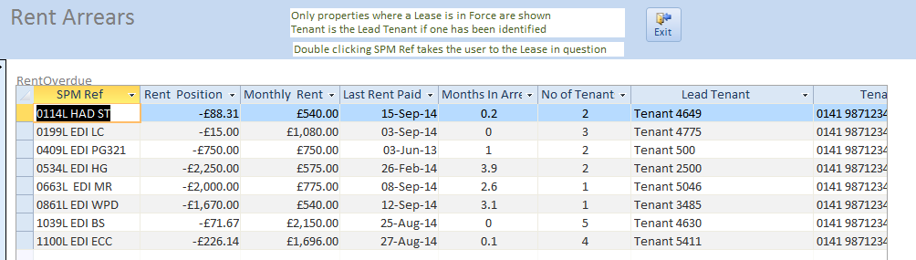

### Unprocessed Cost Summary:

list of costs captured in the system but not yet marked as recovered from landlord (as has been in the system for some time under the Monthly Summary menu).

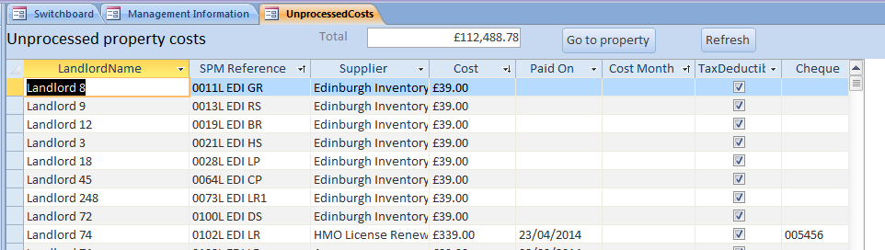

### Maintenance activity: summary of current contractor instructions

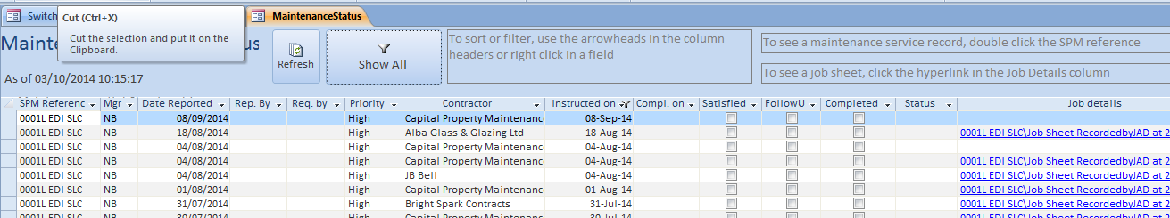

### Property Update Summary

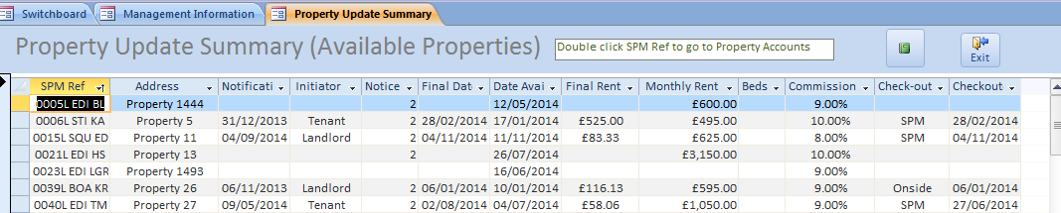

This form and report provides very similar information to that provided by SouthSide’s Excel spreadsheet of the same name. In particular information is restricted to Properties that are available.

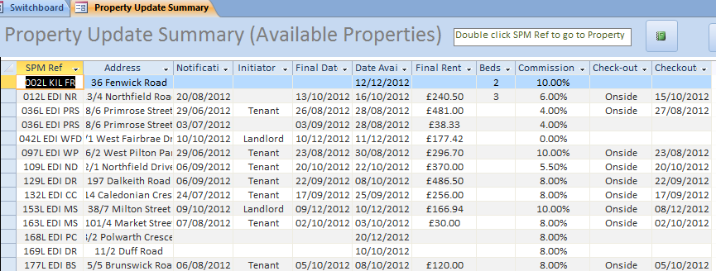

### Properties taken back by Landlord

Properties taken back are entered on the Property Details screen by Date Lost and reason if known.

Clicking Properties taken back by Landlord in the Management Information screen displays

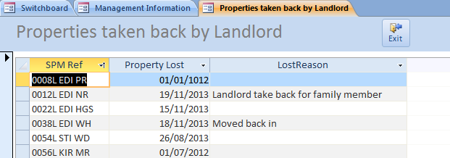

If an NTQ has also been raised relevant data is also shown

### Vacant Properties

The Vacant Properties display displays all properties identified on the Property Details form as Vacant.

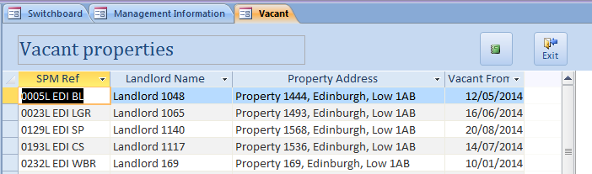

The User is assisted to identify properties as Vacant using the Vacancies and Inconsistencies form – see Section xxxx

### NTQs On-Going

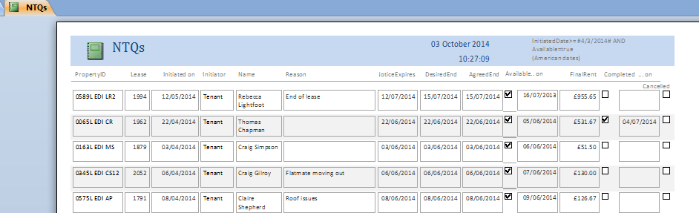

### Letting Activities

Properties available to let

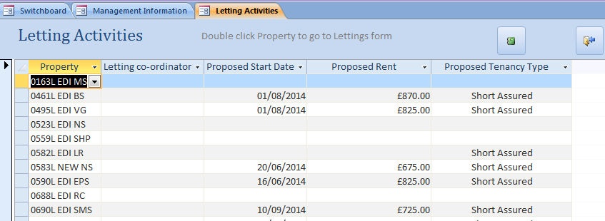

# Landlords and Properties

The system holds name and address data about landlords. Linked to each landlord can be any number of properties owned by that landlord. Data held about properties includes all the data previously held in the MRS worksheets. Linked to each property are the leases of that property – past and present. Currently no archive facilities are provided.

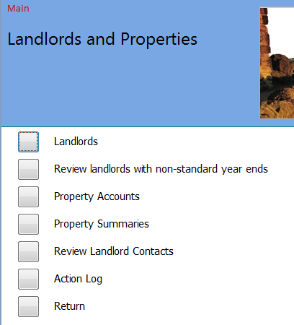

## The Landlord screen

To create a new Landlord click *Add New Landlord* button and enter the relevant details about the Landlord. The *Salutation* field allows you to enter how you wish to address this landlord on any communications you may have.

To edit details for a landlord, select the Landlord in the choice box near the top of the screen, and make the changes required; click Save. Note that you can only delete landlords who have no properties.

To view the accounts data for any Property for a landlord’s property, click the Go to Property Accounts button.

To create a new Property for a landlord, use the choice box near the top of the screen to choose the landlord, click the New Property button and complete the details in the New Property screen.

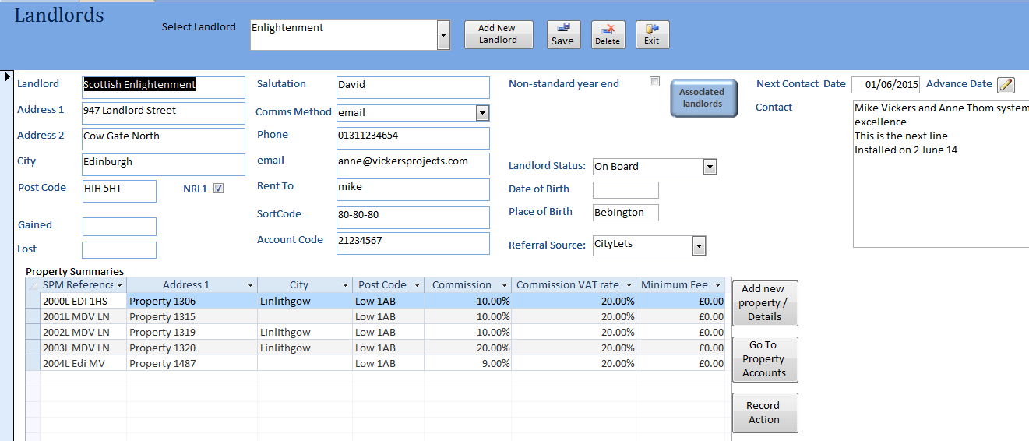

Create New landlord

### Landlord Referral

The source of Landlord may be entered against the Landlord. Landlord Referral is a dropdown list which may be added to through the Standing Data.

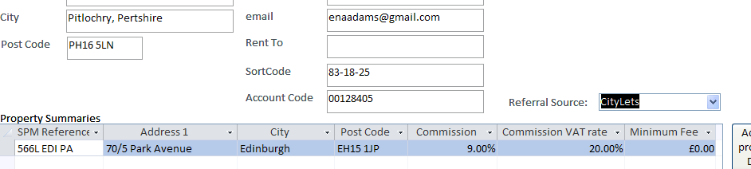

### Landlord Details

* Landlord Date and Place of Birth
* Record Action button provided to add actions related to properties. Note that as Actions are always related to a property the user must select the property to be assigned to the Action

### Landlord bank details

Checks have been put in to warn of changes to Landlord band details. Note that changing details on the Landlord form does not change the details associated with individual properties – these must be changed separately through the Property form.

### Contact with Landlord

A contact field has been added with Date of next Contact

Clicking advances the Contact Date by one year

A form and report are provided to list out contacts made with the Landlord along with the date of the next proposed contact.

Note that the contact details are cumulative. They should be added to after each contact is made providing the Property Manager a running history of discussions with the Landlord.

The form is called up through the Landlords and Properties menu.

Double clicking the Landlord name takes the user to the specific Landlord Window.

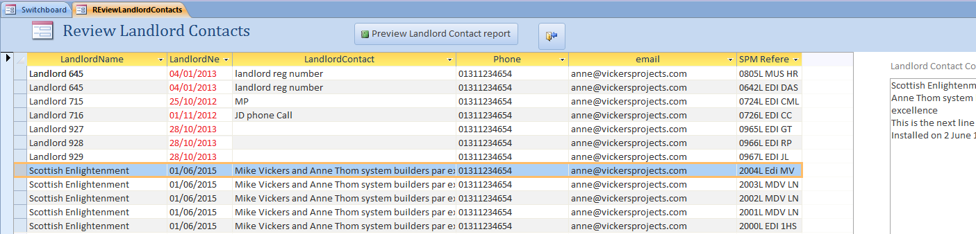

Contact dates which are passed are shown in red.

The corresponding report may be previewed by clicking the Preview button.

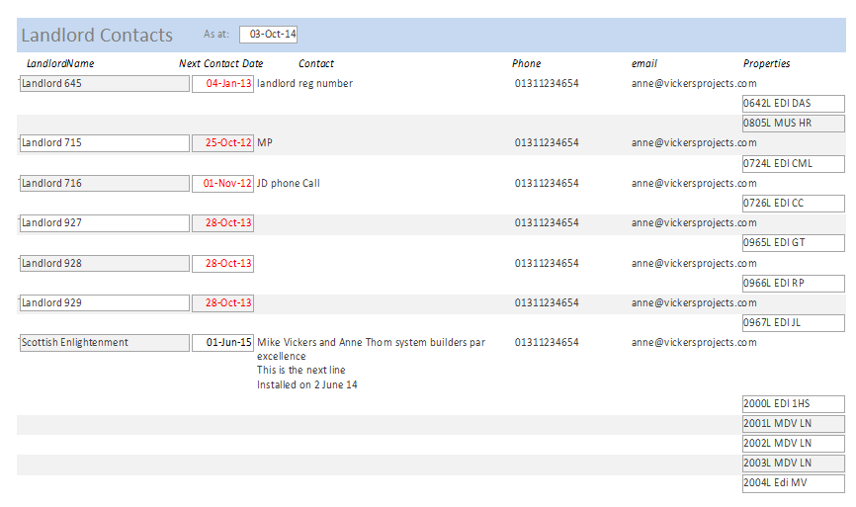

## Multiple Landlords on MRS

A facility is provided to provide for printing more than one landlord on an MRS. Where there is more than one landlord sharing ownership of one or more properties these landlords are considered to be a group and are represented by a Group Landlord. The Group Landlord is handled in the system as are other Landlords at present. Landlords in the Group are considered Associate Landlords – there may any number of Associate Landlords but only the first three can be included in the MRS Associated Landlords are referenced from the existing Landlord window by clicking Associated Landlord button (new in release 23). The following window opens

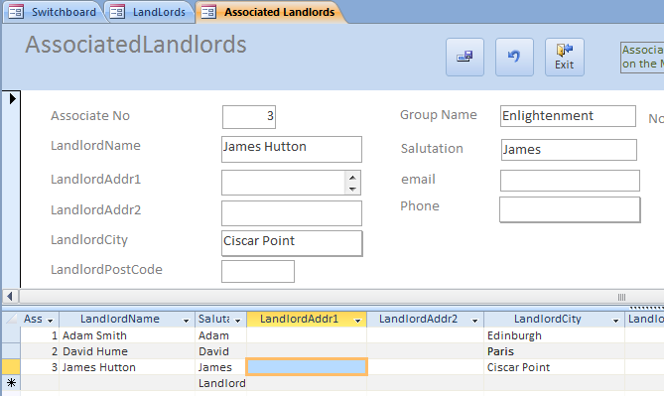

In this case the Group Landlord ‘Enlightenment’ has three associated landlords Adam Smith. David Hume and James Hutton.

When an MRS for a property whose Group Landlord is Enlightenment is created the three associated landlords, the Group Landlord will appear at the top of the MRS – Thus

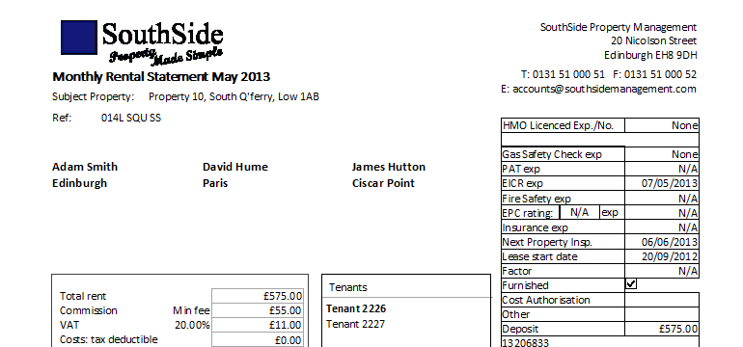

Note that the three associated landlords are printed rather than the Main Landlord name (in this case Enlightenment).

Note also

* That the maximum number of associated landlords that can be accommodated on the MRS is three
* More than three associated landlords may be added in the Associated Landlord window but only those with the three lowest Associated Numbers are selected for the MRS
* All other details of the MRS are the same as current. Indeed the rest of the system is unchanged
* If there are no associated landlords then the Main Landlord is printed as currently.

# Property Summary window

This window provides Summary Information for properties. NB - the window is for display only – data in the window itself cannot be changed

The window is shown below and provides the following data for review

* 1. Property basic data
  2. Tabs: tenants, Costs, Maintenance, NTQ and Letting and Action Log
     1. Tenant tab displays all tenants for the current Lease of the Property
     2. Costs lists all unprocessed costs that relate to the Property. Where a Cost has been carried forward from the Maintenance_Service record then the associated Issue / Job Done is displayed
     3. Maintenance lists – lists all jobs undertaken – Double clicking SPMRef takes the User to the exact record. Once there the User can update any information that needs to be changed
     4. NTQ and Letting – provides both the NTQ and Letting positions side by side with history of Activities completed so far.
     5. Action Log
  3. Buttons on right. These may be considered as two classes
     1. Go to Property Details, Go to Property Accounts and Go to Lease (selects current Lease) takes user to respective window
     2. Go to Tenant, Go to Cost Management, Go to Maintenance, Got to current NTQ and Go to current Letting are only enabled when the corresponding Tab is selected eg Go to Tenant enabled when Tenant Tab selected and Tenant displayed is the one whose row is highlighted; Go to Maintenance is different in that all Maintenance_Service records are available to be paged through.

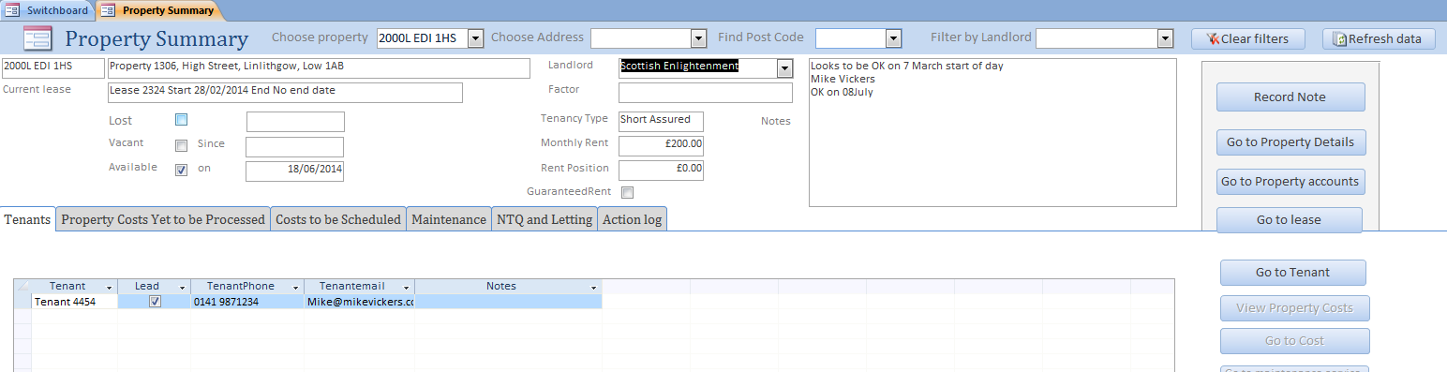

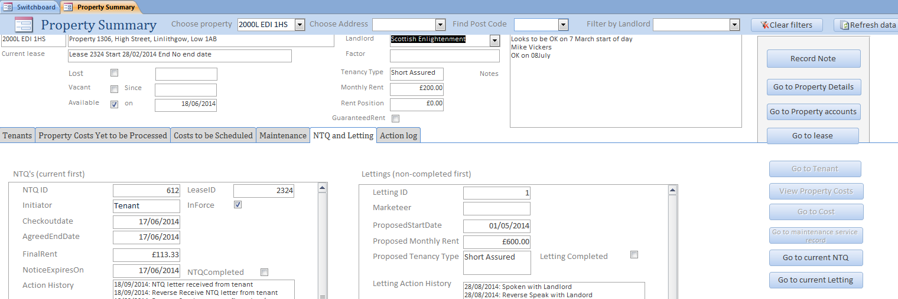

To select just Leases in Force for a property the user can open the Property Summary window for the property and click ‘Go to Lease’ – the lease selected will be the one In Force.

Note, we would advise users keeping the Property Summary window open at all times as it provides either direct access or access via a button, to all current information about the property, eg Go To Lease.

### Double Clicking

Double clicking the Landlord field takes the user directly to the Landlord window

A search of properties has been provided by Post Code

When selecting the Maintenance and Service tab only those records where the job has not been completed and not cancelled are displayed.

When selecting the NTQ and Letting tab only uncompleted and not cancelled NTQs are displayed and for Letting only Lettings for the property which have started but not completed or not cancelled are displayed.

Headings on tabs 2 and 3 have been corrected to correspond to the data. They now are:

* Property Costs yet to be processed – the costs have been scheduled but are yet to recovered from MRS
* Costs yet to be scheduled – some may later be scheduled while others may be charged direct to the Landlord eg Landlord Direct.

# New Properties

A New Property is created by clicking the Add New property / Details button from the Landlords screen. The screen which is invoked is shown on the next page.

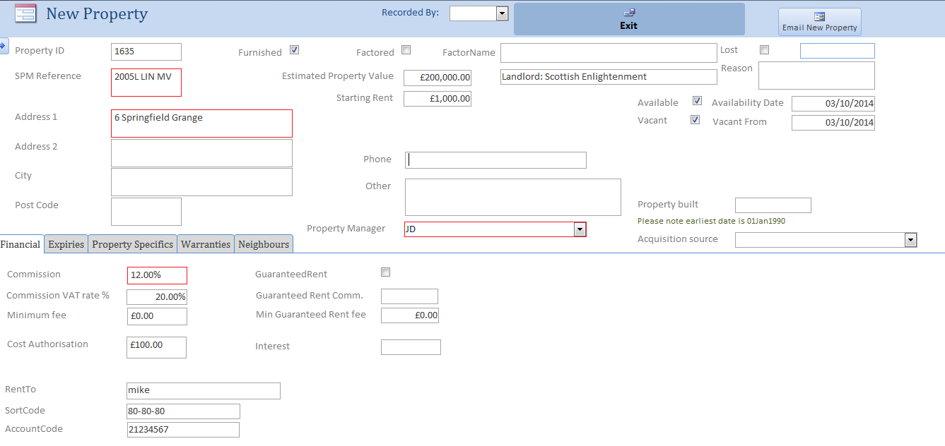

SPM Reference, Address 1 and Commission are mandatory (red boxes); the latter is on the Financial information tab. The top half of the screen covers general information about the property, and the bottom half; separate tabs provide access to financial information (as above), expiry dates, and property details such as number of rooms.

### Expiry Tab

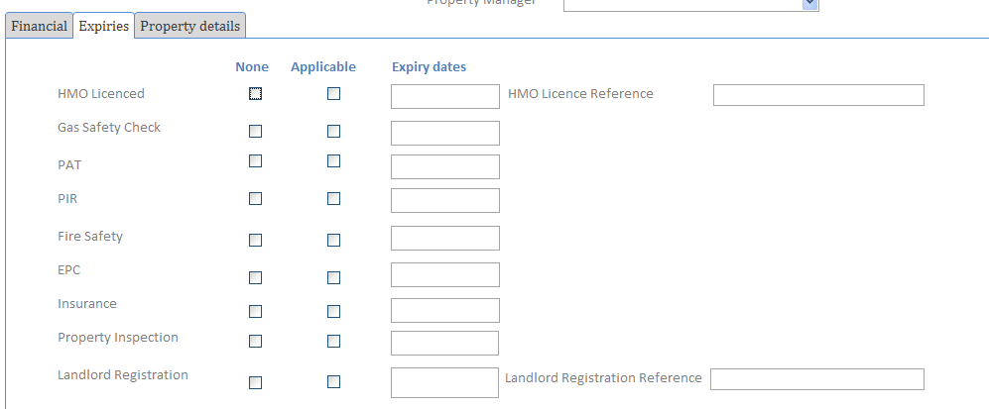

The following Rules apply. For each expiry:

None ticked means that this expiry is not required, eg the property has no gas. If None is ticked, Applicable and Expiry data cannot be set. Applicable ticked means that there is a current requirement for an expiry date; Applicable not ticked and with None also not ticked means that there is a requirement for a date but not at present.

### Property Tab

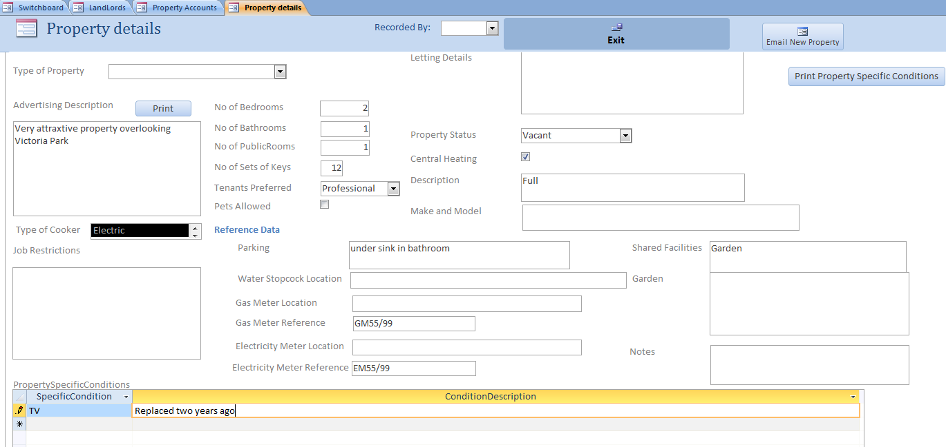

When all information is complete click the Exit button; a record will be added to the Action Log for audit purposes.

### Interest now at Property Level

Landlord Interest has now been moved to the Property level rather than at the Lease level. When a new lease is raised the value of Interest is automatically copied down to the Lease level thereby avoiding the need for the user to do so.

# Property Accounts

This screen allows amendment of financial information such as commission rates, but is principally used for managing leases and costs for a property.

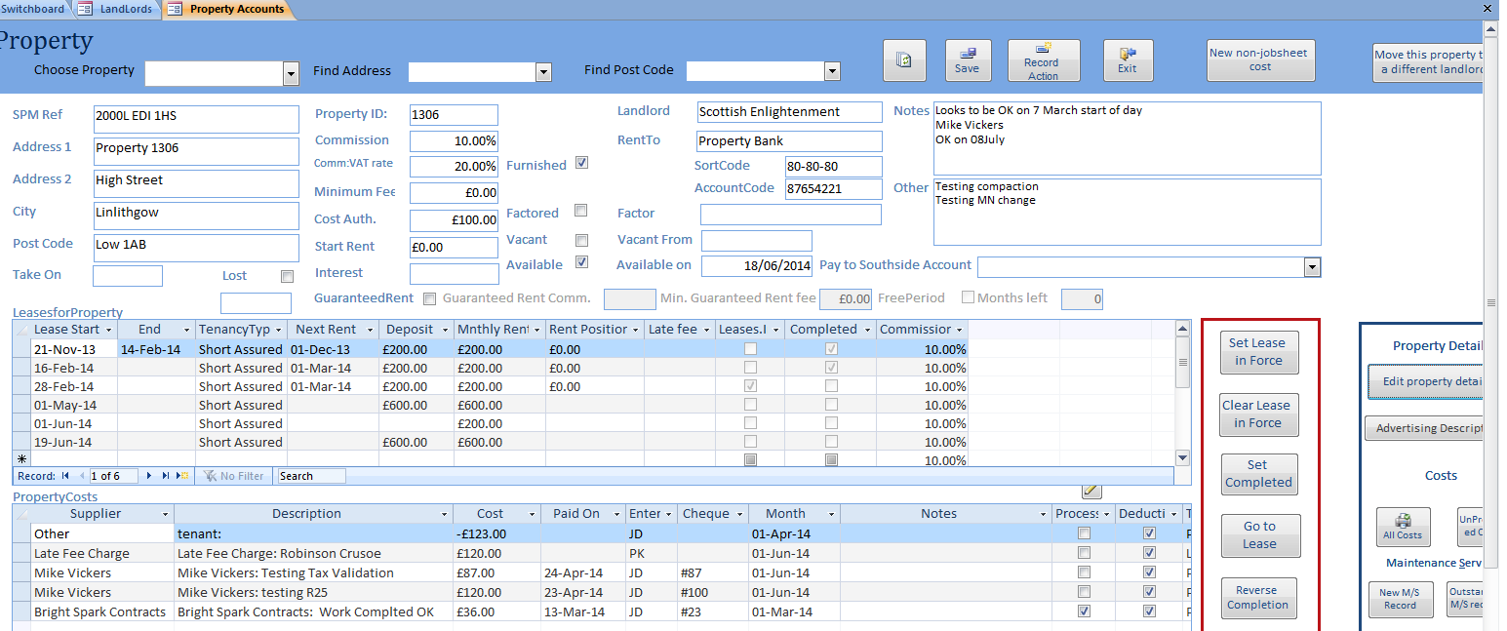

Make lease the current lease

Create New Lease

Just one Lease in Force at a time

Click to bring up Expiries & other property details

When a Lease comes to an end and all transactions have been completed

### Move property to new landlord

A button has been added to the Rental Properties screen to allow property to be moved to a new landlord.

### Bank accounts

Properties now have their own bank account settings. When setting up a property, these default to the Landlord bank account, and can then be overwritten if required. Property bank account is used for the MRS.

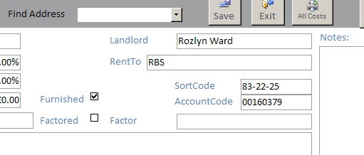

### Rent

Where SouthSide ‘rents on’ a property on behalf of its landlords and pays a fixed rent to the landlord independent of whether or not the property is tenanted, agreed that such a property is treated in the system as two properties:

* 1. Property One being between the landlord and SouthSide as tenant in the system
  2. Property Two being between SouthSide as landlord and the actual tenants as tenants in the system.

To help SouthSide staff recognise that the two properties in the system are one and the same physical property, the Property References are the same except that a fifth digit is added after the first four: G being used to represent the landlord and R for the property rented on. For example 300LG EDI MV refers to the property known to the Landlord while 300LR EDI MV is the property known by the Tenant. SouthSide further distinguishes Rented on properties by R1 where costs are forwarded to the landlord while R2 any costs are born by SouthSide.

### Property data

A new field Start Rent has been added. This rental value is reported in report

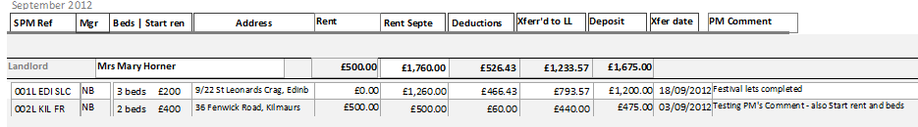

### Guaranteed rent

Properties can now be marked as having a guaranteed rent, with a %age commission, a minimum fee (there is no overall default), and a ‘Free period’ for a number of months when no Guaranteed Rent commission is charged.

To set the free period, tick FreePeriod, and put the number of months in the ‘Months left’ box. During the free period, which starts with the first MRS for the property, the Guaranteed Rent commission box on the MRS will show “Free”. The Months left will be decremented by 1 each month.

Please note that while this facility will cope with MRS’s created in the right order, and reversed after creation, it may not decrement the ‘Months left ‘ as intended if MRS’s are omitted or an early one is reversed; you may need to reset the Months left manually.

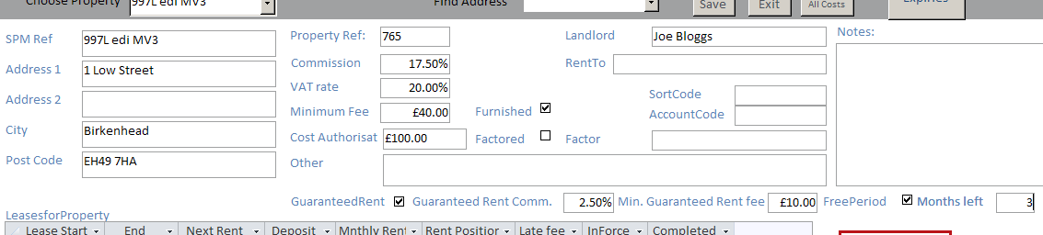

### Minimum fee

Minimum fee will not be applied to any property where the rent for the period is zero; a commission of zero will be applied.

Except in this case, it is now possible to override the calculated minimum fee, for example if two minimum fees have been applied during a month where there is a changeover and this is judged too high. Two small ‘pencil’ buttons on the Monthly Review form allow you to change commission, Guaranteed rent commission, and commission descriptions via prompt boxes. See diagram below.

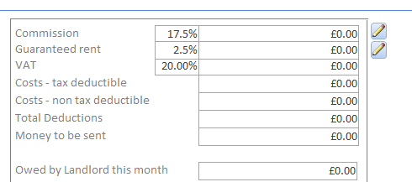

### Property Commission

Commission can now be set on a lease by lease basis, with the default value being the property commission. The commission shown in the Lease form and in the Leases table in the Property Accounts form is the lease commission; property commission display is unchanged.

### Monthly Commission Amount

The commission calculation has been changed to use the minimum on a property basis rather than a lease by lease basis

### Editing of cost data on Property Form

A small pencil button on the Properties form allows the editing of Paid on date and cheque number in the costs table even for costs processed.

### Access to/ Creation of Maintenance / Service Information

The Maintenance / Service Form may be accessed directly from the Property form by clicking

* New M/S Record to creates a new record for the Property
* Outstanding M/S records takes the user to any outstanding M/S records for the Property.

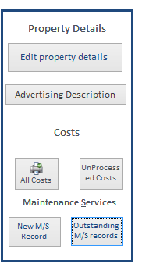

## Summary Details of Leases

Summary details about each Lease are entered here, with full details entered on the Lease Screen (see later). Note – the Start Date, Next Rent Due date, Rent and Rent Position and required.

Key parameters for the Lease are In Force and Completed.

* Only one Lease can be In Force at any one time. Highlighting the Lease you want to be In Force and clicking the Button ‘Set Lease In Force’ automatically un-sets any other lease In Force. Lease Start, Next rent, Monthly Rent, Rent Position need to be completed before the Lease can be set In Force.
* Completed should be set manually when all financial transactions are completed for a Lease. Clicking resets Lease In Force if still set. Commission will continue to be deducted until a lease is marked as complete.
* Lease Start and End are entered directly by the User.
* Future data may be entered for a Lease but it is not possible to create an MRS until the Lease has been set In Force - to enter for example rental payments in the future, set the lease in Force – enter the rents and reset to a previous lease In Force.
* Note in the example illustrated a prospective Lease has been entered to start on 10th April but the Lease beginning on 1st March is the one In Force. In this way the User may input details of future Lease agreements; they will not affect commission deducted from the Landlord.

To go to a particular Lease first click Save – highlight the row of the Lease you wish to go to then click the *Go To Lease* button. The Lease form will open with the Lease selected displayed.

The Property screen also displays any Property Costs; Costs already included on an MRS are marked as Processed. This aspect is covered in some detail later. A sub-form showing Southside direct costs and payments has been added.

## Action Log

The ActionLog is intended as an audit record of specific activities rather than an operational tool. Action log entries are currently created automatically on:

* Creating a new property
* Creating and emailing job sheets
* On entering a follow up in a Maintenance Service record

and can be created on an ad hoc basis from the maintenance service record form. (New action types can be added as part of this if needed.)

The ActionLog can be viewed and queried from the Setup and Housekeeping switchboard, button Action Log.

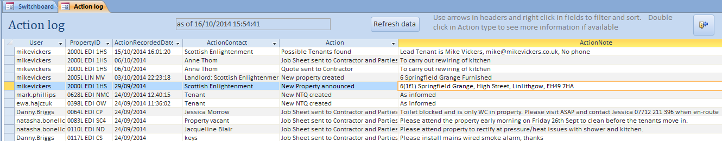

Use the arrowheads in the headers to sort and filter, or right click in a field for a choice of filters. Double clicking in the ActionType will show more detail if available.

### 

### Recording Actions

The user can now record actions from the following screens

* Landlord (see above)
* Property Accounts
* Property Summary (Record Note)
* Property Maintenance
* NTQ (Add general Note)
* Letting (Add Note)

Defaults have been added to the Action Block where this looks a reasonable start.

Eg for Property Maintenance

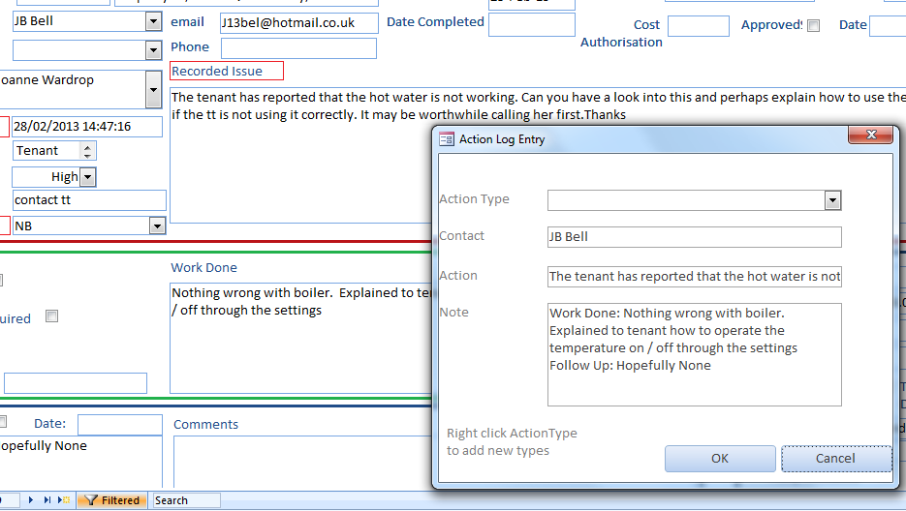

Here Contact is defaulted to Contractor, Action to Issue and Note to Follow up.

These defaults may be overtyped or cleared as appropriate by the user. The user is still required to select the Action Type – or create a new one.

### Automatic Action Logging

An Action is logged automatically in the following situations

* New Property taken on
* Maintenance – Contractor instruction
* New NTQ
* Letting Tenant approved

Contact is the user identified for the job.

### Recording User name for Actions completed

The system records the user completing the action as a field in the Action Log; thus the User in the screen below, given in the User column, is the user name of the logged on individual.

### Pop-ups

You can pop up Actions and Issues in the Action Log and Maintenance and Contact Status window for easy reading. Note – these pop-ups display the full action however long

Here is an Action Pop-up - Maintenance and Contact Status have similar Pop-Ups

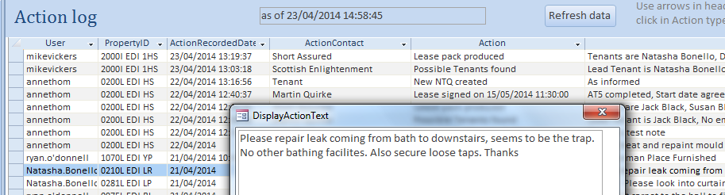

Note you can’t edit the pop-up. However remember in the Maintenance and Contact screen you can double click the SPMRef which will take you to the detailed record itself where you can make changes to the Issue and add a Follow-up.  
BTW did you know you can highlight a block of text and use the Microsoft spellcheck to check it (function key: F7)

# Leases

This is the key screen for reviewing or inputting rental payments. Payments can be uploaded automatically from bank statement worksheets - see Load Rents from Bank Statement or input directly into this screen.

Leases may be called up by

1. ‘Go To Lease’ from the Property Screen
2. Selecting the Property using the Select Property ‘Combo Box’ on the Lease screen itself and clicking along the Record Selector until the required Lease for the required Property is found.
3. Clicking ‘Leases In Force’ on the Switchboard. In this case Leases In Force may be paged through using the Big Blue buttons (for the other cases the buttons are invisible or have no effect).

The Lease Screen is divided into three sections

1. Main section containing details of the Lease – the details that have not been entered from the Lease Summary row on the Property form should be completed here
   1. Note particularly ‘*Current Rent Position’* which racks up when rental payments are received and racks down when the next Rental Payment is due. If the ‘*Current Rent Position*, is negative ie the Lease is in Arrears the field is shown in red.
2. Tenants section – details of tenants for the lease should be entered here
3. Rental Payments section – this section may be completed directly by manual keying. The Payer is the agent who makes the payment; a separate field is provided to indicate for which tenant the payment is being made. The date of payment is entered into the Payment Date field and after update the date is copied into the ‘Allocated Date’ field. The User may change this date if for any reason incorporation of payment is not to be made in the MRS for that month eg should the Agent make a bulk payment covering the next six months and the user wishes to split the payment over the six months. If a Rental Payment has been entered directly in this screen the *Add to Rent* button should be clicked to update the *Current Rent Position* and the AddToRent tick box will show as ticked. If for any reason the Payment record needs to be deleted then click the ‘*Delete Rent’* button and the *Current Rent Position* will also be decremented. A payment may not be deleted if it has been incorporated already into an MRS.
   1. The Months selection allows the User to restrict the rental payments displayed to the Month Selected.
4. The Processed tick box indicates that a rental payment has been included in the MRS. Only ‘Payer’ and ‘Notes’ fields can be amended at this stage. If any other fields need to be amended, the MRS has to be reversed, the change made and the MRS re-approved.

Display only Payments in Month

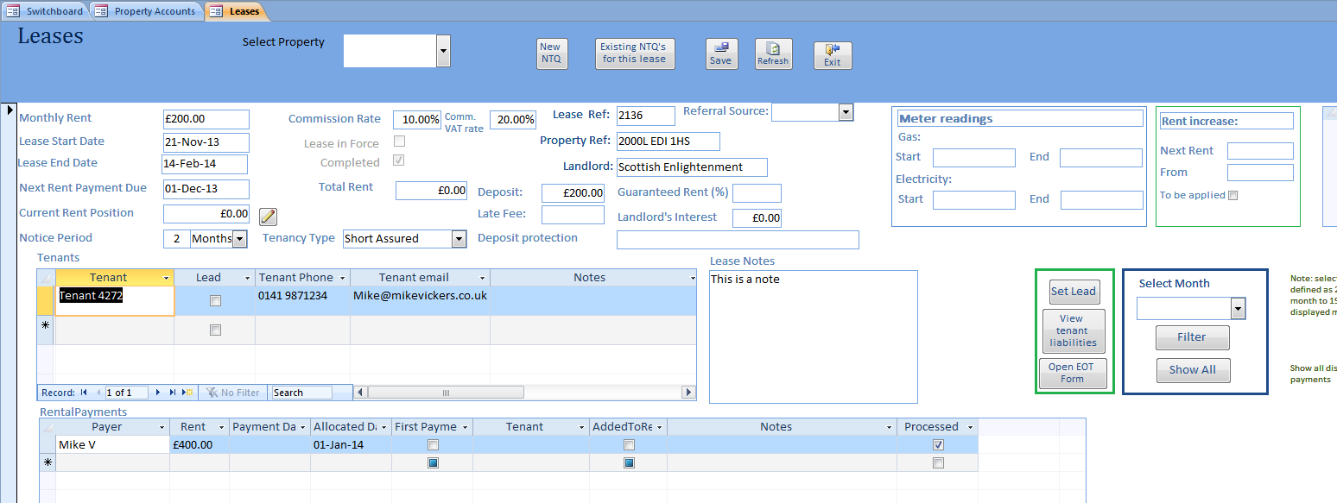

Which month payment will be allocated to?

Select Tenant by double clicking Name

Once Tenant details have been entered click Refresh to allow Tenants to be selected in Tenant Drop Down in Rental Payments window.

Note particularly once a Rental Payment has been processed the only information that can be changed Payer and Notes.

## Leases and tenants Selection

Double clicking a tenant name in the Leases form will bring up the Tenants form at that tenant.

Within the Tenants form, double clicking on another tenant on the same lease will bring up that tenant’s details.

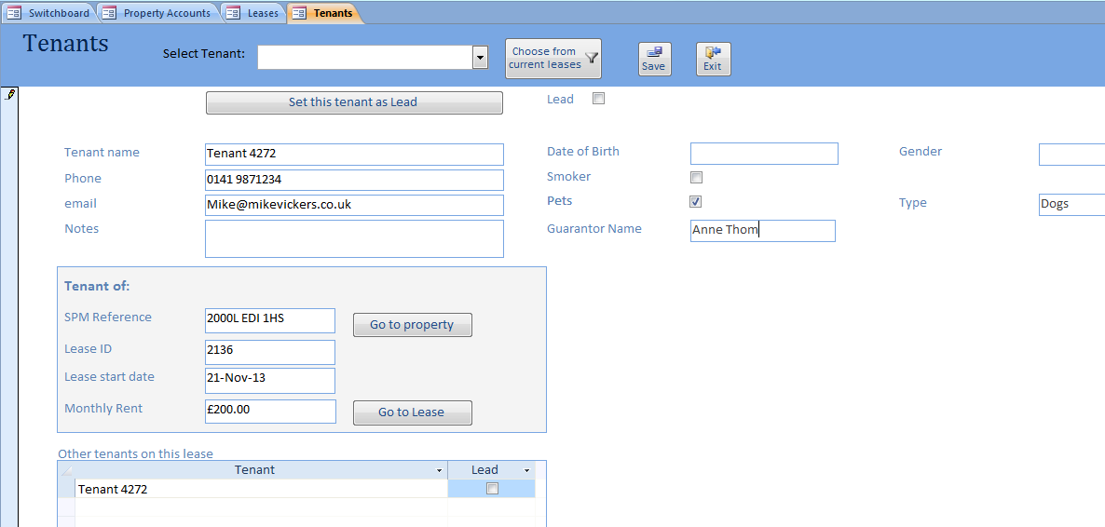

# Leases, Rents and Tenants

The following Switchboard level provides for managing Leases In Force, Rents Due and Tenants and reporting Leases not completed.

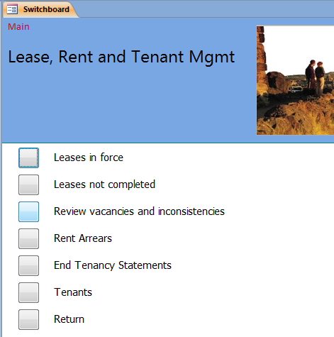

## Leases In Force

Clicking ‘*Leases in force’* calls up the Lease form for the User to scroll through all Leases in Force using the Big Blue buttons. This screen is the same as that presented in the Landlord Properties section.

### Use of Leases in Force form

The Leases in Force form is tended to be used to step through Leases which are in force using the buttons

. If a user chooses to search for a property using the Select Property button on the form the User cannot step through the leases in this way. However the User can now select the property and use the record select arrows to find the lease In Force should there be more than one lease for the property.

## Rent Increases

Rent increases may be introduced in any month.

A description of the overall approach applied is attached.

Where a rent is to be increased complete the block on the Lease form as shown below:

* Next Rent is the new rent to be applied to the lease
* From is the date that the date from which the new rent is applied. Note that the standard date range for the rent applies – 20th of previous month to 19th of current month. In the block below the new rent will be applied to the June rent and thereafter
* The tick box needs to be ticked to signal to system that the rent is to be applied. Once it has been applied the tick box will be reset

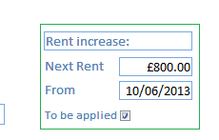

The Rent Increase process should be run on 20th of the previous month for rents to be applied eg 20/07/13 for rents to be increased for the month of August 2013.

The process is initiated from the Main Menu > Leases, Rent and Tenant Mgmt > Rent Increases.

## Catering for Rent Increases

SouthSide want to automate rent increases. Rent Increase to be applied to the Lease in terms of amount and on Date as specified.

Assumptions

1. The tenant will have been informed that their rent is being increased some months in advance. It is therefore to be expected that the tenant will have arranged that their bank payment will increase in line with instructions and for the month as specified by SouthSide
2. Rent increases only applied on a whole month basis.

Consideration

1. Whole month Rents apply from 20th of previous month to 19th of current month
2. Therefore application of increase needs to be between 19Th and 20th of the previous month for which the new Rent applies
3. Access does not have good automated event management so application needs to be handled manually eg the accountant will manually run a system procedure on 20th prior to any rent processing.

System Process

1. Each Lease will be augmented with two additional fields: new rent, month to be applied – It is assumed that rent increases are not be so frequent as not to allow the accountant to load the new data for the next increase well clear of any subsequent increase for the same lease.
2. A job will be created which will trawl through all leases looking for new rents that should be applied for the current whole month as defined above
3. When a lease is found for which a new rent is to be applied, the current Monthly Rent is overwritten by the new rent
4. A change file should be created by the job, listing Lease changed, previous rent and new rent together with date of run.

### Meter readings

Starting and ending gas and electricity meter readings have been added to the Lease form. These will be used for the Inform Utilities action in NTQ’s and Lettings, if available.

### Rent changes

Rent increases may be introduced in any month which is later than both the lease start date and the date of input.

Where a rent is to be increased, complete the block on the Lease form as shown below:

* Next Rent is the new rent to be applied to the lease
* From is the date that the date from which the new rent is applied. Note that the standard date range for the rent applies – 20th of previous month to 19th of current month. In the block below the new rent will be applied to the January rent and thereafter
* The tick box needs to be ticked to signal to system that the rent is to be applied. Once it has been applied all three boxes will be reset to null values.

The table beside the box show the history of rent rates for the lease (this table cannot be edited).

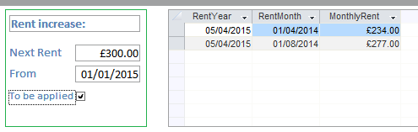

The Rent Increase process is now initiated by approving an MRS for the property. This will check for any rent increases to be applied with dates at latest the MRS month, and run the process.

## Arrears

The arrears accumulator on the Leases form has proved difficult to maintain, as it requires regular monthly processes to be initiated manually, and this has sometimes been missed. Calculation of the accumulated ‘rent position’ on the lease form (negative for arrears) has been changed, and a new form has been introduced which recalculates arrears from scratch, and produces a report similar to the arrears cut & paste spreadsheets presently used.

### Arrears accumulator:

This is updated monthly for leases in force to 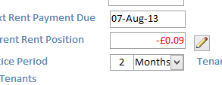

‘current rent position + rent payment in – monthly rent due’

The process is now initiated by approving an MRS for the property, and requires no manual intervention – the buttons Add to Rent and Delete Rent have been removed

Note that if later MRS’s have been run, and you then run an MRS which changes the rent, the rent accumulator may be incorrect and should be checked using the arrears form below.

### Arrears form:

This new form recalculates arrears from scratch, and produces a report similar to the arrears cut & paste spreadsheets presently used. It is reached from the switchboard Lease, Rent and Tenant Management / Rent Arrears / Arrears.

This form uses a table of rent changes, which were not previously captured in SID. (Please see separate note about initial setup of this table.) For new leases, the rent rate will be captured when the lease is put in force, and any subsequent changes will be captured by use of the Rent Changes box (see section on Rent Changes).

Choose a property and lease from the choice box at the top. You will be asked for a date from which to start the calculation, defaulted to the lease start date. Note that for older leases; say before 2011, no data is held so you must choose a later date. The program will then calculate the arrears.

The print button produces a summary of rent due/paid, and calculation of arrears. Note that one of the Aprils has to be knocked out for the calculation of Rent Due; the month beginning 06th April has been chosen. This may unfortunately be inaccurate for leases starting around then.

The program will calculate initial rent and final rent (if appropriate) exactly as the Lettings and NTQs forms do. Either or both of these boxes, and the ‘Payment not captured on the left’ box, can be overwritten to cater for, say, arrears carried over from an earlier date.

Note: this form is still a work in process. It does not cross-refer to Lettings and NTQ’s; it will not cope with erroneous (missing) data. A number of older leases have inconsistent treatment of deposits and other payments, which will need manual adjustment.

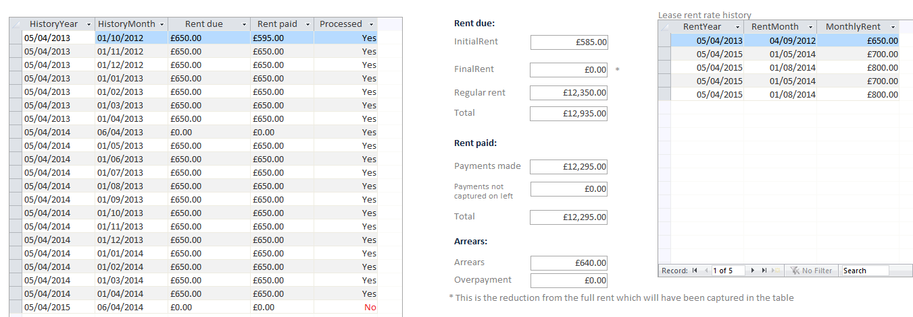

The Print button in the form header produces a printed version of this information.

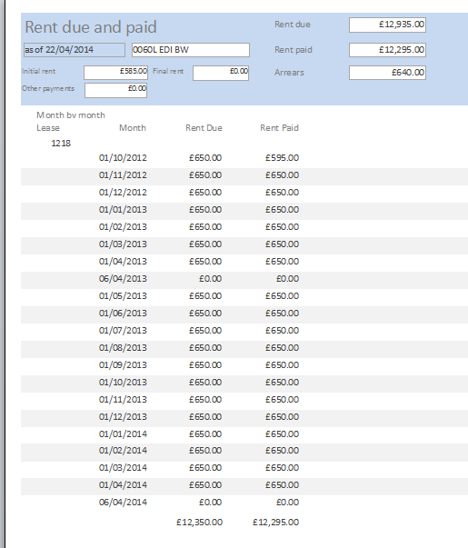

### Arrears Additions

A Refresh button has been added to allow new starting values to be created and the arrears calculated without closing & opening the form. The calculation has also been revised to use rent records rather than history records; this is more accurate but it is still the case that early payments have been inconsistently recorded and will need to be checked.

## Leases not completed

This report provides a list of Leases which have been In Force but are no longer so and have yet to be completed.

### Deposit protection

A field has been added to the Lease form for information on Deposit Protection – see example of Lease above. This will be printed on the MRS below the word Deposit. For legibility on the MRS, this should be no more than 30 characters – see example of MRS at end of this note

### Leases

Tenancy types and Notice Periods have been added:



With Release 19

* Notice Period is defaulted to 2 “Months”
* Tenancy Type is defaulted to “Short Assured”. Note Tenancy Type is a required field.

## End of tenancy statement

The End of Tenancy Statement is a statement of Deposit to be returned to the Tenants on termination of their Lease. The statement shows all liabilities that the tenants may have incurred during their tenancy; included are interim payments that they may have made in response to requests from SouthSide Management.

In the screen shot above it can be seen that the tenants are presently in debt to £1,590. The screen shot overleaf shows a different lease, with £105 to be taken off a deposit of £1320, and £1215 to be returned.

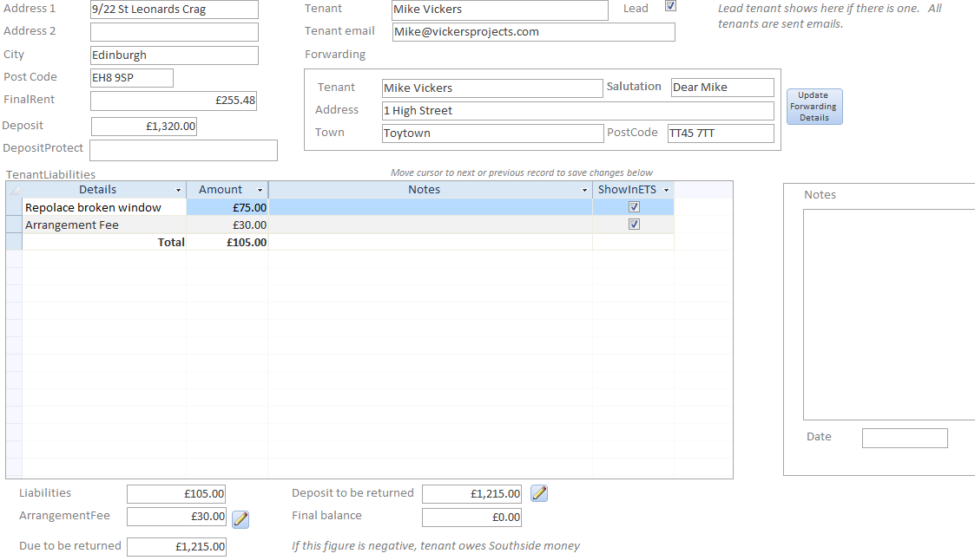

The ‘Due to be returned’ field calculates the proposed amount to return. Input actual amount to return in the ‘Deposit to be returned’ field.

Note that Arrangement Fee and Deposit returned can only be set or adjusted using the pen icon. 

The End of Tenancy Statement may be printed as below, or emailed to the Tenant and/or LPS as pdfs via the Email button in the form header.

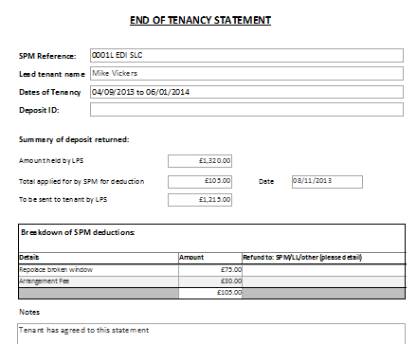

# Tenants

The Tenants of any lease may be called up through the Select Tenant Combo Box. Tenants are listed in alphabetical order of Surname.

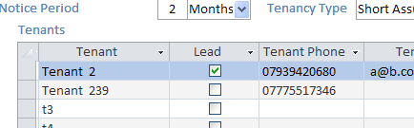

or from the Tenants form:

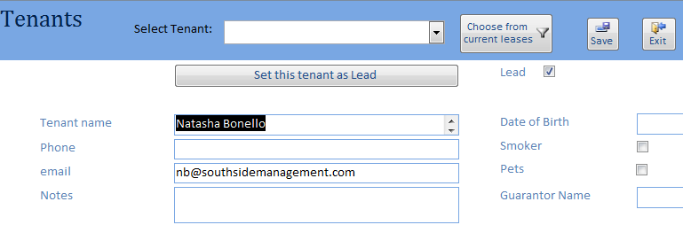

### Lead Tenant

A field for Lead tenant has been added, set from the Lease form:

The lead tenant will appear in bold on the MRS.

The MRS now displays up to six tenants.

Note that if a Tenant moves from one Property to another they are considered as two separate tenants and will appear twice in the list.

# Properties and Maintenance

Maintenance and Services requests and their follow up are progressed through the Properties and Maintenance switchboard

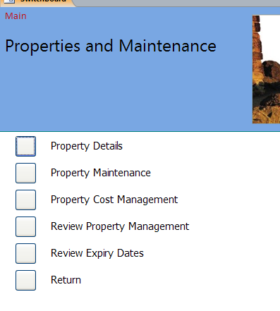

# Property Details

The Property and Expiry details may be edited through this form.

Please note that this form may also be entered from the Property form via the Rental Properties switchboard. To edit accounting details for the Property go to Properties form, select the Property there and click and click Edit Property Details.

### Property data

The following fields have been added:

* + Landlord Registration Reference
  + Fields to indicate that there is no:
    - HMOLicenced
    - Gas Safety
    - PAT
    - PIR
    - Fire Safety
    - EPC
    - Insurance
    - Property Inspection
    - Landlord Registration
    - Next rent Review
    - Management Fee Review
  + Source for Property Acquisition
  + Property Manager

### Display of property data

On most forms which display SPM reference, double clicking this field on the form will pop up the Property Details form (in read-only mode). Whether or not financial data is shown depends on where the call is made from.

### Property details

Scrolling bars have been implemented on Electric Meter and Gas Meter fields in property details

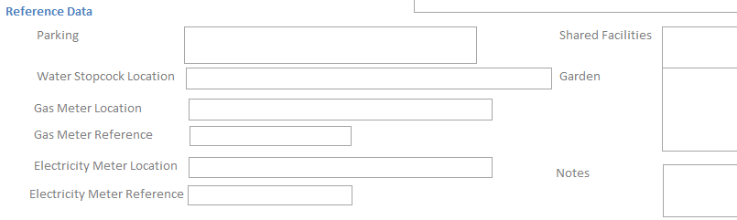

Note that new lines may be entered in any ‘memo’ field by pressing Return with Control Key held down.

### Tenants Preferred

Landlords made enter the tenants they prefer using the Tenants Preferred above. This is a pull down list and the list is updatable through the Standing Data

### Identification of Property Manager

A field has been added to Property Details to identify Property Manager responsible for that Property.

Property Managers are defaulted in Release 19 to 001L – 300L NB; 301L-600L EH; 601L and above MP.

The Property Manager’s name and email appears on all Maintenance and Service emails.

### Advertising Description

A brief Advertising report has been provided to report on property details currently held in the Property Details form.

This report may be printed from the Property Form and the Property Details form:

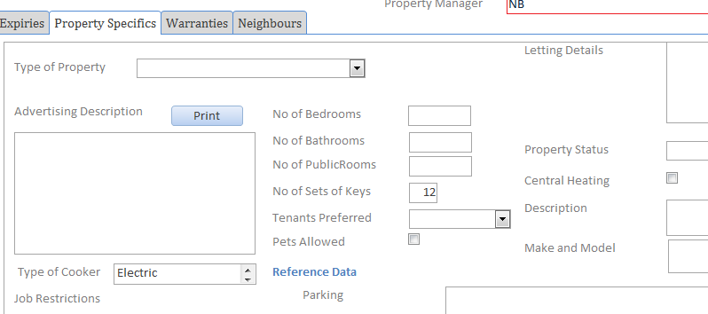

### Warranties

New Tab added to Property Details to provide for input of warranties for Appliances

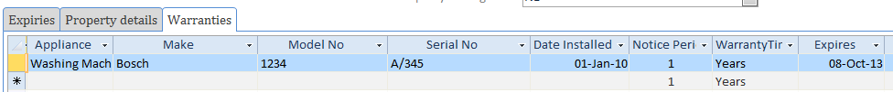

Appliances is a drop down list and can be added to in the standing data.

### Job Restriction

A field, Job Restriction, has been added which if completed will be detected when raising new Maintenance and Service jobs. The User when raising a new job is presented with the Job Restriction and is asked as to whether to continue raising the job or not. If the User chooses Cancel the job is not raised. If the user chooses OK then job raising continues as usual.

### Property Type and Status

The following extra date items have been added to the window in support of emailing information on new properties

* Property Type – drop down list including for example 1st floor flat, Semi-detached
* Property Status – drop down list including for example vacant, tenant occupied

### Neighbour details

An additional tab has been provided on the Property Details window to allow details on properties adjoining the property selected to record basic details of neighbours. Thus

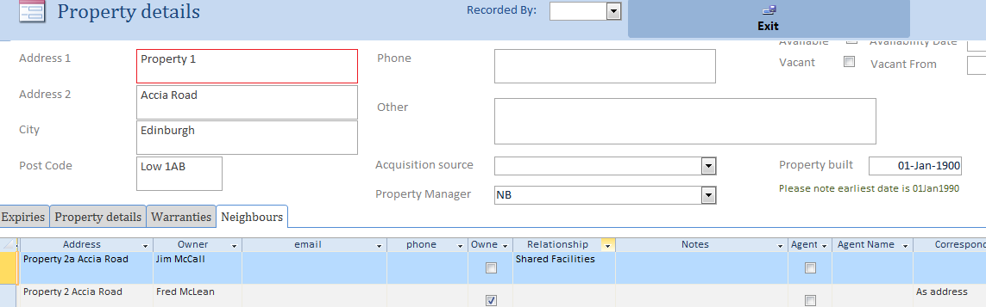

Neighbour details are also intended to hold details of tenants of other flats in a shared block of flats. The Neighbour relationship may be entered in the Relationship field. The actual relationship can be created using a drop down menu which opens when right clicking the field and selecting ‘edit list items’ (only available on PCs with Full Access).

### Property specific conditions

The user may record property details in the Property Specific tab of Property Details. The detail conditions are common to all properties. However the user may select other specific conditions which are not common to all properties through the sub form:

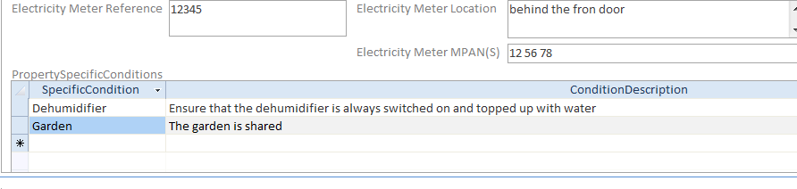

Specific conditions are selected from the drop down menu.

A detailed report of common specific and property specific details is printed by clicking the ‘Print Property Specific Conditions’ button

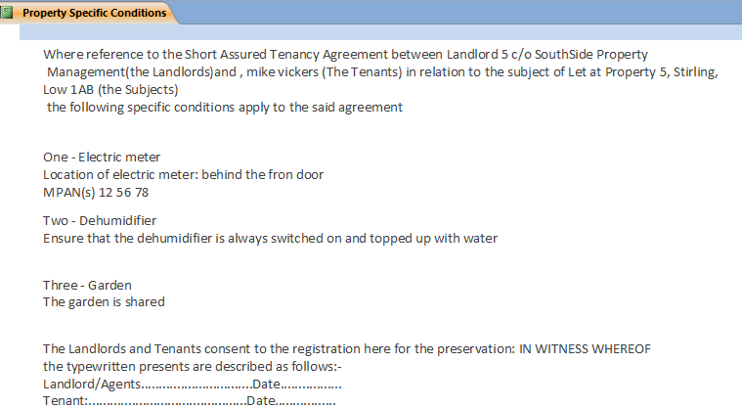

Property Specific Conditions are set up via the Standing Data > Appliance and Specific Conditions > Specific Conditions.

Note that as yet there is not a reminder action in the Lettings Opportunities form for creating these specific conditions.

### Property Lost

Clicking Property Lost in addition to setting the Lost Flag also sets all Expiries to the None state.   
In this state they will no longer be included in the list of Expiry Dates needing review.

## Emailing information on New Properties

Property managers when completing the take on of a new property can email details of the property to the SouthSide team. Most data is collected from the database if it has been input. However some date is too specific to the actual transaction that it is considered better to be put entered by the property manager at the time of sending, if available.

The following screen dump shows the email that is created.

Data that needs to be put in specifically is shown in red; the rest is from the database: note that the latter is not maintained in the database.

|  |  |
| --- | --- |
| **New Property** | |
| **Property Reference** | 2000L EDI 1HS |
| **Address** | 6(1f1) Springfield Grange, High Street, Linlithgow, EH49 7HA |
| **Forms Received** | To be specified |
| **Forms scanned/Filed** | To be specified |
| **Uploaded to SID** | To be specified |
| **Landlord Name/s** | Scottish Enlightenment |
| **Landlord Registration & Exp** | No registration  Expiry: No Expiry Date |
| **NRL1 Required?** | No |
| **Available for short let:** | To be specified |
| **Contact Tel No** | 01506 671307 |
| **Emergency Contact** | 01506 671307 |
| **Email** | mike@mikevickers.co.uk |
| **Available Date** | 18/06/2014 |
| **Rent Agreed** | £ 0 |
| **Commission Rate** | 10.00% |
| **Minimum Fee** | £0.00 |
| **No. Bedrooms** | 2 |
| **Ideal Type of Tenants** | Professional |
| **Pets** | No |
| **Floor** | 4th Floor Flat |
| **Parking** | In front of flat |
| **Landlord Cost Authorisation** | £100.00 |
| **Property Status** | Vacant |
| **Safety/EPC Checks Booked & Who With** | As required |
| **SPM Agreed to pay for** | Nil |
| **Photo’s Booked & Who With** | As required |
| **Board to be Erected & No. Bedrooms** | As required |
| **Keys** | As required |
| **Comments / Recommended work** |  |
|  |  |

Review Outstanding Issues by Property and Date

# Property Maintenance

Preview job sheet

Add a new Issue

This screen is for entering and tracking Maintenance and Service requests.

Email: Contractor  
Landlord  
Tenant

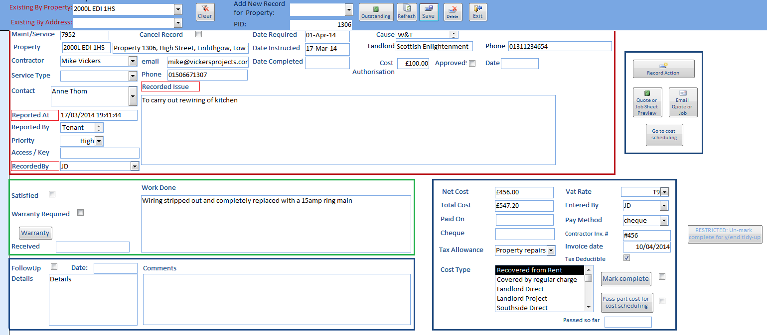

Allow for Part Payment

Tick if follow up is required

Select Cost Type

Contractor  
/ Servicer

To enter a new Issue select the Property through the ‘*Add New records for Property’* combo box and a blank form will be presented.   
‘*Issue*’, ‘*Maintenance_ServiceDate*’ and ‘*Recorded By*’ are required fields. They are defaulted and should be changed to that required.

On creation of a new record the Recorder is asked first to identify them from the list in the combo box; their initials are entered into the Recorded By field.

Contact field offers a choice box of the Tenants of the Lease in Force for the Property selected or the ability to enter any other contact. If another contact is entered, enter the contact’s email if known.

There is a pull down list of Contractors which may be selected from but any name may be entered in the Contractor field. An email address should be entered if a name entered. The *Contractor* pull down list may be added to through the Standing Data function.

A Job Sheet may be previewed by clicking the preview button.

Once the work is completed the Maintenance and Service Request may be pulled up via Property or Address search combo boxes and the work done reported. Where appropriate the Follow up section should also be completed.

The Cost of the work done should be entered in the Net Cost block; VAT will be added at the rate selected. Payment is defaulted to the Landlord but Tenant or other may be selected – see screen view above.

### Maintenance / Service Records – Contractor comms stored

Both Contractor email and phone default to those on assigned to the Contractor unless overtyped.

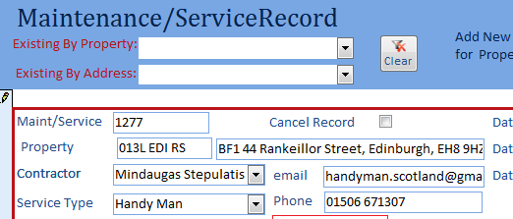

### Maintenance / Service Record Changes

Changes to the Maintenance/Service Record form are:

* Contact field offers a choice box of the tenants of the lease in force for the Property selected for maintenance/ service or the ability to enter the name of any other contact
* On creation of a new record the Recorder is asked first to identify themselves by their initials. This information is copied into the Recorded By field
* The Cost To field has been changed to a selection field allowing Landlord, Tenant or Other to be selected

## Emailing

The email button provides for informing the Contractor of the work to be undertaken, the Landlord of the work planned, the Tenant to make contact with the Contractor or Service agent.

On clicking the email button the emails are automatically created and loaded into the user’s Outlook **Drafts** folder in succession:

1. Email to Contractor confirming the job along with a copy of the Job Sheet
2. Email to Landlord notifying them of work to be carried out along with the status of approval
   1. If cost exceeds Authorised amount
   2. If cost not greater than Authorised amount
   3. If Authorisation is still awaited
3. Email to contact/tenant providing information of the contractor, their cost responsibility if they are responsible and advising them of proposed method of access to the property.
   1. If by key
   2. If they need to phone the contractor to arrange an appointment.

The user will be asked to enter email addresses for each party if they are not stored in the database.

All emails are presented for the Property Manager’s further input if they so require.

If a party has no email address, the User may print out the emails and send to a party by fax or mail.

## Format of the emails

Templates are provided for all three emails; these may be adjusted to suit SouthSide’ requirements. The current templates are displayed in Appendix VI and the format of all three emails may be arranged to suit SouthSide’s requirements. When creating modified templates, please note that the data fields to be used must be enclosed in % signs exactly as shown.

However note that in the present implementation not all data are available to all three emails.

Job Sheets sent to the Contractor are copied to the ‘Other Documents’ folder and identified by SPM Reference and date and time of emailing, and an entry is made in the Documents register, marked as Approved and Published.

### Email Types

The maintenance emailing capability has been extended and now automatically creates in the user’s Outlook **Drafts** folder the following three mails in succession:

1. Email to Contractor plus a copy of the Job Sheet
2. Email to Landlord notifying them of work to be carried out along with the status of approval
   1. If cost exceeds Authorised amount
   2. If cost not greater than Authorised amount
   3. If Authorisation is still awaited
3. Email to contact/tenant providing information of the contractor, their cost responsibility if they are responsible and advising them of proposed method of access to the property.
   1. If by key
   2. If they need to phone the contractor to arrange an appointment.

For both Landlord and Contact/Tenant the emails are presented for the Property Manager’s further input if they so require.

The format of all three emails may be arranged to suit SouthSide’s requirements and the data available from the Maintenance/Service record currently are:

|  |  |
| --- | --- |
| *Item* | *Expected Usage* |
| Salutation | Name of person to be emailed |
| Property | SPM Reference |
| Issue | The work reported as needed to be done |
| Cost Estimate | Cost estimated by SouthSide / Contractor |
| Approval | Details of who bears the cost |
| Date Instructed | Date that Southside has given instructions to the Contractor |
| Maintenance | Type of work to be carried out |
| Contractor | The name of the Contractor, phone and mobile numbers |
| Contact | Contact provided by the person who has requested that there is an Issue |
| Access | Method of access to the property proposed by the SouthSide Property manager |

As most PM’s now have Outlook signatures applied automatically, signatures have been removed from the email templates.

However note that in the present implementation not all data are available to all three emails.

The email address is Contractor, Landlord, or Tenant as appropriate. If any of these are missing from the database the user is requested to provide them, or to leave them blank. In the latter case, the email in question will still be placed in the Drafts folder and can be printed and posted if required.

Job Sheets sent to the Contractor are copied to the ‘Other Documents’ folder and identified by SPM Reference and date and time of emailing. In the current implementation the Documents Register is not updated for the SPM Reference and so the Job Sheet will not automatically be sent to the Landlord through the Lettingsemail system.

The property reference is now included in the email title to Contractors.

### Job sheets

On the Maintenance Service record form, job sheets can be previewed via the Job Sheet Preview button, or created and emailed via the Email button. The Email button creates emails to contractor, landlord, and tenant; all can now be edited as they are being created.

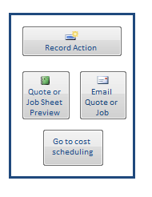

A log record will be created on emailing a job sheet. The Record Action button can be used to create an ad hoc log entry if required.

Current Templates are shown below. When creating modified templates, please note that the data fields to be used must be enclosed in % signs exactly as shown.

### Contractor

Dear *%Salutation%*

Please find attached a *%Job Card%* for Property *%Property%* . If you have any queries please do not hesitate to contact me.

Access to the Property is as follows: *%access%*

*________________________________________*

### Landlord

Dear %Salutation%

We have arranged for *%Maintenance%* to be carried out for property *%Property%* as follows:

Issue: *%Issue%*

Cost Estimate: *%Cost Estimate%*

Date required: *%Date required%*

Your approval: *%Approval%*

Our proposed contractor is: *%Contractor%*

Date Contractor Instructed: *%Date Instructed%*

*Your comments here*

Please confirm within 24 hours if you wish to arrange an alternative solution.

_________________________________________________________

### Tenant

Dear *%Salutation%*

Please note we have instructed *%Maintenance%* to be carried out at your property *%Property%* as follows:

Work required: *%Issue%*

Date required: *%Date required%*

The Contractor is: *%Contractor%*

Contractor instructed on: *%Date Instructed%*

Approval has been given by: *%Approval%*

Please provide access to the Contractor as follows: *%Access%*

*Property Manager’s comments here*

Should you have any queries as to the work involved or should the contractor have not made contact by the Date of Work please contact me immediately.

_______________________________________________________

### Landlord email on Job completion

Marking a job complete will produce a draft email to the landlord:

Dear %Landlord Name%

We had arranged for %Maintenance% to be carried out for property ref: %Property% at %Property Address% as follows:

Issue: %Issue%

Date instructed: %Date instructed%

Contractor: %Contractor Name%

To confirm that this job has been completed and we have received the invoice for the total %INVOICE AMOUNT%. This will be deducted from your rental statements over the coming months and a copy of the invoice will be attached to your rental statement.

Comments:

Kind Regards

## Entering Request for Quotations

Quotations may be requested from a Contractor in advance of issuing Job Sheets in the Maintenance and Service Request capability. On clicking the ‘Email Quote or Job’ the user will be asked to specify which service they want. Clicking Job Sheet is as previous but on clicking Quote the system will create a Quote document rather than a Job Sheet and an email will be sent to the Contractor seeking a request for quotation –emails will not be sent to either the Landlord or the Contact.

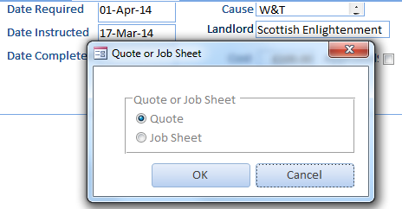

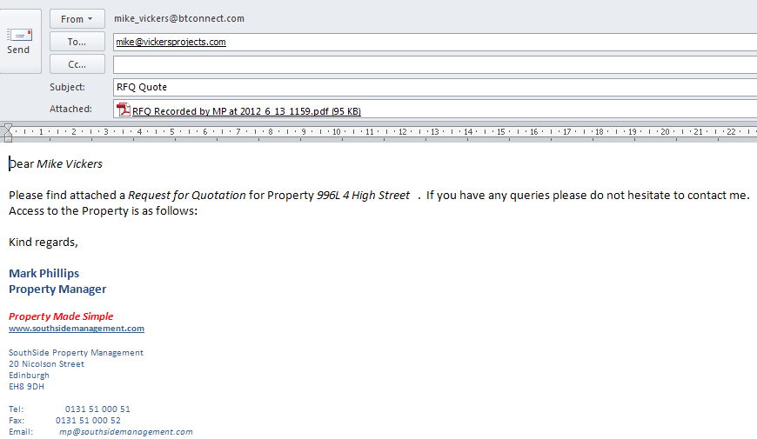

The Documents form below shows both a Job Sheet and a quote for Property 996L

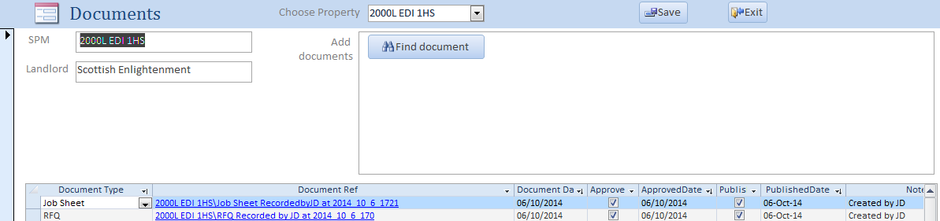

Note that the User will receive a warning if they attempt to email the same Job Sheet but not if they attempt to email the same Quote.

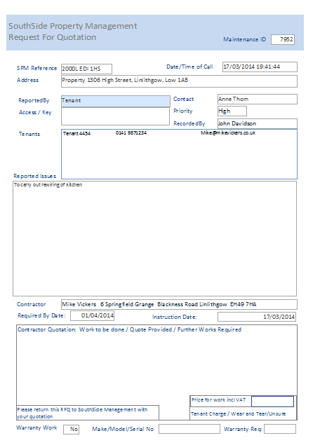

## Actions on Costings

Referring to the Cost Block bottom right of the Maintenance/ Service Record window

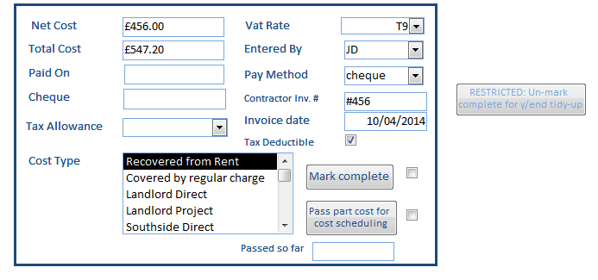

The Rules are as follows:

1. Cost Settings
   1. Negative costs rejected
   2. Can over type Total Cost
   3. Automatic calculation of Total Cost = Net Cost * chosen VAT rate
   4. Recalculation of Total Cost if Net Cost or VAT Rate changed
   5. If VAT changed after Net Cost entered then Total Cost recalculated
   6. VAT rate is chosen by drop down

For further details see section on Costs below.

## Maintenance / Service Records – Contractor comms stored

Both Contractor email and phone default to those on assigned to the Contractor unless overtyped.



# Preparation of Statement Summary

The Properties and Maintenance\Review Property Management switchboard gives access to summaries of service records and costs, and to a screen for preparation of comments:

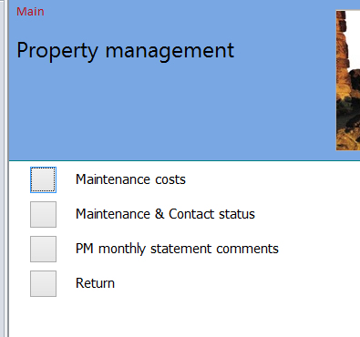

Click PM monthly statement comments. Choose month and create comments by clicking the ‘Set or update comment’ button. A preview of the report is also available from this screen.

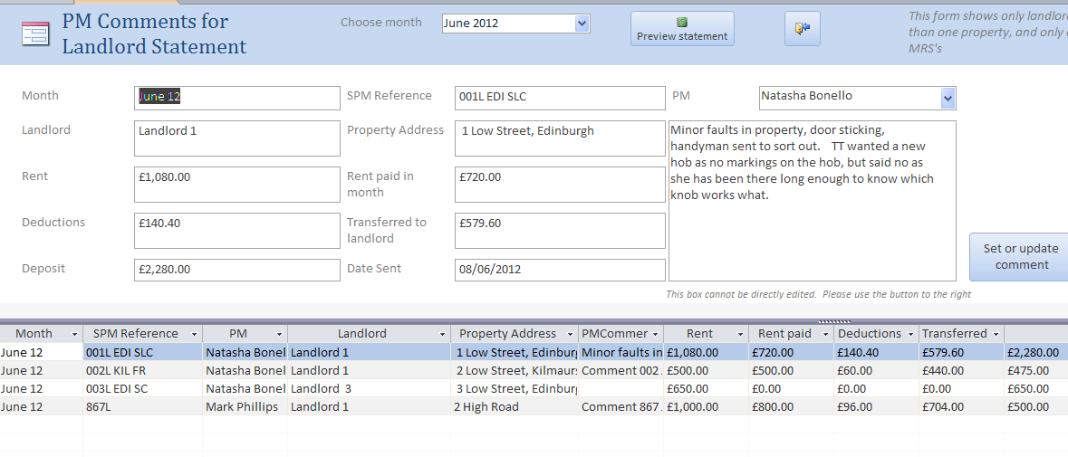

# Costs

Input and management of costs has been enhanced to allow:

* Allocation of liability between landlord and tenant
* Matching of maintenance invoices with recovered property costs
* Easier scheduling of costs to be recovered
* One-off input of regular charges

and to reduce duplication of input.

Costs are of one of several types:

|  |  |
| --- | --- |
| Recovered from rent | The landlord pays this cost via a reduction in rent remitted |
| Covered by regular charge | Recovered from rent via a regular charge |
| Landlord Direct | To be paid directly by the landlord |
| Landlord Project | To be displayed on the MRS. This is used for major projects, which are usually budgeted and tracked outwith SID. |
| Southside Direct | A write-off. |

Payments to Southside are treated as negative costs, with categories Recovered from Rent, Landlord Direct, Landlord Project.

### Overall process

### Cost switchboard

The Costs switchboard is accessed from Properties and Maintenance / Costs.

### Cost input

Costs can be input directly or can be created automatically from Maintenance Service Records. Payments to Southside are input directly.

***Note***: costs are no longer input as directly typed lines on the Property Accounts screen.

### Direct input of non-jobsheet costs

The fields on this screen are all the same as those required to input a cost in previous versions, plus two new fields CostType and TenantLiability.

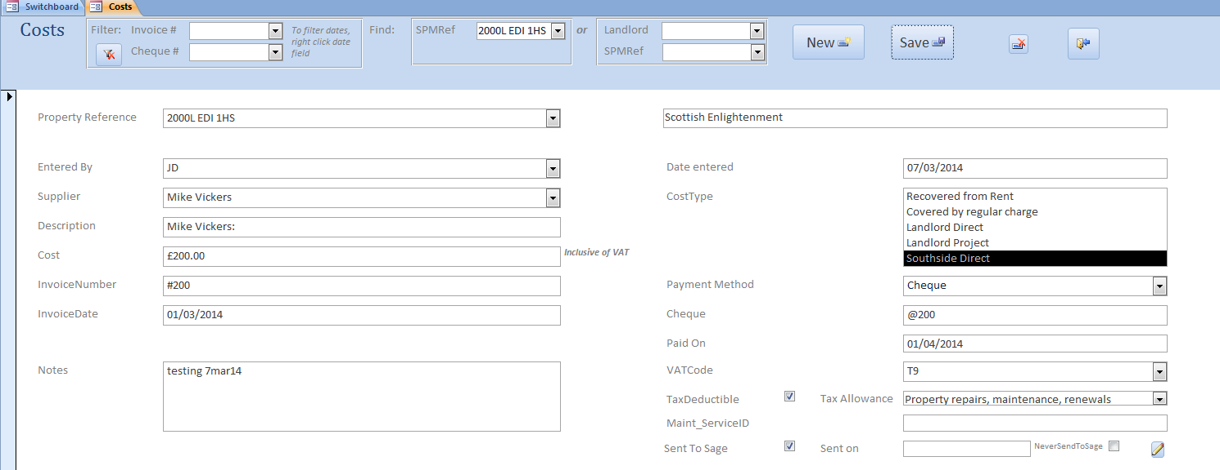

### Cost type:

Costs are of one of several types:

|  |  |
| --- | --- |
| Recovered from rent | The landlord pays this cost via a reduction in rent remitted. This is the same as Property Costs which were previously typed directly into the Property Accounts screen. |
| Covered by regular charge | Recovered from rent via a regular charge. Regular charges are *new,* and are a way to recover month by month items such as broadband or factoring charges. The ‘Covered by regular charge’ type applies to the actual bill as it comes in. |
| Landlord Direct | To be paid directly by the landlord. |
| Landlord Project | To be displayed on the MRS. This is used for major projects, which are usually budgeted and tracked outwith SID. |
| Southside Direct | A write-off, ie paid by Southside and not recovered. |

### Tenant liability:

If a tenant is judged to be, say, 50% liable for a cost, type 50% in the Tenant Liability box; this will then appear in the End of Tenancy statement. If a tenant hands in a cheque to cover damage, the same applies with the payment being a negative figure; see below under Payments.

The box at the bottom of the screen displays costs already scheduled for recovery for the property.

Tenant liability can now be entered as an amount or a percentage on costs and payments.

### Jobsheet costs

Costs are automatically created when a job is marked complete on the Maintenance/Service record screen. There is also a facility to pass part of a cost for scheduling, for example if part-payment has been made for materials.

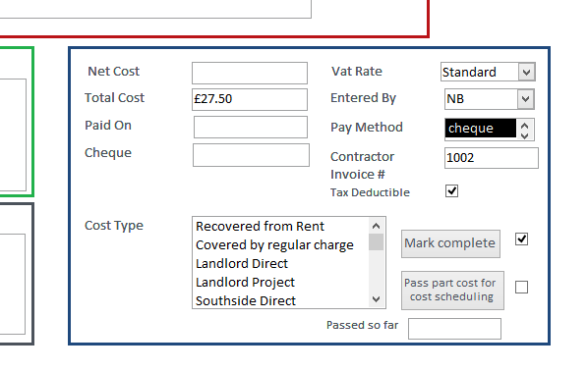

This allows for a much closer tie-up between jobs and payments, and for immediate allocation of liability if required. When marking a job complete, you will be asked for the job description, and to input tenant liability if appropriate.

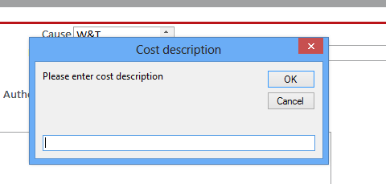

This job description will now appear on the MRS rather than the supplier name.

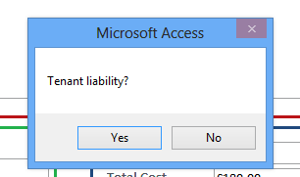

If the tenant has some liability, the system will automatically move to the cost screen for this to be input.

### Input payments to Southside

Payments being made to Southside are treated as negative costs. The screen is very similar to the Costs screen, with the Supplier box being replaced by the ‘Payment from’ box, which has options From Landlord, From Tenant, and Other. Payment types are:

|  |  |
| --- | --- |
| Recovered from rent | A payment made against a cost which is being recovered from rent. This has the effect of reducing the amount being recovered. |
| Landlord Direct | Paid directly by the landlord against a cost directly incurred for the landlord. |
| Landlord Project | To be displayed on the MRS. This is used for major projects, which are usually budgeted and tracked outwith SID. |

### Tenant liability:

If a tenant has been judged to be liable for a cost, and then hands in a cheque to cover this liability, input the percentage of the payment being made which relates to the liability. This will usually be 100%.

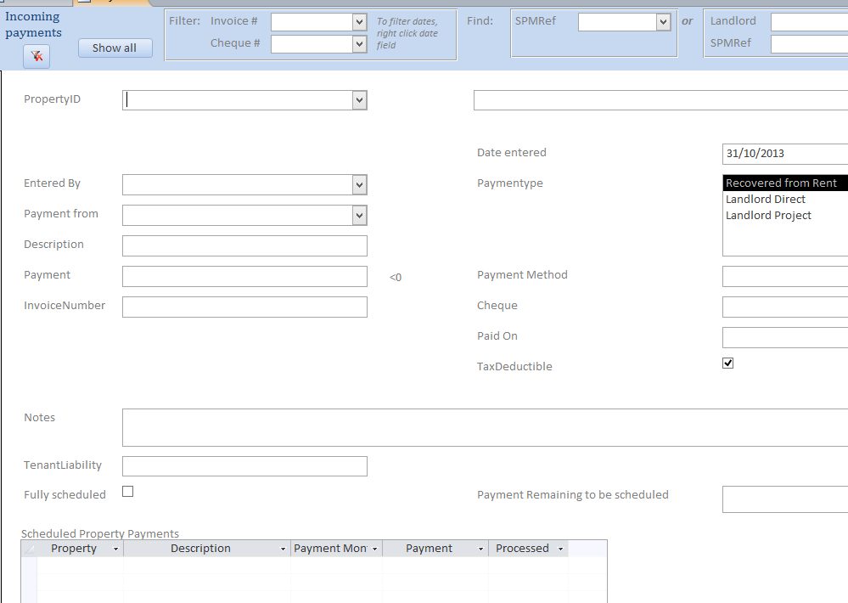

### Regular charges

Regular charges cater for items such as broadband or factoring charges, where a regular amount is charged periodically.

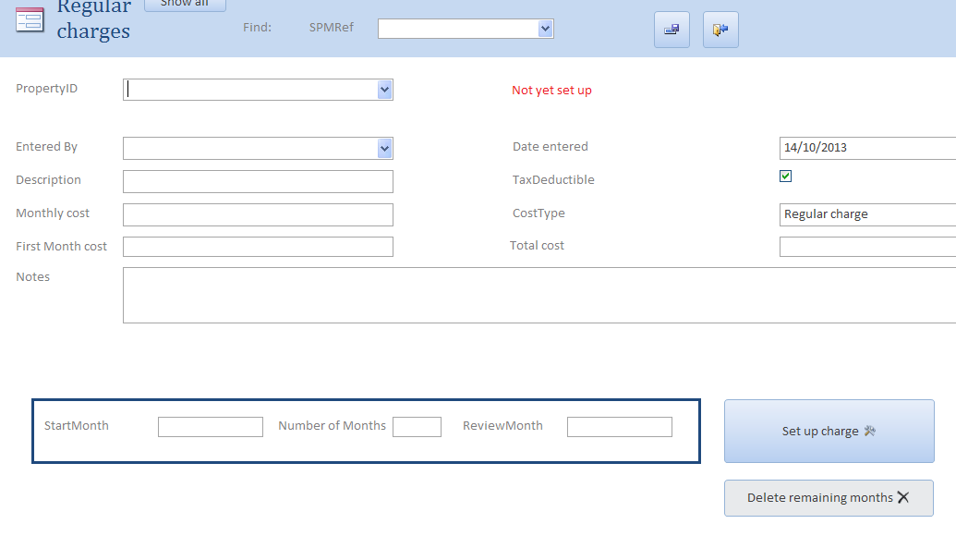

### Input of regular charges

Regular charges have

* A description
* A monthly cost
* A first month cost if this is different
* A number of months (including the first)
* A start date

For example, a broadband contract of £470 to be recovered over 18 months with a first month charge of £45 and seventeen subsequent charges of £25 would look like the screen below after the ‘Set up charge’ button had been clicked.

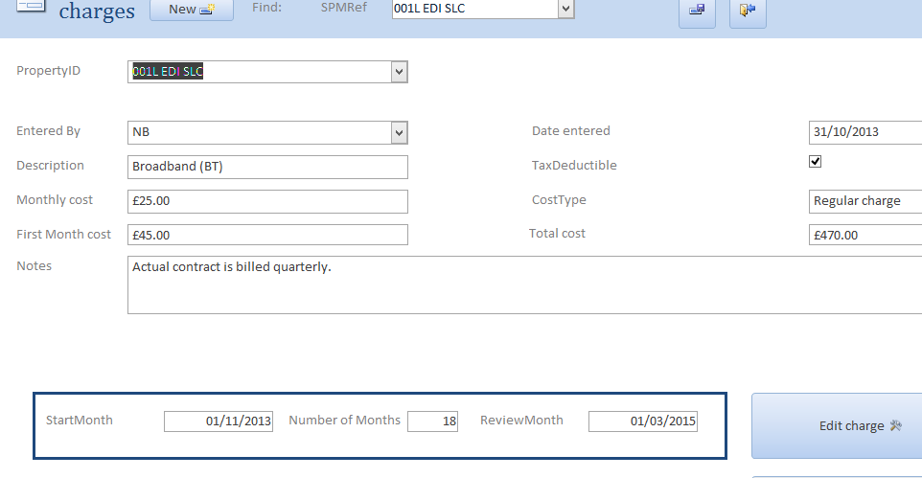

The total cost is calculated automatically, as is the review month - two months before the end of the contract. One property cost of £45 has been created for property 001L for November 2013, and one per month of £25 for seventeen months thereafter.

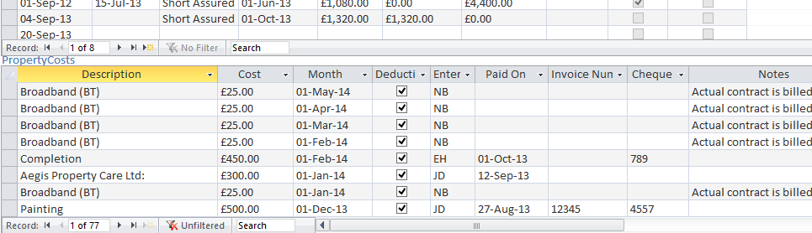

Note that these property charges are how the broadband contract cost is recovered. The actual bills may be to a different schedule, eg quarterly. When these come in they can be input via the Costs screen, with a type of ‘Covered by regular charge’ to avoid double counting.

Regular charges can be modified to a certain extent once they have been set up. Any charges which have been included in an MRS cannot be changed unless the MRS is reversed. Charges which have not yet been included can be modified to a new amount by clicking the ‘Edit charge’ button, or can be deleted by clicking the ‘Delete remaining months’ button on the Regular Charges screen. If the length of a contract needs to be extended, the simplest way is to set up another regular charge for the additional months required.

### Landlord projects

Landlord projects in SID are used purely to advise the landlord via the MRS what the budget for a large job is, and what payment has been received. The information appears near the top of the MRS, just below the landlord address.

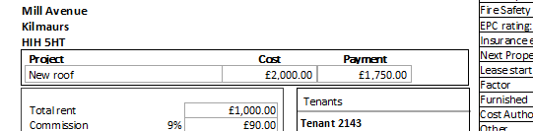

To set up Landlord Projects, use the Landlord Projects screen. Note that there is only a limited amount of data checking in this screen – a warning will show if you set two projects for the same month.

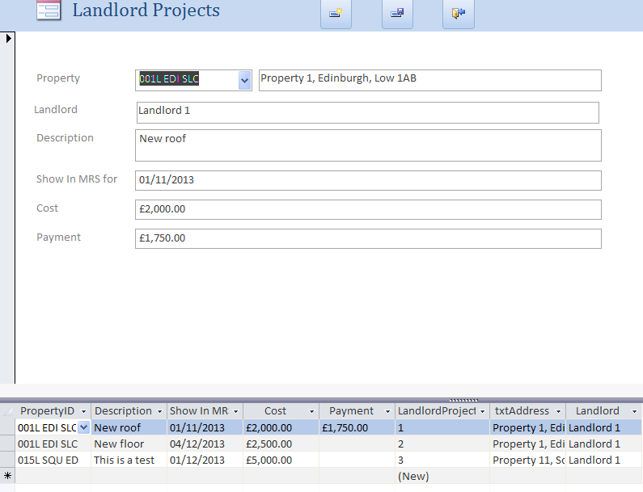

### Cost and payment recovery scheduling

Cost recovery is achieved by reducing the amount remitted to landlords, with payments increasing the amount remitted. To do this, Property Costs and payments must be allocated to properties in a particular month.

Previously this was done by typing costs data directly into the Property Accounts screen, for costs not associated with a job sheet; and by using the Allocation screen for jobsheet costs – although this was not much used in practice. Jobsheet costs have often been typed in directly, with duplication of effort and loss of information about contractor job payment.

The new Cost and Payment Scheduling screen displays all directly input and job sheet costs, and allows for bulk scheduling of multiple costs to the next available month, or for individual scheduling, for one month or over a range of months.

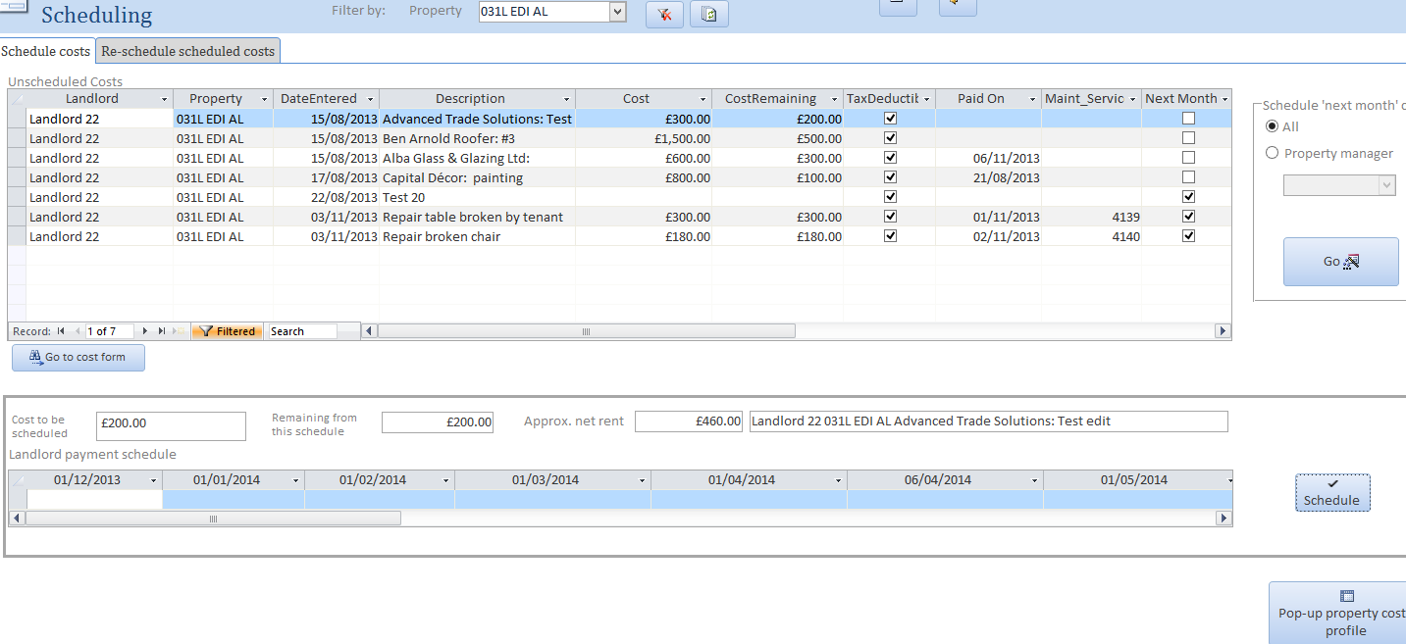

All costs will initially be marked as ‘Next Month’. Clicking the Go button will schedule all costs marked as Next Month to the next available month for each property.

Individual costs can have the Next Month tick box cleared to allow for specific scheduling. For example, you might use the small black filter arrows to find all costs over, say, £500 and clear the box for them in anticipation of splitting the recovery.

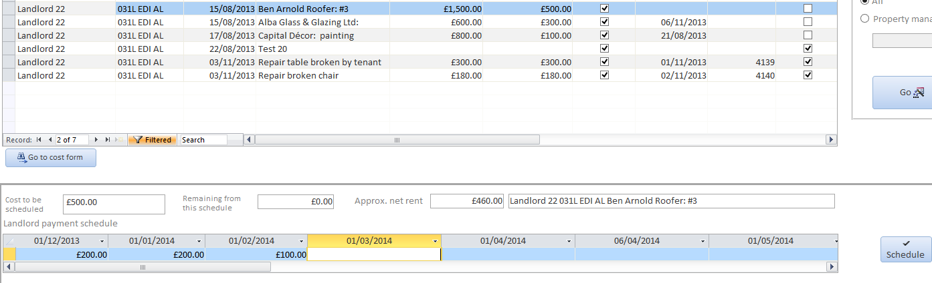

In the example above, the remaining cost of £500 had been split across December, January and February. Clicking the Schedule button will create individual Property Costs for each of these.

If need be, a cost profile of each property can be shown by clicking the 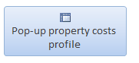Pop-up property costs profile button, although it should be noted that this is a heavyweight query which takes a few minutes to run. Once run, it can be minimised until needed. The example below shows the scheduled costs for one property over several months.

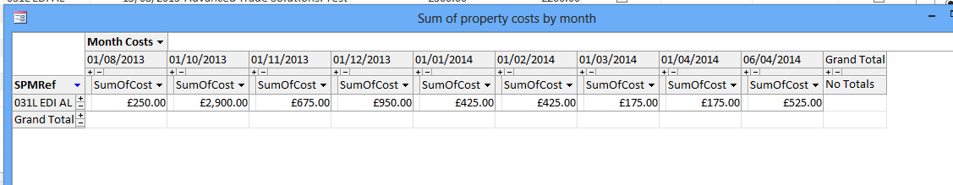

### Reschedule scheduled costs

You might on occasion need to change the scheduling of a cost. The Reschedule scheduled costs tab allows a cost to revert to unscheduled, provided not all components of it have been processed.

### Costs summary

The costs summary screen lists all costs, with totals at the foot of the columns.

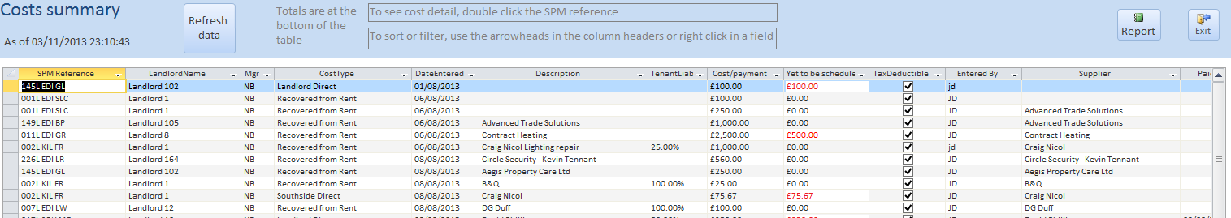



This screen can be filtered and sorted by using the small arrowheads at the top of each column, or by right clicking in a field. A report of the (filtered) costs can be printed by clicking Report.

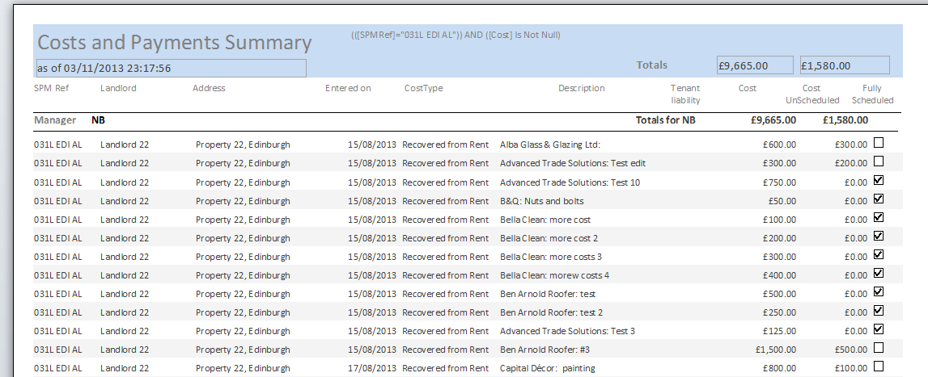

### Other cost reports

The Unprocessed Costs report on the Management Information screen shows scheduled property costs which have not yet been included in an MRS.

The Maintenance Costs report under Review Property Management/Maintenance Costs shows costs associated with job sheets.

## Remembering Costs without setting Lease in Force

SouthSide staff has noted that property costs entered before a lease for the Property has been put in force, cannot be set against Recovered From Rent and are typically set against Landlord Direct. Staff have stated that they get ‘lost’ and when a lease is eventually raised staff forget to change the allocation to Recovered From Rent.

To avoid ‘losing’ these costs staff have created a ‘dummy’ lease, put it in force and re-recorded the cost as Recovered from Rent; and set the dummy lease out of forces.

The downside of this approach is not only that this is misleading from any audit trail but that Availability is reset and no longer attracts attention by the letting staff and such costs that should be recovered from the Landlord when incurred are delayed until the property is eventually leased. It approach is therefore to be deprecated.

Two enhancements have been made.

* The Direct Costs form at the bottom of the Property Costs window has been augmented to include the selection of cost assignments including to Landlord Direct. See screen dump below of bottom of the Property Accounts window. Including this data on the Property Accounts form means that these costs are less likely to be ‘lost’ when the property becomes leased.

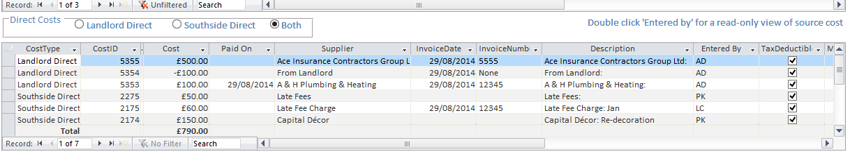

Note that the costs displayed may be those allocated to either SouthSideDirect (as   
 currently) or Landlord Direct or both according to the radio button selection.

* A warning is provided to the user when attempting to raise a Lease In Force for the property if there are Costs allocated to Landlord Direct and not yet recovered.

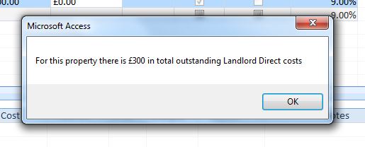



### Tax allowances

The system now provides for classification of property costs by Tax Allowance category as the costs are entered.

The Categories are set out below and are taken straight from HMRC documentation:



Tax Allowance Category Entry

Entry on the Cost form is beside the Tax Deductible tick box:

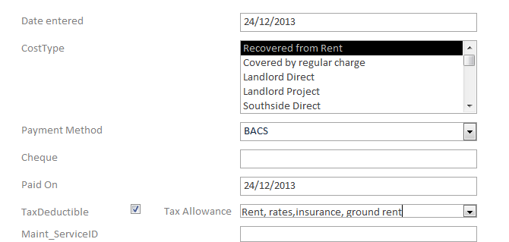

In this example the cost is assigned to tax allowance category: Rent, rates, insurance, ground rent.

Similarly for the Maintenance and Service form:

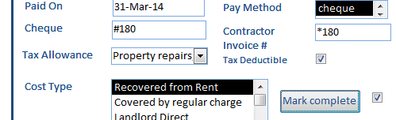

### Yearly report to Landlords of Tax Allowances by Category

An annual report can be produced showing total deductions for each Tax Allowance category.

Note any cost may be assigned to only one Tax Allowance category; if this not sufficient then the cost must be broken down into separate costs subject to different allowances.

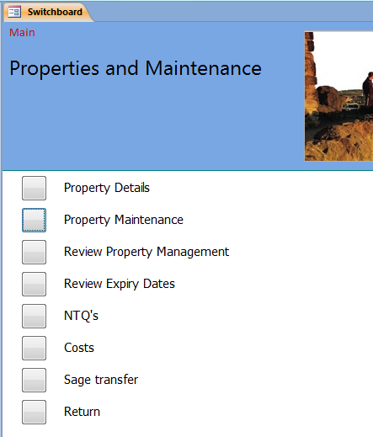

### Review Property Management provides Three buttons:

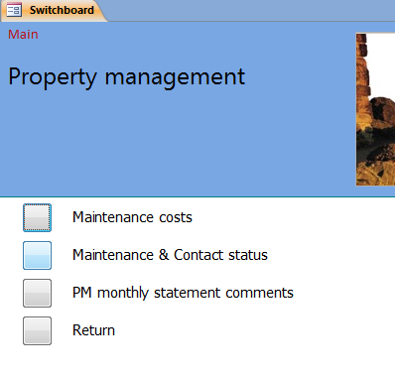

* Maintenance Costs – lists costs associated with all maintenance work. The user can select whether to view those costs for outstanding work or for all costs since system start up.

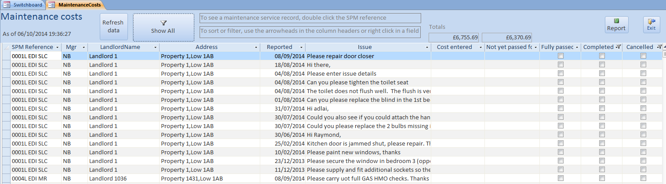

* Maintenance & Contact Status –lists the status of all maintenance work. The user can select whether to view the status for outstanding work or the status for all work since system start up

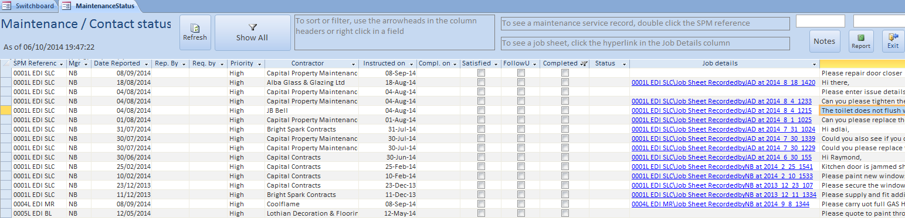

Note the user can call up the job details of any job by double clicking the hyperlink of the job in job description. The user can display the full description of the work by Issue eg

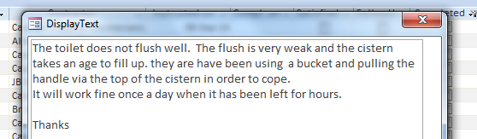

* PM Monthly Statement Comments – allows the Property Manager to enter details about the progress of work etc for any property. Their comments will appear

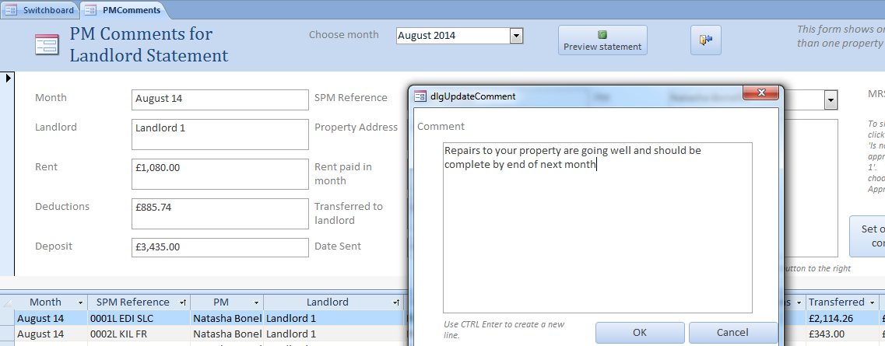

Extra Button provided within Set up and Housekeeping

* Communications Log – provides a snap shop log of work. It is expected that opportunities for snapshot recording will be added to as the functions within the overall system are added to.   
  So far:
  + For Maintenance / Service – a snapshot of the state of each issue including whether complete
  + For Properties – when a new property is added – it is considered that this is valuable for Property Management.

## Review Property management

This switchboard gives access to two forms and reports for viewing an overview of maintenance progress and cost management.

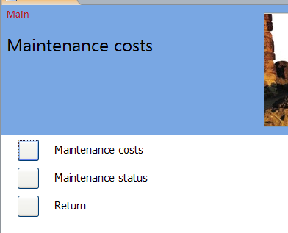

### *Maintenance Costs*

Clicking this button opens a form, with a further click to a report, which lists costs of all maintenance service records. Using the arrowheads in the headers and/or right clicking in fields, the form can be filtered and re-ordered by a wide variety of criteria, and the report will reflect that filtering. Double clicking the SPM ref field will open the corresponding maintenance service record.

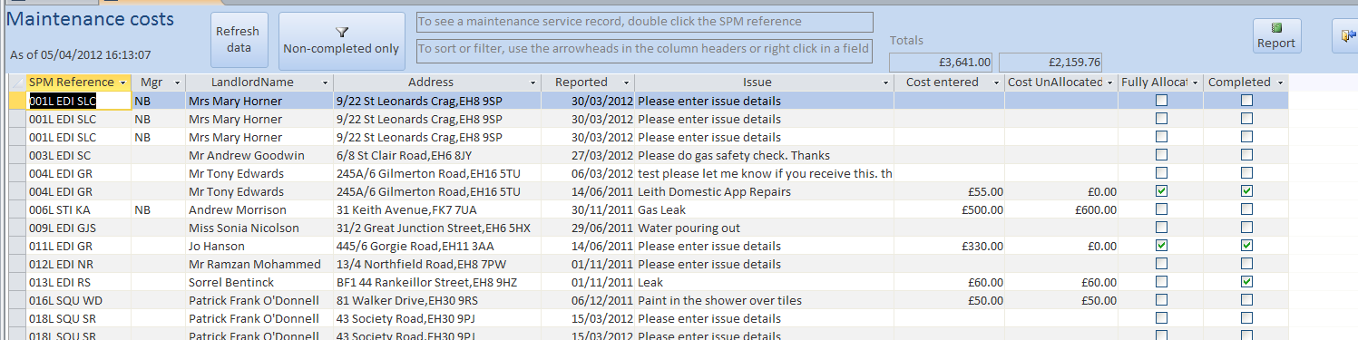

Example: form filtered to just one landlord

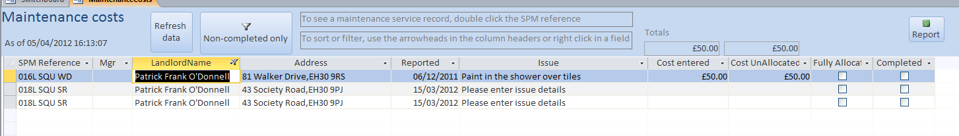

Matching report:

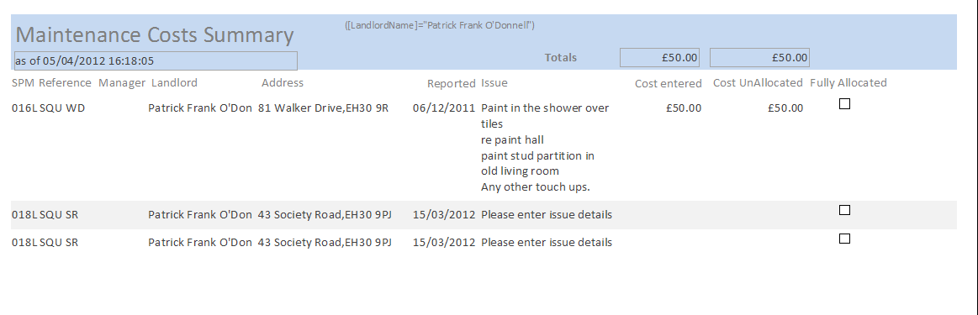

### Maintenance Status

Clicking the Maintenance Statusbutton opens a form, with a further click to a report, which lists the status of all maintenance service records (note: a record for which a Job Sheet has been prepared more than once will appear more than once). Using the arrowheads in the headers and/or right clicking in fields, the form can be filtered and re-ordered by a wide variety of criteria, and the report will reflect that filtering. Double clicking the SPM ref field will open the corresponding maintenance service record, and clicking the Job details field will open the job sheet.

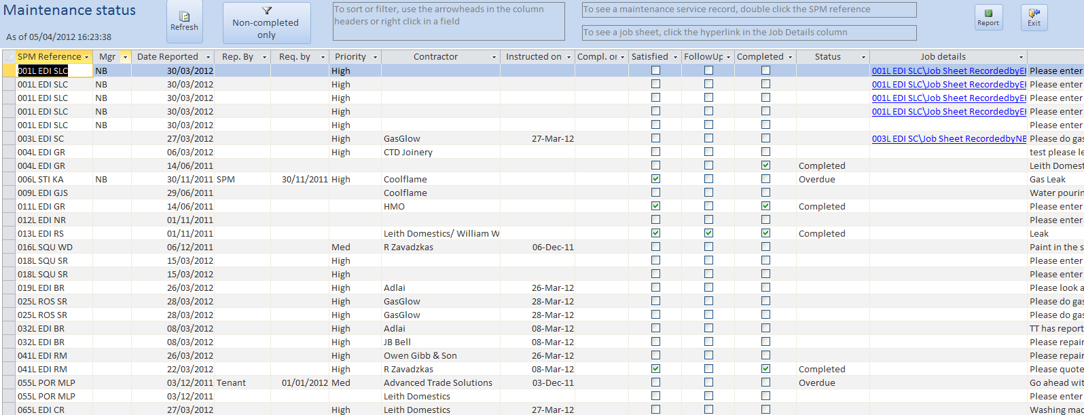

Example: filtered to medium priority only

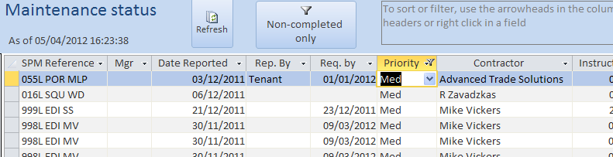

and the corresponding report:

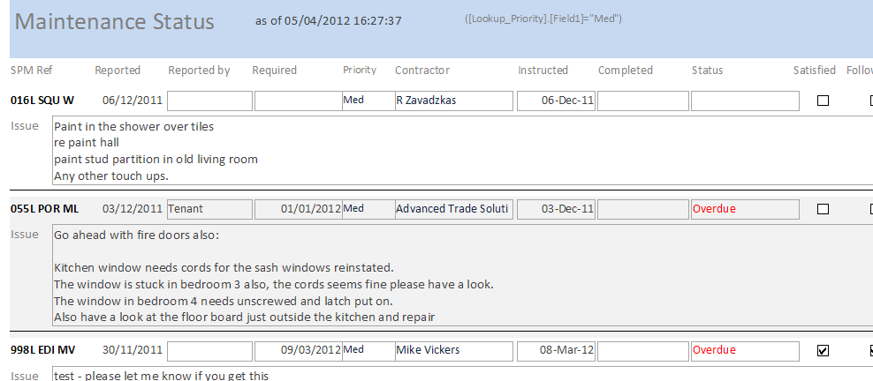

# Expiries

Expiries are set up through the Property Details form, Expiries tab.

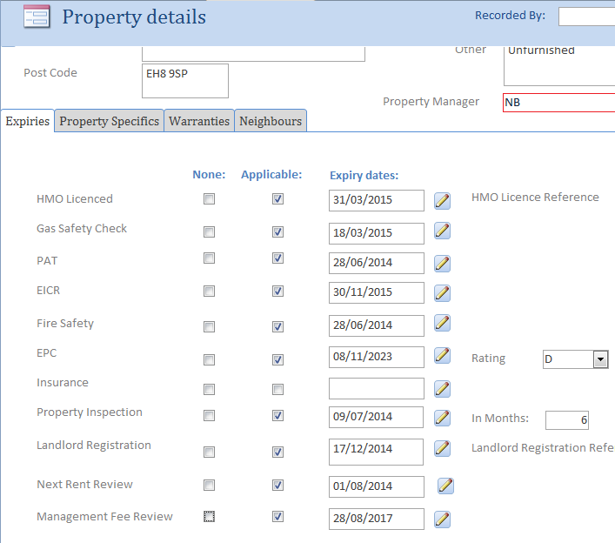

Ticking None against a check indicates that this property never requires this check (eg a property with no gas). The MRS will show ‘None’. Clearing None and ticking Applicable means that it does require this check, and there should be a date. The MRS will show the date. If neither None nor Applicable is ticked, it indicates that the check is appropriate at some point, but not now. The MRS will show ‘N/A’.

### *Review Expiry Dates*

To review Expiry dates open Review Expiry Dates and select the Expiry Type to review. The dates displayed are those where the date is within a default date 2 months from present - this date may be changed if required. Note that whether an expiry date that is in the past is displayed in red.

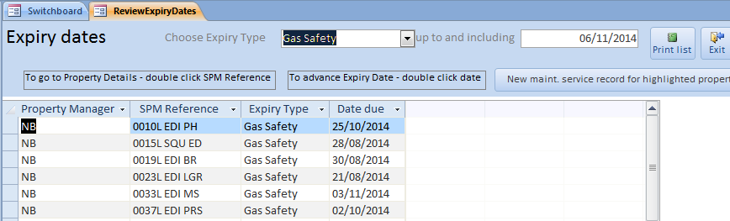

The report looks like

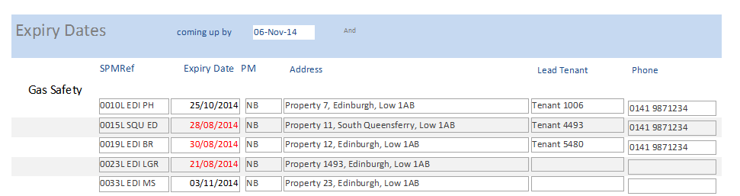

## Applicable for Property

All expiries for a property have an ‘Applicable’ tick box, and there is an HMO reference.

If a property has an expiry ticked as Applicable, the expiry date will appear in the MRS; otherwise it will show “N/A”.

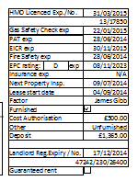

### EPC Rating

A field for EPC rating has been added, set on the Expiries tab of the Property Details form.

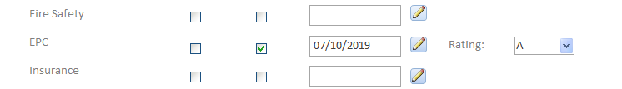

This rating is now shown on the MRS:

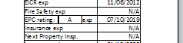

### HMO expiry

If you wish to show that an HMO coming near expiry has been applied for, add ‘Applied for’ to the end of the reference number on the property details form:

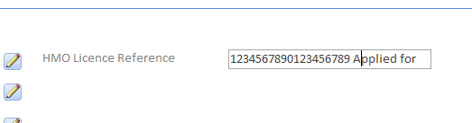

and it will show in the MRS.

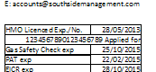

Two further ‘expiries’ are added to the list of expiries

* Next Rent Review – allows the user to enter a Rent Review date as to when the property manager should undertake a review of the rent.
* Management Fee Review – allows the user to enter a Management Fee Review date as to when the property manager should undertake a review of the SouthSide management fee

Both reviews can be managed through the Expiry Window as other Expiries ie listed as needing consideration by the responsible property manager and dates can be advanced once the reviews have been completed.

Note that these ‘expiries’ are not included on the MRS

### Expiry Dates by Property Manager

Expiries may be selected by Property Manager for printing.

Below are the dates for EPC:

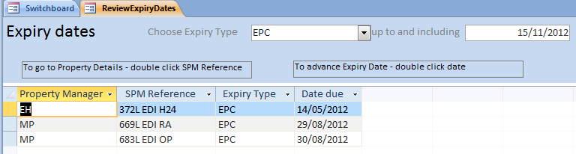

To select Property Manager MP filter Property Manager by MP and click the Print button:

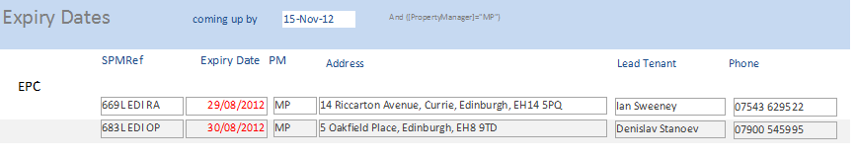

Note that

* the name of the Lead Tenant is provided along with their phone number for service engineer’s convenience
* the default look ahead has been reduced to one month.

By double clicking Date due the Date due is advanced to the next Date due.

### Updating Inspection Dates –

Inspection Date are advanced by appropriate period by double clicking Date Due for Property.

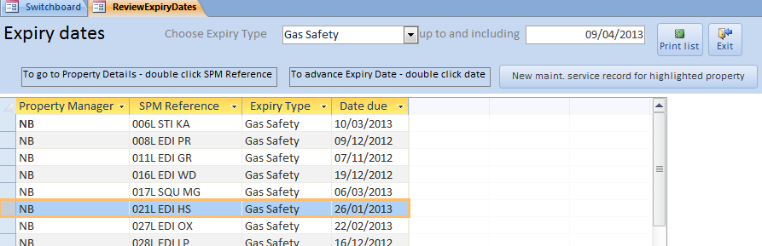

Thus clicking Due Date 09/12/2012 for Property 008L the date will advance by 1 year. It is intended that the User will advance each date as they are notified by the Contractor that the inspection work has been done.

### Expiry Type – Period between Inspections

The length of time between inspections for a particular Expiry type is set up in Standing Data >Services> Routine Expiry Work - Contractors - thus Gas Safety has a Period Unit in Years and Duration of 1 year – frequencies supported are ‘month’ ,’quarter’ and ‘year’.

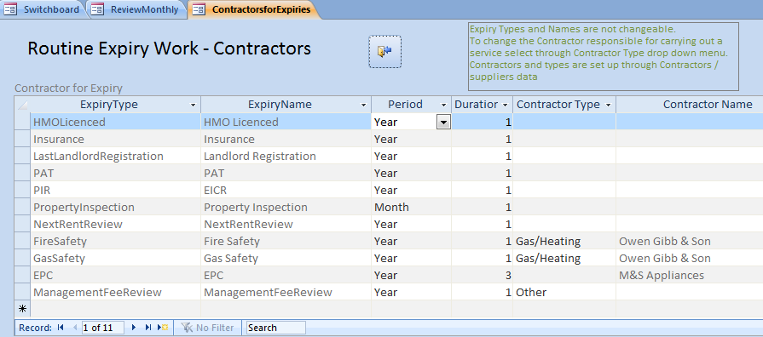

The one exception is for Property Inspection where the number of months may be set individually by Property through the Property Details > Expiries Tab.

Note that Expiry dates may also be updated on the Property Details window by clicking the small ‘pen’ icon next to the Expiry Date

# NTQ (Notice To Quit)

The data structure and initial sets of actions for NTQ’s have been created.

In all cases, where documents are created (either printed or created as email attachments), the merged document (usually the document for all tenants) is stored in the property Other Docs folder, and an entry (hyperlink) made against the property in the Documents Register.

## Set Up Actions

Set Up actions are called from the Southside/Set Up & Housekeeping/NTQ Setup switchboard.

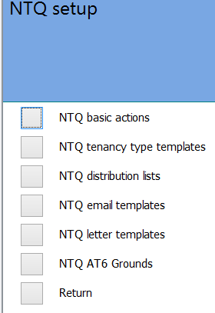

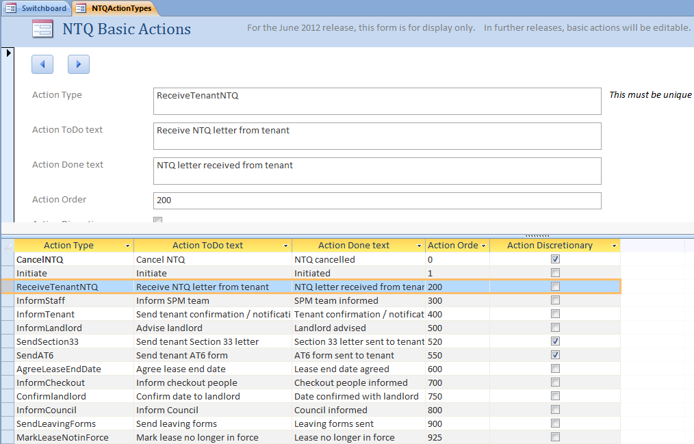

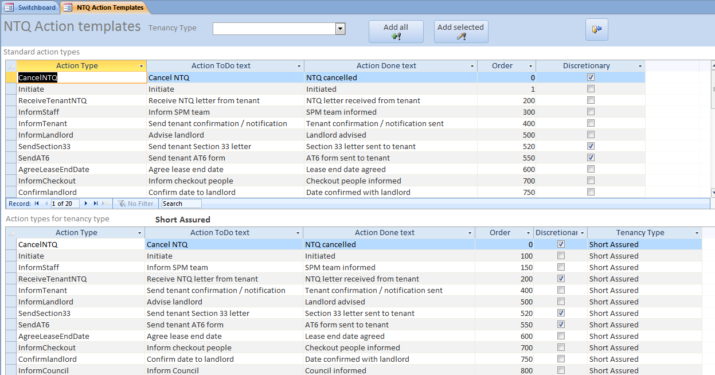

Other setup items are the distribution list for internal emailing of a new NTQ, a mail template for the same purpose, mail merge letter templates, tenant confirmation emails, and landlord emails.

Mail merge letters contain merge fields (which are visible) and in the case of the AT6 letter bookmarks (which are not visible) to produce the merged letters. Please consult Vickers Projects about any wording changes to make sure that fields or bookmarks are not lost.

New NTQ’s can be created from the Lease screen or the Property Maintenance switchboard; existing NTQ’s can be reviewed from the Properties & Maintenance switchboard or the Marketing switchboard. From the marketing switchboard, the form will initially open with only available properties showing, although others can be requested.

A typical email is shown below

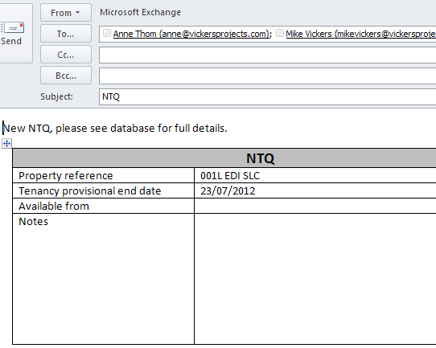

## Overview of NTQ Actions

New NTQ’s can be created from the Property Maintenance switchboard or directly from the Lease screen.

Existing NTQ’s can be reviewed from the Properties & Maintenance switchboard or the Letting switchboard.

From the Letting switchboard, the form will initially open with only available properties showing, although others can be requested.

## Review NTQ’s

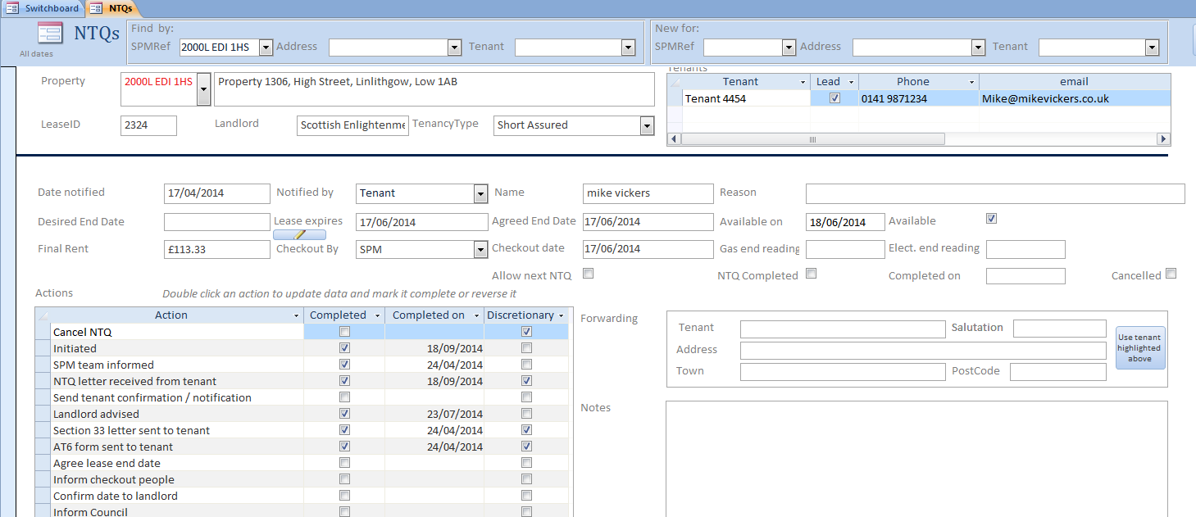

Each NTQ has a list of actions to be carried out:

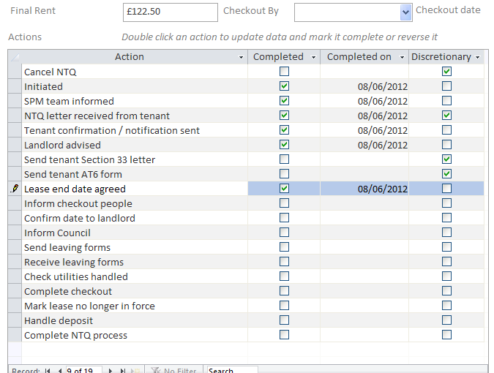

An NTQ cannot be marked as complete until all actions have been complete except where an action is marked as ‘discretionary’.

Actions marked as ‘discretionary’ do not to have to be completed to allow the whole series of NTQ actions to be completed.

Many of the actions create emails or mail merged letters to tenants, the landlord or to the Council

The final rent is automatically calculated from the agreed end date.

The NTQ process keeps an audit trail of what has been done:

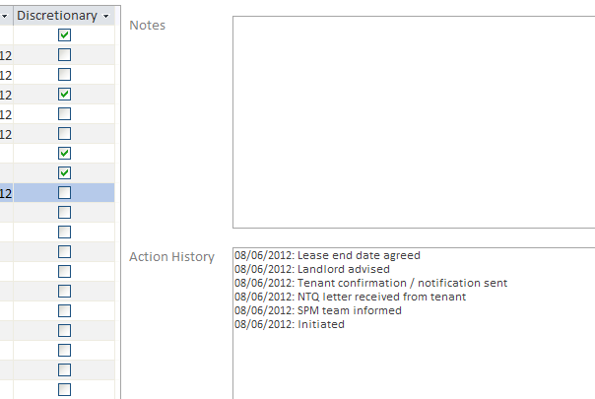

### New NTQ Considerations

On entering a new Property NTQ the following screen will come up

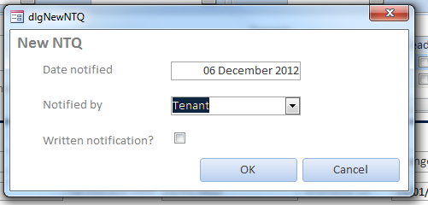

The Date Notified will default to today’s date.

It may be changed or left as default and this is the date will be set in the Notified Date of the NTQ window. This date will also be used to set the Lease Expires, Agreed End Date and Availability Date

If the Written notification is Not ticked then Received Notification from the Tenant will remain unticked. It is for the User to double click Received Notification from the Tenant and the current date is the one that appears as the confirmation of written notification by the Tenant (assuming that NTQ was raised by the Tenant). Final date remains as Agreed End Date.

If the Written notification is Ticked then Received Notification from the Tenant will be triggered and the Completed on date will be set to the Notification date.

## Internal notification email

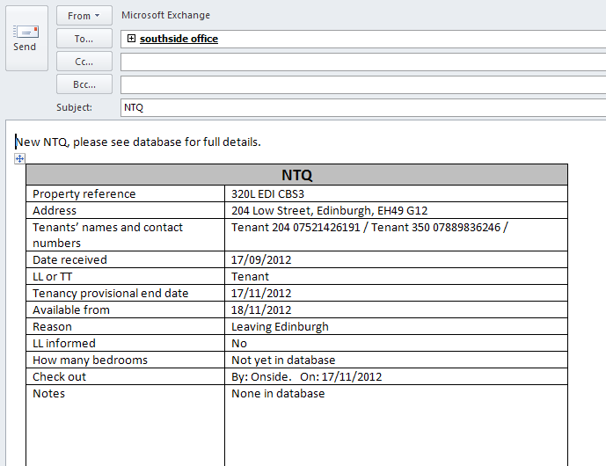

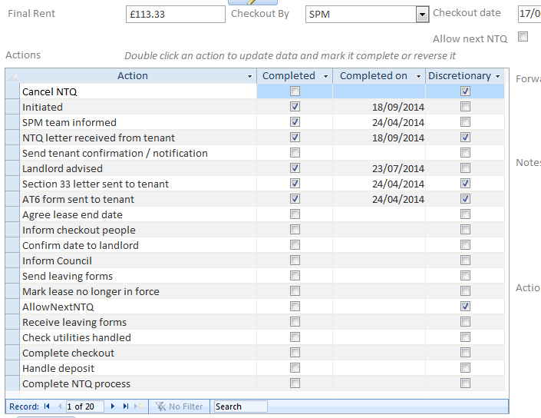

Double clicking an action row will mark it complete, or reverse it if it is already complete. A number do further processing:

* ”Cancel NTQ”: un-sets the property availability and marks the NTQ as cancelled
* “Inform SPM team”: automatically sends an email to the SPM team
* “Tenant confirmation / notification sent”: prepares tenant email or paper confirmation of NTQ received from tenant, or ‘Doc 1 – Notice to Quit’ if NTQ received from landlord
* “Advise landlord”: prepares email to landlord advising of NTQ received, or pops up phone number if landlord has no email
* “Send tenant Section 33 letter”: prints section 33 letter
* “Send tenant AT6 letter”: prompts for grounds and reasons, and prints AT6 letter
* “Agree lease end date”: updates lease end date in lease record
* “Send leaving forms”: prepares tenant email or paper leaving forms
* “Mark lease no longer in force”: just what it sounds like!
* “Allow Next NTQ”: allows the user to create a further NTQ for the Property even though the previous one is not yet completed provided that the leaving forms have been sent to the tenant
* “Complete NTQ process”: marks the NTQ as completed

The final rent is automatically calculated from the agreed end date.

The NTQ process keeps an audit trail of what has been done:



A report of status of all NTQ’s is available – all NTQ’s may be displayed or only those that are still outstanding may be displayed

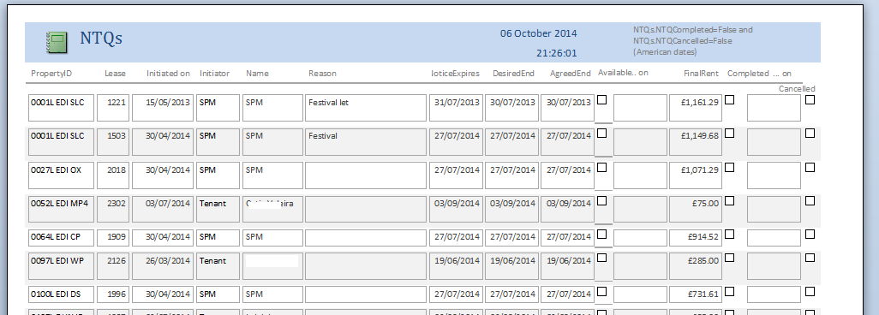

## AT6 text

The mail merge for AT6 letters will merge in standard or edited text for the grounds and reasons required. Setup and maintenance of standard text is via Setup and housekeeping / NTQ setup / NTQ AT6 grounds.

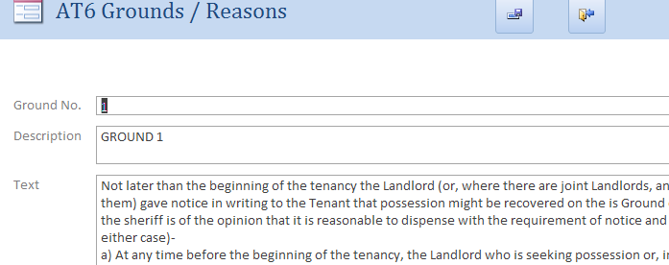

Ground number is used to order the grounds when choosing from a list. The text can be typed in or cut & paste from Word. In the latter case, you may notice odd characters such as a question mark in a box; these are formatting marks and do not show in the final letter.

## Producing an AT6 letter

Double clicking the Send AT6 NTQ action will open a form to allow preparation of grounds and reasons text. This can be standard text picked from the standard list (as many as needed), edited standard text, or typed-in text.

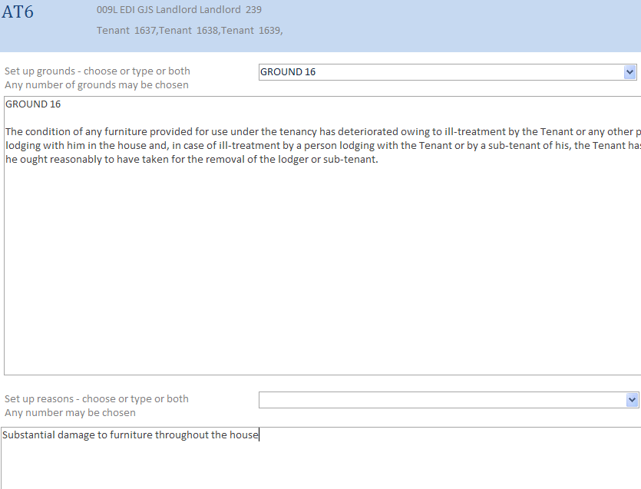

### Meter readings

The NTQ form now captures final meter readings.

## Concurrent NTQs

The system now supports *limited* concurrent NTQs for the same property. This feature has been introduced because tenants who have left may be very late in returning leaving forms and agreement on deposits can take a long time.

For Short Assured leases, a new NTQ may be initiated once the Action ‘Send Leaving Form’ has been sent but before ‘Receive Leaving Form’ has been received. Note that the next NTQ cannot logically be initiated before the previous lease has been set out of force.

In the example below the Leaving form has been sent – Action ticked and stating Leaving form sent but Receiving leaving forms has not been received and action remains un-ticked.

An extra Action has been added – NTQAllowed. The Action Allow NTQ has been added to indicate to the system that a new NTQ may proceed in parallel with the remaining steps of the current NTQ.

Note: This action has been added to NTQs created previously where NTQs are Not completed and Not Cancelled as part of the migration process.

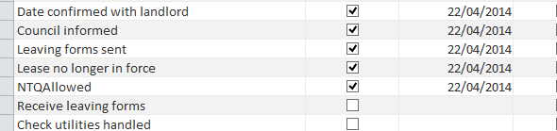

### List of Actions and Action Templates

The new action NTQAllowed has been added to the list of actions, and within the Short Assured template. If it is required to allow NTQ concurrency for Short Term and Fixed Term tenancies, this action can be added to the action templates for Short Term and Fixed Term templates.

.

### Setting and resetting Available and Vacant Status

Checks have been introduced throughout the system prompting the user to decide whether a property should declared Available or Vacant. For instance when an NTQ is received and the Availability Date is known the Property Available flag will be set along with the Availability Date. Similarly with Vacant.

Likewise when a new Property is taken on both the Vacant and Available flags are set and are reset when a Lease is established and put into force

# Tenant Liabilities and End of Tenancy Statement

## Tenant Liabilities for a Lease

The liabilities that tenants accrue during their lease may be viewed at any time from the Lease form by clicking the View Tenant Liabilities button.

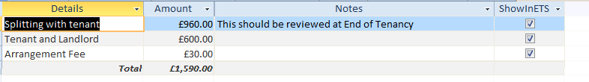

These liabilities are carried forward to the End Of Tenancy Statement.

# Letting and Property Availability

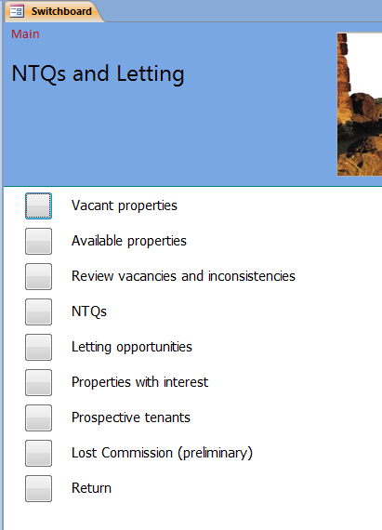

### Checking vacant and Available properties

Properties have two flags indicating:

* Vacant: ie actually empty, from ‘Vacant from’ date
* Available: available to let, from ‘Available on’ date

When a property is first taken on, it is marked Vacant and Available by default. Once a lease is in force, it is no longer available or vacant; when an NTQ is issued, it becomes available. It is a candidate for being vacant if the Available on date has passed and no lease has been taken out.

These flags and dates can be set from the Properties screen, or, more usually, Available / Available on would be set from the NTQ screen, and Vacant / Vacant from on the Review vacancies and inconsistencies screen. The NTQ screen will be used as & when NTQ’s are initiated; the Review vacancies and inconsistencies screen should be checked on a regular basis, say once a day.

It is up to the Property Managers to verify that this is indeed the case

### Vacant Properties

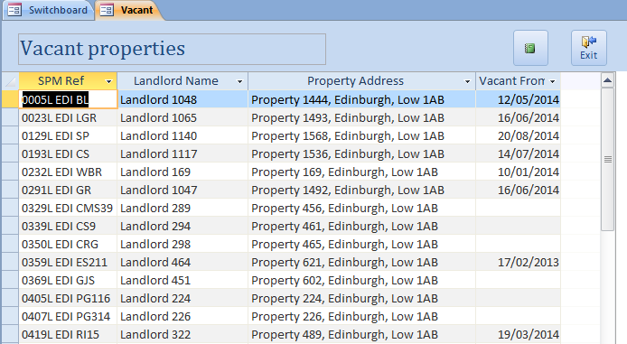

## Available Properties

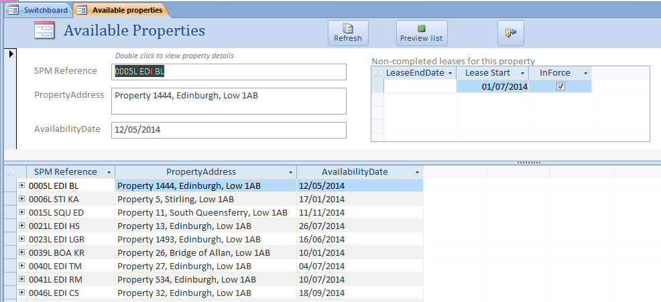

### Reviewing vacancies and inconsistencies

It is important to ensure that the vacancy and availability of a property as held in the System correct reflect the status of the property in actuality. The window Review Vacancies and Inconsistencies displays where the system considers that there is inconsistency

This screen shows properties which have no lease in force and/or leases which are not completed. If there is a future lease on a property, the system will work out a ‘gap’ of time when the property would be available for a short let, if appropriate.

Examples

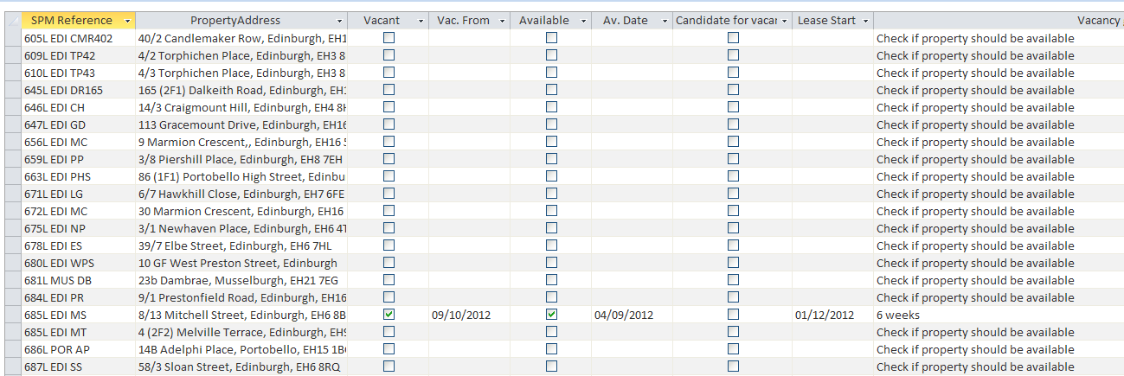

Property 685L EDI MS was available to let on 4/9/12, and became vacant on 9/10/12. A lease has been arranged starting on 1/12/12. There is therefore a gap of about six weeks.

Property 685L EDI MT has no lease arranged, but has not been marked as available. “Check if property should be available” is therefore shown.

Double click the SPM Ref to view the property Accounts screen:

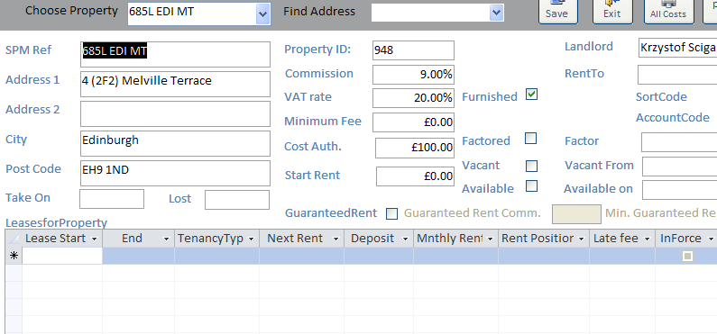

The property below has a new lease, but the old lease, which is past the lease end date, is not yet complete. This is the line below starting 21/05/2012, and the message “Check if lease should be in force and/or completed, and/or property availability flags should be set” is highlighting the fact that this lease is still in process of completion.

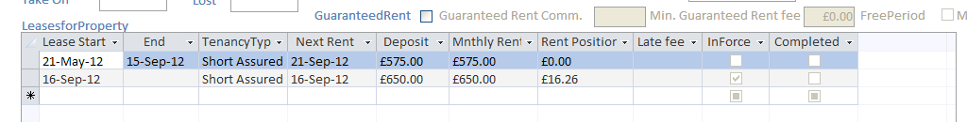

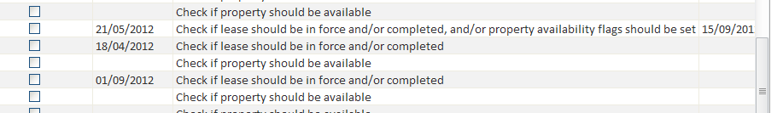

The property below, which is the line beginning 18/04/12, has only a lease which is neither in force nor completed, and no lease end date has been set. The message “Check if lease should be in force or completed” highlights this.

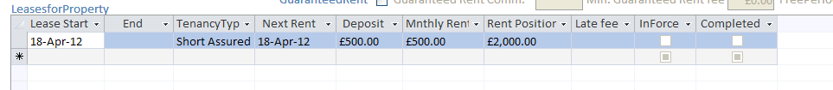

The property 999L below has been marked as available from 31/8/12 but not marked as vacant. It is a ‘candidate for vacancy’.



Selecting this row and clicking Update selected candidate to vacant will set this property to vacant. This property has a lease which is neither in force nor vacant; once marked complete, this property will no longer appear in this screen.

Properties where the Availability date has been set after a future lease start date will have a message “Inconsistent data”.

# Letting and Leasing

Available Properties may be progressed through the System using the Letting Opportunities menu .The main window is displayed below and is invoked through Letting switchboard.

The series of Actions are initiated by selecting the Property in the New for SPMRef – only properties which are available are listed for Letting.

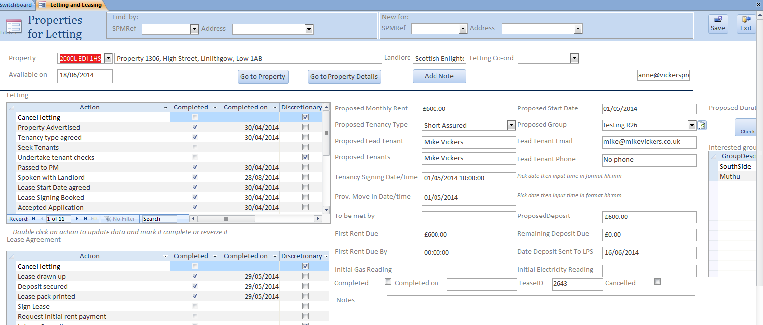

Leasing Actions

Letting

Actions

Create New Letting

Once the property is selected the series of Marketing Actions is displayed – as above.

There are two sets of Actions

1. Letting where a Property is Available or will become Available and SouthSide is seeking tenants.  These activities are undertaken by the Letting Staff and Property Managers
2. Leasing where Tenants have been found and a Lease Agreement needs to be drawn up, Deposit collected and Tenants inducted.  These activities are completed by the Property Managers.

As each Action is completed the Action displayed should be double clicked and the Action text will change from an imperative action to completed action eg ‘Review Rent’ to ‘Rent reviewed’. See below to see how these texts are set up.

In the first set of Actions the user will double click each action as they are completed. Before ‘Rent Review’ and ‘Agree Tenancy type with Tenant ‘ will be accepted, the System will check that the user has completed the Proposed Monthly Rent and the Proposed Tenancy Type. The User will also be asked when double clicking ‘Seek Tenants’ to enter the Lead Tenant’s name, email and phone number

Once all the Actions for the Letting set are complete or have been set up as discretionary the user needs to double click ‘Complete Letting’ at which point the second set of Actions is displayed in the window below. See below

In the second set of Actions the user will double click each action as they are completed. In addition the System will check that the user has completed the ‘Proposed Start Date’, ‘Tenancy Signing date and time’, ‘Prov. Move Date/Time’ and who will induct the tenant into the Property (assumed to be someone from Onsite). SouthSide would like to record time as well as date for Tenancy Signing Date / time and Pro. Move Date / Time: to do so the user needs to enter time in the Date / time field after selecting the date.

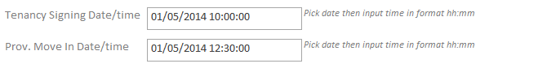

Clicking the Send AT5 will first ask the User to provide all tenant name and on completion will create and print the AT5 form on the default for the tenants to sign the Lease.

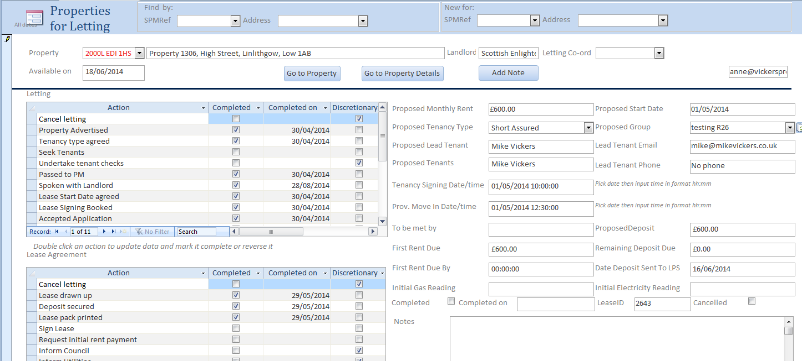

An email ‘Application Accepted' is sent to the Lead Tenant, Onsite and to SouthSide staff when ‘Book Check in’ is double clicked and again when ‘Initial Rent Received’ is double clicked.

The Initial Rent payment received is calculated as follows:

1. If Move in Date is 19th of the month or earlier then the rent is the prorated amount to the end of the month – the first full rent is payable at the end of the month.
2. If Move in Date is 20th of the month or later the tenant is required to pay the sum for the rest of the month plus the rent for the subsequent month.

It is assumed that the User, once the Lease Start Date is agreed, will create the Lease in the System and enter the full Lease details for the Property. A button is provided on the form to go direct to the Property Accounts window. There is currently no automatic interconnection.

Once all Actions are complete the User will double click ‘Complete leasing’, click the Save button at top right of the window and the date will be set in the Completed on field.

## Key Notes

1. that the Letting and Lease Agreement process may be cancelled at end time
2. The sequence of Actions may be undertaken in any order consistent with business practice; however it is recommended that the order of Actions should be as displayed in the Property Letting Window. The order of Actions may be changed in the Standing data – this is discussed below
3. Any sequence may be resumed by selecting the Property in Find Property combo boxes either SPMRef or Address. Where there have been more than one change of lease the Current one may be displayed by selecting the Property and clicking the right arrow in the Record Selector at the bottom of the window   
   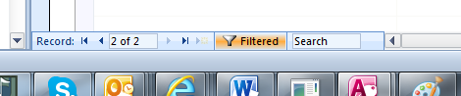
4. records of all Lettings are maintained and once

Tenancy Application Accepted

Dear Mike Vickers

|  |  |
| --- | --- |
| **Application Accepted** | |
| **Property Reference:** | 2000L EDI 1HS |
| **Full Property Address:** | Property 1306, High Street, Linlithgow, Low 1AB |
| **Name on lease/contact details (bold is lead tenant and is main point of contact from our office for access to property etc)** | **Mike Vickers No phone mike@mikevickers.co.uk** |
| **Tenancy start date:** | **01/05/2014** |
| **Tenancy signing date, time:** | **01/05/2014 10:00:00** |
| **Tenancy Length:** | 10 months (2 month rolling thereafter) |
| **Current rental agreement:** | £ 600 pcm |
| **Your dedicated Property Manager is:** | John Davidson / 0131 51 000 51 / / jd@southsidemanagement.com |
| **Collecting keys and inventory** | **You will need to collect your keys and inventory on your tenancy start date at the office between 2.30pm and 6pm.** If you cannot collect the keys during this time then please contact the office to arrange out with this time.  Upon receipt of your inventory (which is generally available for collection at the same time as keys) you will have seven days to make any amendments necessary and return to Edinburgh Inventory Services ([info@edinburgh-inventories.com](mailto:info@edinburgh-inventories.com)) who can also be contacted on 0845 862 8620. |
| **Rent Due:** | **£ 600 - Due 3 working days before moving in (00:00:00)** |
| **Remaining Deposit Due:** | **£ 0 Due at Lease signing**  This will be secured with the tenants deposit scheme within 30 working days from the start of your lease. |
| **Out of Office Emergency contact details** | 0131 510 2424 please note this is only to be used for property emergencies where fire, water ingress that cannot be contained, security |
| **Payment Method for Deposit/1st Month Rent:** | Your deposit and first month’s rent can be paid in a variety of ways, however SouthSide strongly recommend setting up a Standing Order for your rent going forward thereafter. A mandate can be requested from the office in order to provide your bank with the necessary details. SouthSide DO NOT operate with Direct Debits, and it is the tenants responsibility to maintain and cancel the Standing Order where necessary.    Please see below charges/fees incurred from your bank for payment methods available:     |  |  |  | | --- | --- | --- | | Payment Method | Deposit/1st rent | On-going rent | | Cash* | No charge | £9 additional | | UK Debit Card | No charge | £6 additional | | UK Credit Card | 2% additional | £6 + 2% additional | | American Express | 3.5% additional | £6 + 3.5% additional | | Non-UK Debit Card | 3.5% additional | £6 + 3.5% additional | | Non-UK Credit Card | 3.5% additional | £6 + 3.5% additional | | Cheque** | £6 additional | £6 additional | | UK Transfer*** | No charge | No charge | | Non-UK Transfer*** | Additional £7**** | Additional £7**** |     *Change not available for cash payments  **Cheques must clear prior to keys being given, usually 3-4 working days  ***Account details for transfer below  ****Minimum charge £7. Charge may be higher depending on payment amount. Please check with a member of staff who can advise.     |  |  | | --- | --- | | Account Name | SouthSide Property Management | | Bank Address | The Royal Bank of Scotland, 36 St Andrews Square, Edinburgh EH2 2YB | | Account Number | 18083267 | | Sort Code | 83-06-08 | | Reference | 2000L EDI 1HS |     Please advise your property manager in advance if this has been paid by bank transfer and make sure  you use the correct property reference.    Payment can also be made via our website, please see link below.  [**http://www.southsidemanagement.com/pay-online/product/your-payment/**](http://www.southsidemanagement.com/pay-online/product/your-payment/) |
|  |  |

Kind regards,

## Marketing actions

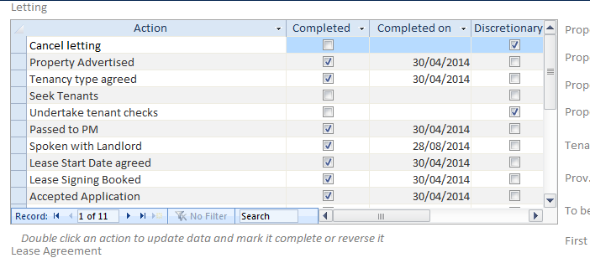

Most of these actions are either reminders to do something, or checks that necessary data has been decided – eg monthly rent, lease start date. The Lease Agreement actions will appear after Tenancy Type has been agreed.

The Date Deposit sent to LPS box is the latest date it can be sent. First Rent Due By is three working days before the lease starts.

### 

### Lease agreement actions

Some are reminders / data checks. Others:

|  |  |
| --- | --- |
| Draw up lease | Creates a lease record and opens the lease form for further input |
| Print lease pack | Prints eight completed lease documents AT5, Prior Notice of Grounds, Lease Document 3, Lease Signing Report, Tenant Information Pack acknowledgement sheet, Tenant Information Pack, Repair Standard Letter, and LPS letter. The Tenant Information Pack is a pdf document which has a blank acknowledgement sheet, which should be replaced by the completed one printed immediately before. The Repair Standard letter has not yet been converted to a Word document, and so needs to be completed by hand. |
| Inform Council / Inform Utilities | Prepares emails. |

### Meter readings

The Lettings form and the Lease form now show initial gas and electricity readings. The Inform Utilities action will generate one or two emails depending on whether the property has gas or electricity or both. NOTE: this is inferred from the presence of a Gas and/or Electricity Meter Reference in the Property Details. We have an impression that many of these have not been completed.

### Groups and prospective tenants

See Managing potential Tenants below

Email attachment:

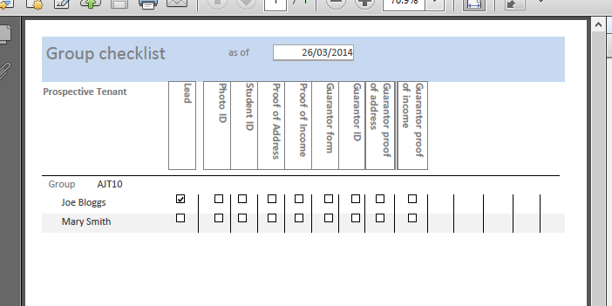

### Properties and interested groups

The NTQ’s and Letting switchboard has an additional option, Properties with Interest. This displays groups of prospective tenants and properties in which they have shown an interest, and can be filtered by group or property.

### Tenant Guarantor (Check whether still available)

The ‘Sign Guarantor Form’ Action in the Letting Opportunities sequence prints a Tenant Guarantor document for completion by the Guarantor of their obligation to guarantee tenant.

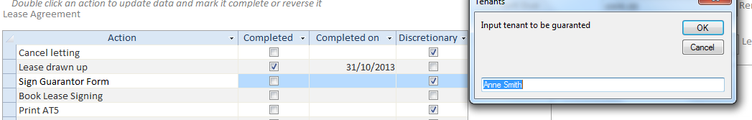

The tenant to be guaranteed is the lead tenant. If other tenants of the group require a guarantor then the names should be entered in the dialog box. If more than one tenant requires a guarantor then the user should reverse the Action and enter the next name in the dialog box.

Note that this Action is discretionary.

### Signing Lease

The ‘Book Lease Signing’ Action in the Letting Opportunities sequence requires the user to enter a date and time for signing the lease. On completion of the Action the date and time is entered in the user’s Outlook Diary.

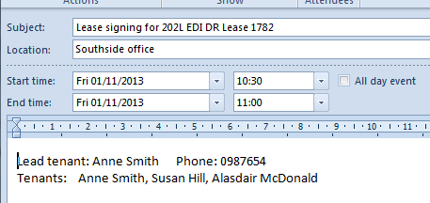

### Informing Council and Informing Utilities

emails are sent to the Council and Utilities on completion of these Actions.

For Utilities the user is asked to select the utility, Gas or Electricity, and to enter the Meter Readings as appropriate. For the present to send emails to both utilities, having emailed the first utility please reverse and email the other. This will be improved in the next release along with the ability to email other utilities.

### Proposed Tenancy Application

A new email has been provided to email landlords of Proposed Tenancy Applications. This email is created by the action ‘Speak with Landlord’. Should the property manager have already spoken with the landlord by phone the email can be deleted from the Outlook Draft list.

An example of the email is given below:

|  |  |
| --- | --- |
| Proposed Tenancy Application Please note if a response to this email is NOT received within 24 hours we will proceed to accept the below application | |
| Property Reference: | 2000L EDI 1HS |
| Full Property Address: | 6(1f1) Springfield Grange, High Street, Linlithgow, EH49 7HA |
| Occupants: | Alex Salmond, John Swinney, Nicola Sturgeon |
| Current employment/study situation: | Completed as required |
| Combined Annual Salary (of Guarantor(s) if applicable): | Completed as required |
| Preferred Move in Date: | 01/05/2014 |
| Rent Agreed: | £ 600 |
| Lease Type and Length: | Type: FixedTerm; Duration: Festival |
| Pets / Smokers: | Completed as required |
| Any Requests: | Completed as required |
| Exclusions from Lease: | Completed as required |
| Your Comments:  (Please detail any objections, questions, exclusions from lease etc) |  |

## Lease pack

The production of the lease pack of documents has been changed to allow use of printing options such as two up, double sided etc.

The Lease Signing Report will be printed, but the other seven documents are now handled as follows:

|  |  |  |
| --- | --- | --- |
| Document | File produced | Print |
| AT5 | A pre-populated pdf file called ‘AT5 for <SPMRef> on <date>’ is placed in the document library. | Click to open in the Document library and choose preferred printer options. |
| Lease Document 3 | A pre-populated pdf file called ‘Lease Document 3 for <SPMRef> on <date>’ is placed in the document library. | Click to open in the Document library and choose preferred printer options. |
| LPS Information | A pre-populated pdf file called ‘LPS Information for <SPMRef> on <date>’ is placed in the document library. | Click to open in the Document library and choose preferred printer options. |
| Prior Notice of Grounds | A pre-populated pdf file called ‘Prior Notice of Grounds for <SPMRef> on <date>’ is placed in the document library. | Click to open in the Document library and choose preferred printer options. |
| Tenant Information | A pre-populated pdf file called ‘Tenant Information for <SPMRef> on <date>’ is placed in the document library. This file contains the tenant and property information for page 2 of the Tenant Information document/form, and is intended as an aid to filling in the Tenant Information | Open the Tenant information pdf form from your template location, and complete page 2. Print using preferred printer options. |
| Repair Standard Letter | No file produced | Open the pdf Repair Standard Letter from your templates location, print using preferred options, and complete by hand. |

## Letting basic actions and action templates

The system maintains a list of basic actions, and sub-lists for particular types of tenancy.

Currently the list of Basic Actions cannot be added to by the user. If required to do so please contact Vickers Projects.

Where are two sets of templates to support the two phases of the letting process.

* for Letting (listed as Marketing and the title cannot be changed). It is assumed that this set will be the same for all types of Tenancy
* Lease Agreements – currently the system is set for the three types of Tenancy; Short Assured, Short and Fixed term

All actions are contained in the basic list and may be accessed through Letting Setup > Letting basic actions

To assign actions to specific Tenancy lists go through Letting Setup > Letting tenancy type templates and select the Tenancy type in the top drop down menu. An initial set of actions has been created for the three types. Actions may be removed by row of the action to be deleted and clicking the Delete key. A new action may be added using the Add Selected: the order that the new action will appear in the set of actions is determined by its Order number - the higher the number the later it will appear in the list – the actual number is immaterial.

The initial list for Short Assured is shown below.

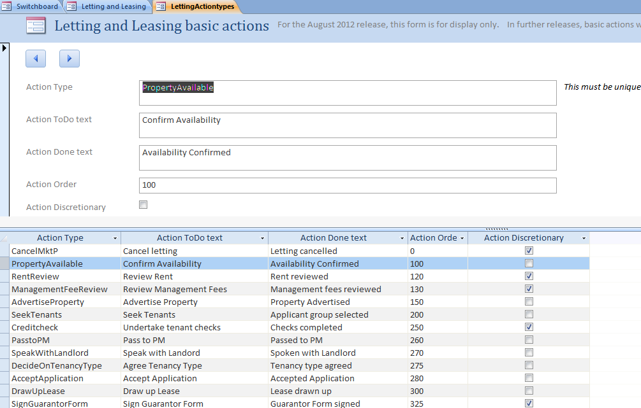

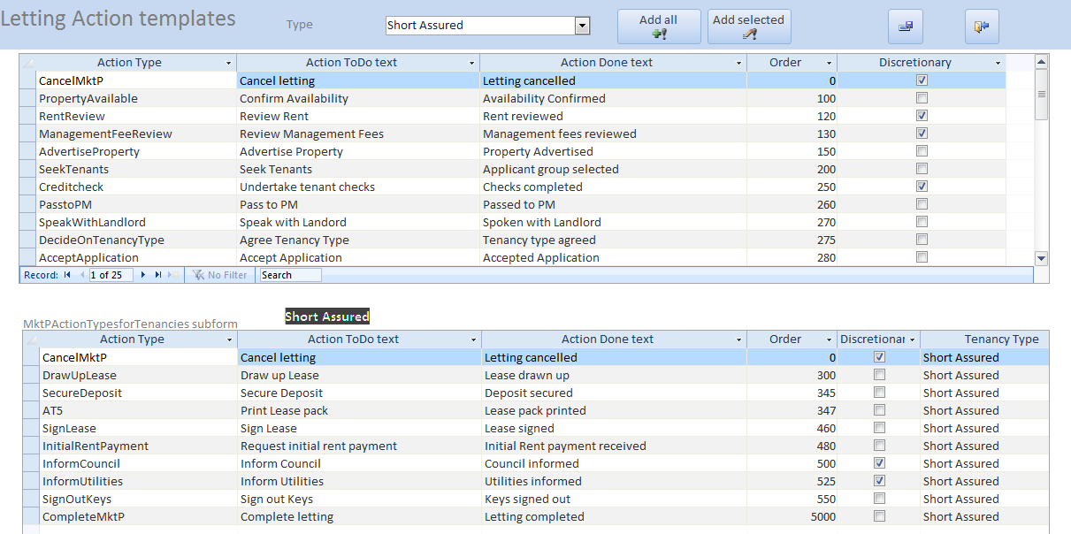

Other setup items are a distribution list for internal emailing of a new Letting: this may be the same as for other internal emails eg for distribution of NTQs, a mail template for the same purpose– the Application Accepted email– see above, emails for the Council (Edinburgh) and for notification of Initial Rent.

Mail merge letters contain merge fields (which are visible) and in the case of the AT5 letter bookmarks (which are not visible) to produce the merged letters. Please consult Vickers Projects about any wording changes to make sure that fields or bookmarks are not lost.

The AT5 form can now accommodate 5 signatures.

# Managing potential Tenants

### Preamble

The Letting Coordinators can create Groups of Tenants who have applied to lease a property – typically the groups are of students wishing to lease a property for the next academic year. Note that even in the case of a single person wishing to lease a property, they now need to be in a group (of one, in this case).

Once a specific group has been accepted a Lease may be created based on the Group and the tenants assigned to the Lease. The lease will not be set In Force till the date that the group legally moves in.

It remains with SouthSide letting coordinators whether they choose or not to keep Groups and Tenants indefinitely or merely until a lease has been let.

### Managing Prospective Tenants

Prospective Tenants may be created and deleted through the form below

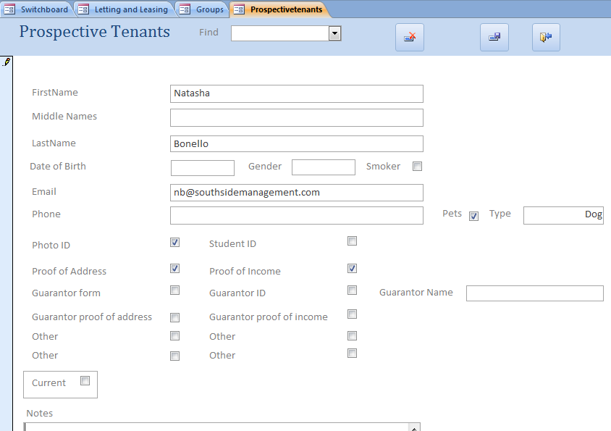

To create a new tenant click the yellow cross in the record selector line at the bottom of the screen and add the appropriate details.

Tenants may be chased by email for missing data eg Photo ID, Guarantor for proof of income, by clicking the Prepare update email and an email will be prepared as follows:

­­­­­­­­­­­­­­­­­­­­______________________________

Dear Joe

Just a reminder that we’ve not yet received the following documents with regard to your application to become a prospective tenant:

Photo ID (Passport or driver's licence)   
Guarantor proof of income

Could you please confirm when we are likely to be in receipt of these documents.

We look forward to hearing from you

Thanks

***Danny Briggs***

***Lettings Co-ordinator***

[](http://www.rightmove.co.uk/estate-agents/agent/SouthSide-Property-Management/Edinburgh-50169.html)  
SouthSide Property Management   
20 Nicolson Street

Edinburgh

EH8 9DH

### Creating and managing Groups

The system provides for creating a group and assigning prospective tenants to it.

Below is a typical form for adding and editing Groups:

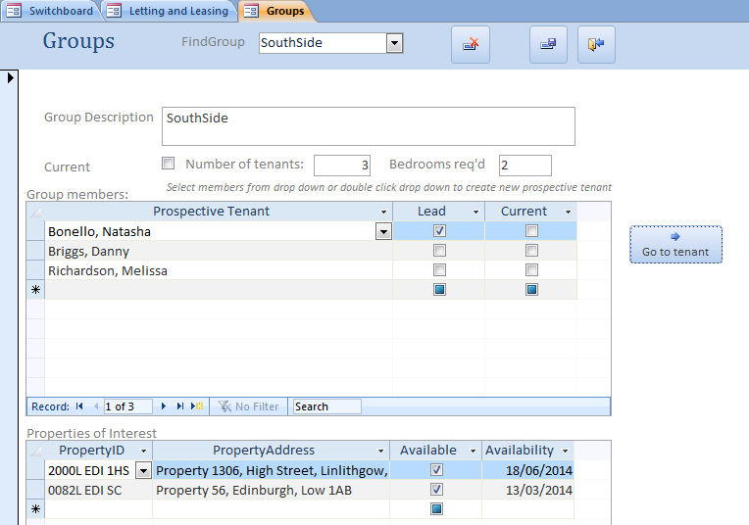

To create a new group click the yellow cross in the record selector line at the bottom of the screen.

To add a prospective tenant to the group highlight the last line displayed with an * and a combo box will open. Select the prospective tenant you wish to add, or double click to create a new tenant.

To delete a prospective tenant from a group highlight the line containing the tenant and click the Delete key.

To delete a group use the Delete Button.

Note that a prospective tenant may be included in one or more groups.

### Groups and their Members

This form provides a quick overview of all groups and their members and which members still have outstanding information required by SouthSide.

### Application of Groups

A prime use of Groups is to apply these when drawing up Leases.

When completing the Letting section of Letting Opportunities, at step ‘Seek Tenants’, choose a Group of prospective tenants from the drop-down menu of the field Proposed Group.

You can only select groups where ‘Current is True’ for the Group.

Note that the Lead Tenant is automatically selected from the tenants in the group.

NB – it is no longer possible to enter tenants directly into Letting and Leasing form; the user must create a group of tenants first.

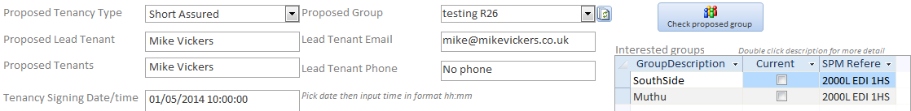

Further, in the Letting Opportunities – section, Action ‘Draw up Lease’, the Leases form will be displayed with a new lease created with proposed lease start date and the prospective tenants added to the lease as tenants.

Note that the Lease is not set In Force as in general this date may be months in the future (student tenants are likely to be accepted for the property in early of the year but not taking up residence of the property till September of the year).

## Tenants selected for Letting

The SouthSide team has decided that it is unproductive to enter details on all tenant groups competing for any property or a selection of properties. Therefore the menu choices Properties with interest and Prospective Tenants will not be used. Rather letting management prefer to enter only those tenant groups that have been accepted for a property.

It is now possible to enter a group directly from the Properties for Letting window. The user opens the drop down menu ‘Proposed Group’ and if the group is not in the list they click the small button 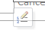 at the bottom of the list and the Tenant Group opens. An existing group will be displayed but the user should ignore this and create a new group by clicking the small yellow arrow in the Navigation bar at the bottom left of the window 

An empty group will open and the user may enter the tenants composing the group – see a description of how to complete Group and Tenants within Group in User Changes Release 24.

Note that the Proposed Tenant window has been augmented with fields for entry of ‘Date of Birth’, ‘Pets’ and their ‘Type’, and ‘Guarantor Name’. These are carried for to the Tenant window for the Lease set up.

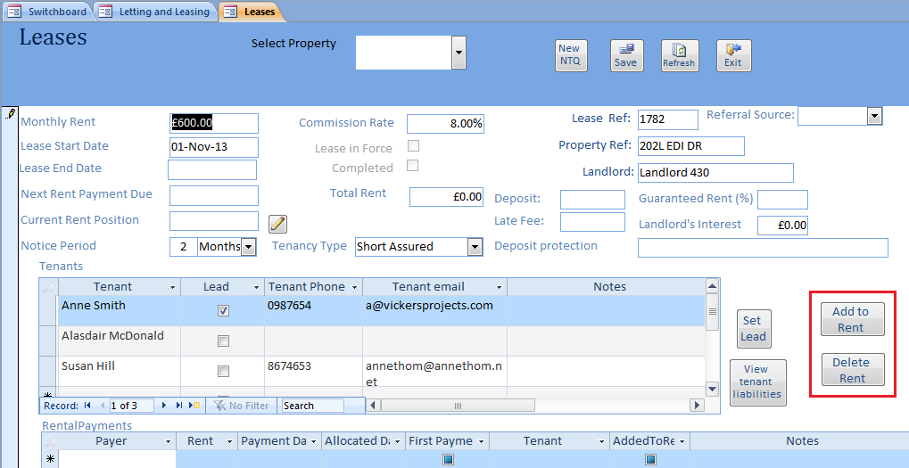

On Exiting the Leases form you are taken back to the Letting Opportunities form.

Once a lease has been created using the group, the group’s ‘Current’ field is marked as ‘False’ – it is no longer available for another lease. Likewise prospective tenants comprising the group are no longer current (but are not deleted).

Note that above processes may be reversed by reversing the Action ‘Draw up Lease’

# Monthly Statement Review &Creation

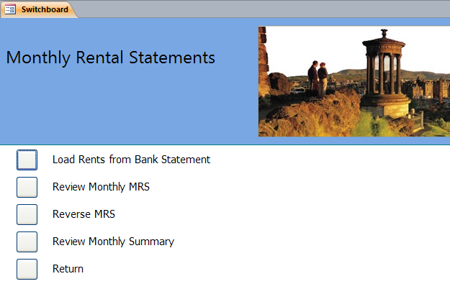

The Monthly Rental Statements switchboard gives access to four functions:

* Uploading rental payments from bank statements – this can be done as often through the month as suits
* Reviewing draft MRS’s property by property, and approving them ready for emailing to landlords
* Reversing approval of an MRS if a mistake has been made
* Reviewing summaries of MRS’s for the month

## Load rents from bank statement

The system can read data from a spreadsheet formatted as below, and propose allocation of rental payments. This can be done as often as suits, but please be aware that the system has no way to check for duplicate entries! The Audit Report assists in mimising the chance of importing bank statements twice.

Spreadsheet format: the spreadsheet must have columns as below. The system will import all rows with a positive number in the IN column, and attempt to interpret them.

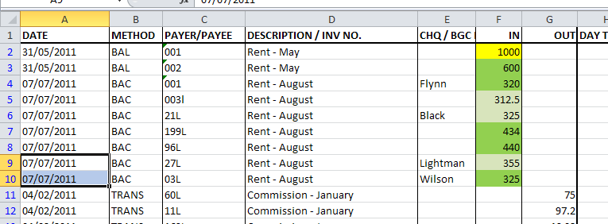

Rows with description “Rent – xxxx” will be interpreted as rental payments. If possible, the system will match the characters in the column Payer/Payee to Property SPM refs.

The ‘Load rents from spreadsheet’ form is shown below.

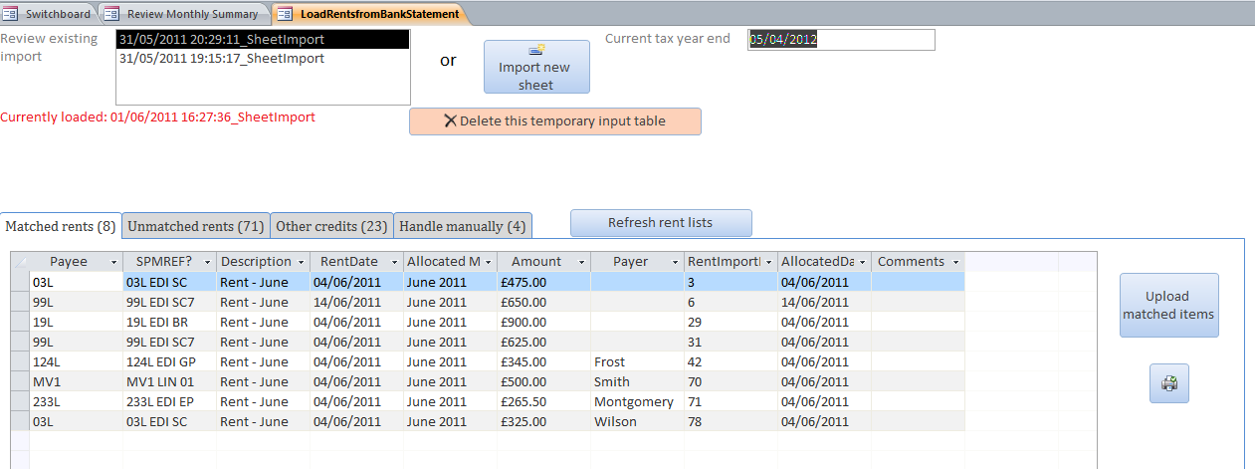

### To load a spreadsheet:

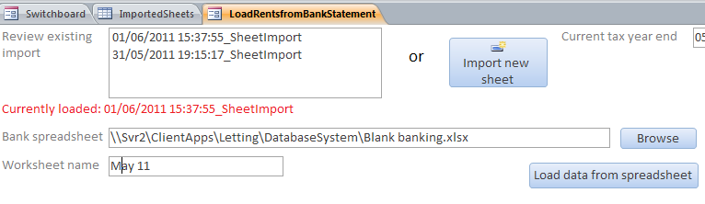Click the Import new sheet button, and then the Browse button to navigate to the spreadsheet you want to import. Fill in the sheet name in the box Worksheet name, and click Load data from spreadsheet.

**To reload an existing import**: choose the date-stamped filename from the *Review existing import* choice box.

Once imported, the (temporary) input table will be displayed in four categories on four tabs: *Matched rents*, *Unmatched rents*, *Other credits*, and *Handle* *manually*. The process of handling the imported data can be thought of as similar to reconciling a bank statement, ticking off lines until all are allocated or removed.

* **Matched rents**: rows with “Rent – xxxx” description and a Payer/payee that the system has been able to match to a property. If the matching is correct, click the *Upload Matched items* button and the rent payments will be transferred to the appropriate lease (and deleted from this screen). 
* **Unmatched rents**: rows with “Rent – xxxx” description and a Payer/payee that the system has been unable to match to a property. This may be because the Payer/Payee column has a misplaced character, for example, or a non-rent row has been accidentally described as Rent. Picking a property in the SPMREF column will move the line to Matched rents on clicking *Refresh rent lists*, and it can then be uploaded.

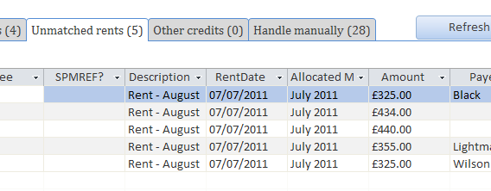

Choose a property here if you recognise the line

* **Other credits**: rows which do not have description of the form “Rent – xxxx”. The import picks up all lines with a positive number in IN, and so will pick up subtotals, commissions, etc. Some will not be rents, some may be incorrectly described. Either allocate an SPMREF, or select the line and press the delete key to remove it.
* **Handle manually**: rows which the system cannot interpret automatically. This is most likely to happen when a lease has come to an end, but not yet been completed (perhaps some money is still due), and a new lease has been set in force. The system interprets by Property, not Lease, and so does not know which lease to allocate the payment to. The comments column at the right will have a message.

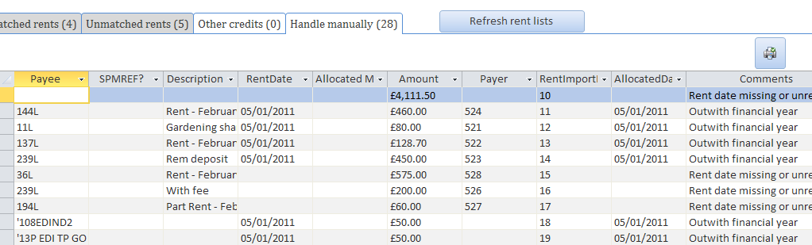

On each tab the printer button will produce a list of items on the tab, to help keep track. The *Refresh Rent Lists* button will update the status of items.

The temporary input table is retained until explicitly deleted, and can be chosen from the Review existing import choice box, so there is no need to reconcile all items in one go. Once you are satisfied that you have captured all the rents from a particular input, use the *Delete this temporary input* *table* button to delete it.

## Review monthly MRS

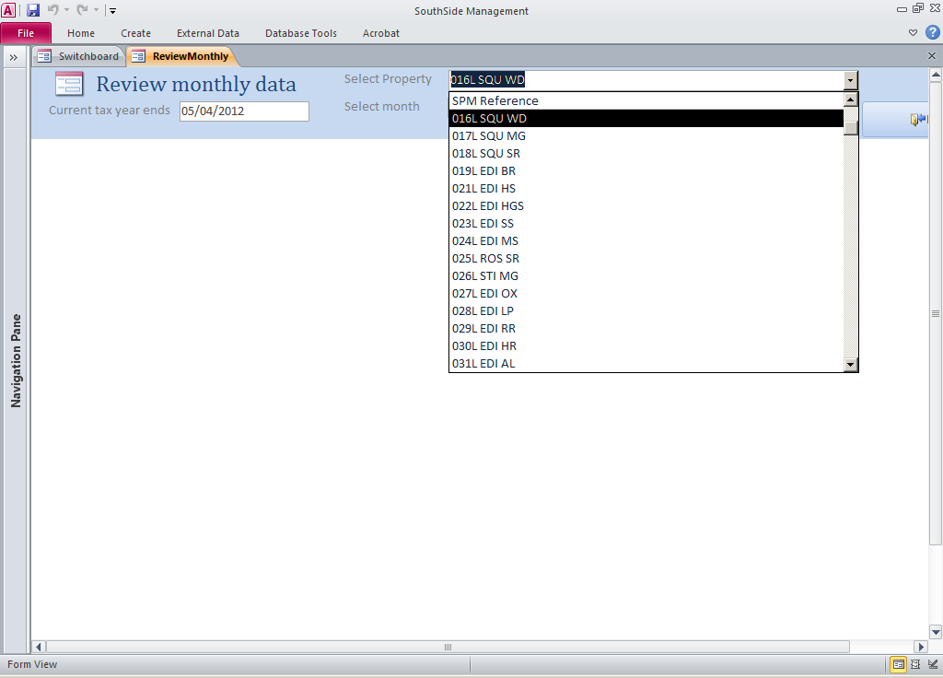The Review monthly data form prepares a draft MRS for a particular property for a particular month. This can be reviewed as often as required. Once satisfied, this screen can then be used to produce and approve MRS, ie a pdf file ready to be printed or emailed to the landlord.

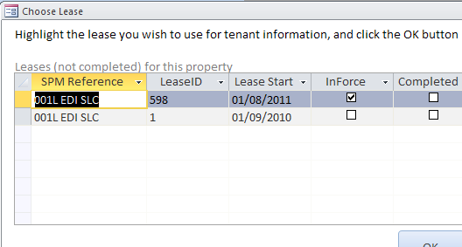Choose a property and month from the choice boxes at the top of the form. If the property has more than one non-completed lease, choose the one to be used for tenant details from the pop-up form.

The form populates tabs with rents, costs, annual summary and totals as below. The Comments box appears near the bottom of the MRS, and can be changed for each property if wished by typing in the box. The default comment is “Please email any changes in contact or bank details, and any specific instruction we should be aware of”.

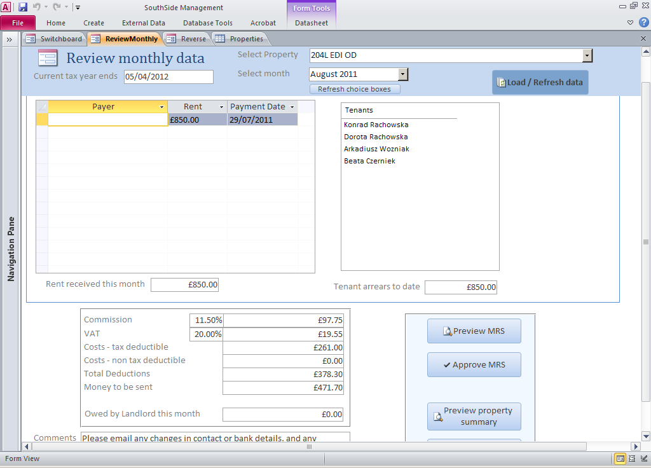The Preview property summary box gives a draft preview of the property summary, before any cost rescheduling has been done.

To see a preview print of the MRS, click the *Preview MRS* button.

To approve the MRS and create a file ready to send, click *Approve MRS*. You will be asked for a ‘Date sent’ for the Sent field on the MRS, and for an internal comment (which can be null) for the Monthly Summary (see below).

Two sample MRS’s are included at Appendix I. One has one cost, the second nine; in the latter case, seven costs are shown explicitly and the eighth and ninth totalled as ‘Other costs’.

### Interest

When producing an MRS for either April period, the system will ask if interest is to be recorded.

### More than 10 costs in a month

If there are more than 10 costs in the month, the MRS shows a sum of numbers 10 to whatever as ‘Other’, with Tax Deductible not ticked. If **all** these costs are in fact Tax Deductible, the system will now show Tax Deductible ticked; otherwise not

## Reverse MRS

If you realise that an MRS has been approved before all rents of costs have been recorded, it can be reversed. This will mark associated rents and costs as not processed, and delete the MRS pdf file.

Marking an MRS as unpublished will clear the published flag, allowing it to appear in the email program; it will not delete the file or change processed status.

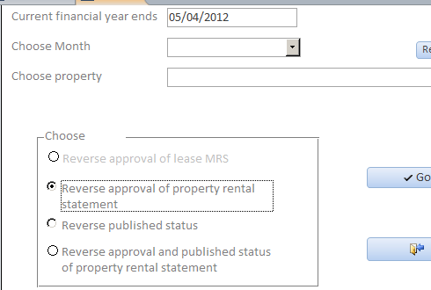The grey button Reverse approval of lease MRS is retained for purposes of conversion from earlier versions.

## Review monthly summary

The Review Monthly Summary form provides access to a number of forms and reports to help with managing MRS approval:

* List or form of approved MRS’s with totals and comments
* List with totals of all potential MRS’s (‘property summaries’) before any cost rescheduling has been done
* Lists of all properties eligible to have an MRS, and approved but unpublished MRS’s for a particular month
* Lists of properties with multiple non-completed leases
* Lists or forms of unprocessed (ie not included in an approved MRS) rents and costs
* List of all documents.
* ‘Quick look’ views at rents & costs in a bar chart time view

The list views give an overall report which can be printed as an aide memoir. The form views allow for filtering and ordering, are quicker to produce, and can be used to focus in on, for example, larger costs or older rents unprocessed.

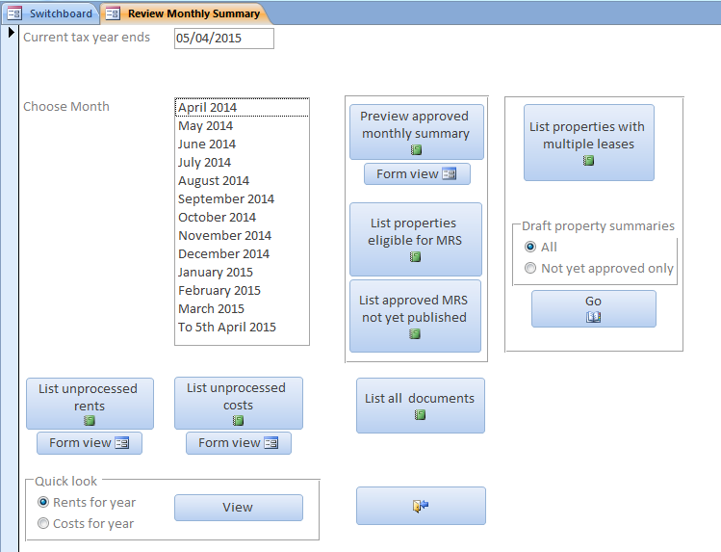

Summary of approved MRS’s for month

Summary of all MRS’s for month

### Monthly Summary Statement of approved MRS’s

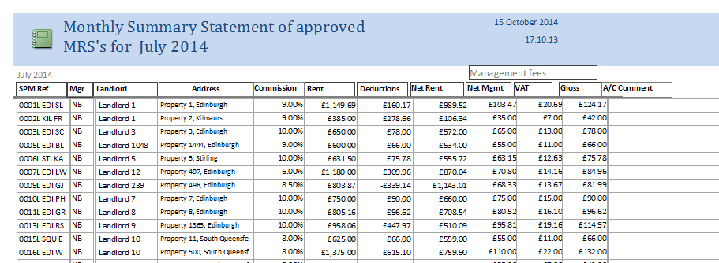

### Report view of approved MRS’s

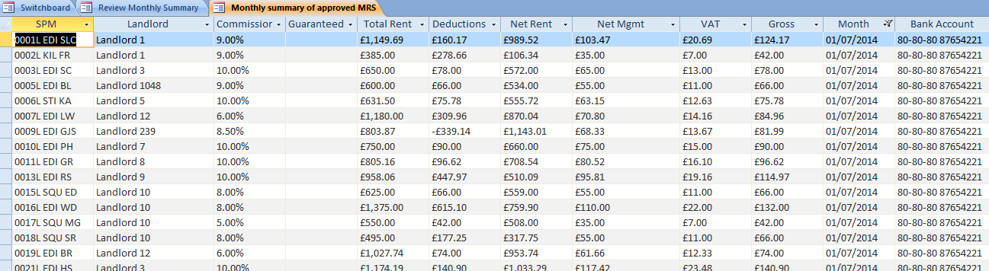

Form view of approved MRS’s. Click the small black arrowheads to filter or sort this view, for example to show Net Mgmt in largest to smallest order.

### List of properties eligible for MRS, and processed status

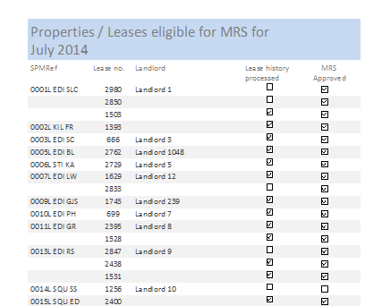

### List of all documents

A blank line under a landlord’s name means it is the same as the one above.

### Quick look views

These reports give an overview of rents or costs across the year.

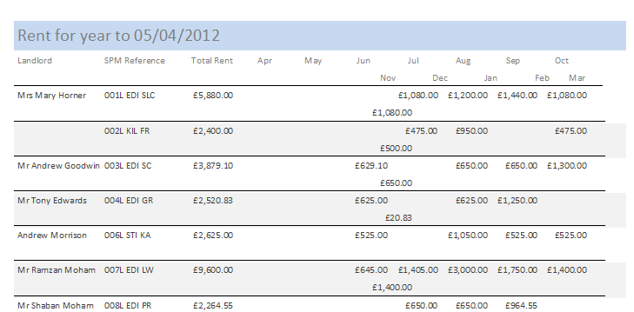

## Draft Property Summary

It is important to know whether an MRS can be produced for a month for a property particularly can any costs incurred be met if the rent is received. A report was available to list out at any time the rent / cost position for all properties. A form is now available with this release to provide the same information more flexibly. The form is kicked – off by clicking the Draft Summaries Go button. First select whether all properties are to be displayed or just those that haven’t as yet been approved by creating an MRS.

In the form below two properties are shown 774L and 780L. For 774L no Rent has yet been received but Costs of £1,385.97 are outstanding; these would need to be covered by the rent when forthcoming or deferred to a later month if not covered by the rent; in contrast for 780L the rent of £1,025 covers SouthSide Commission and the Money to be sent to the landlord is £914.30. Note that the final column is headed ‘Owed by Landlord’ being the cost to be recovered from the Landlord if no or insufficient rent, in the case of 774L, is forthcoming.



The report can still be printed but from the Draft Summary form

### Review Monthly MRS

A sub-form showing NTQ’s has been added.

# Landlord year end processing

This function moves year end date, month choice buttons, and tax year totals forward by one year. It is called from the Setup and Housekeeping switchboard:

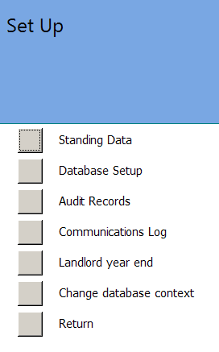

Please see separate specification document for a description of how the year end processing works.

# Non-standard year end reports

A facility has been added to produce tax statements for landlords with tax year ends other than 5th April – ‘non-standard year ends’. It is important to note that this facility uses the standard underlying periods, and that the accountant will therefore need to make specific decisions on occasion regarding which period to allocate rent or costs to.

### To set a non-standard year end:

Open the Landlords form, choose the landlord, and tick the box Non-standard year end.

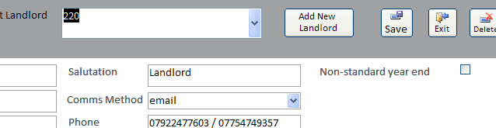

Input the current non-standard year end date into the pop-up form, and click OK.

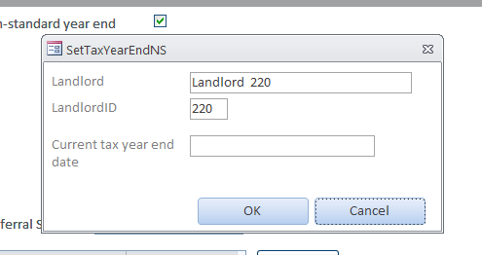

The Landlords form will now display the non-standard year end date and last period.

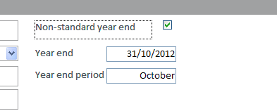

In the example shown above, the system will use ‘October’, ie 20th September to 19th October, as the last period. If it is important to capture rents or payments which come in between 19th October and 31st October, specifically allocate them to October rather than let the system allocate them to November.

### **To unset:**

clear the tick box. All previous tax year end sums will be deleted.

### To change year end date:

Unset the year end as above, and then set again as above.

### Reporting

Non-standard tax year end reports are automatically produced monthly at the same time as MRS’s are created, and are put in the same folder with the same ‘Approved, Not Published’ status. The MRS is unchanged, and will therefore show the standard tax sums. The Preview button will produce both previews, and the Approve button both approved reports. The non-standard statement accumulates over the year, and shows month by month for the non-standard tax year.

Standard MRS:

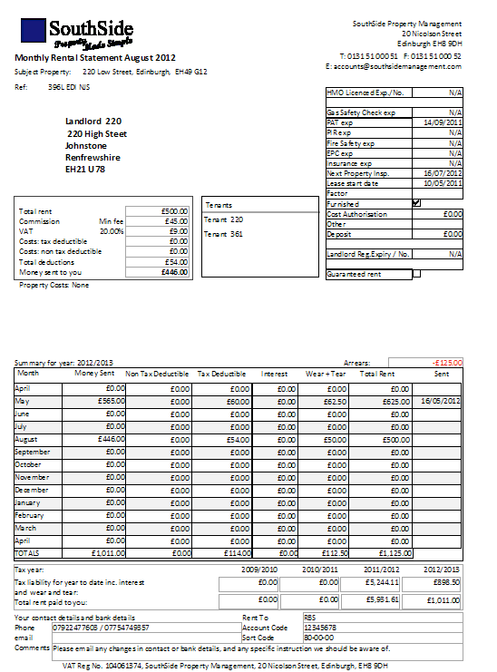

### Tax statement:

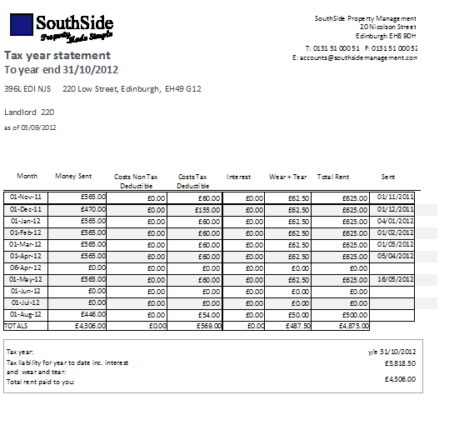

The standard MRS shows months from April 2012 to April 2013, and corresponding tax year totals. The tax statement shows months from November 2011 to August 2012 (the current month), and current accumulated tax year total. Once past October 2012, this report will also show a tax year total headed ‘y/e 31/10/2012’ and begin a new current one headed ‘y/e 31/10/2013’.

The next two example reports show a property with non-standard year end 25th July, showing a previous year total.

Standard MRS:

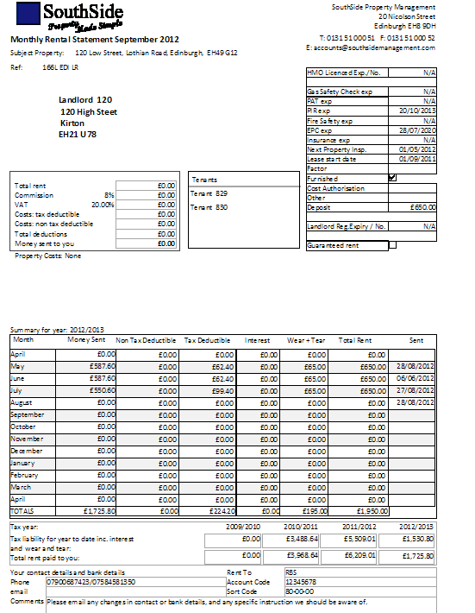

### Tax statement:

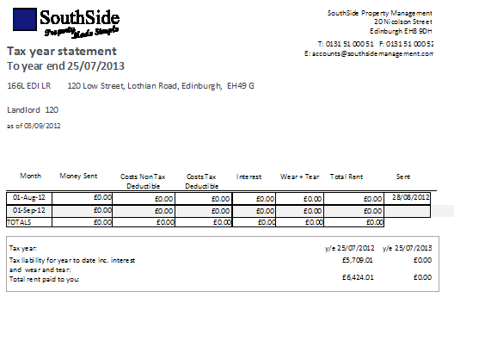

### Tax year end:

The Review Monthly process will detect when a non-standard year end has been passed, and will prompt to update it.

### Review non-standard tax year ends:

The Landlords and Rented properties switchboard has a new button, Review Non-standard year ends. This brings up the following form:

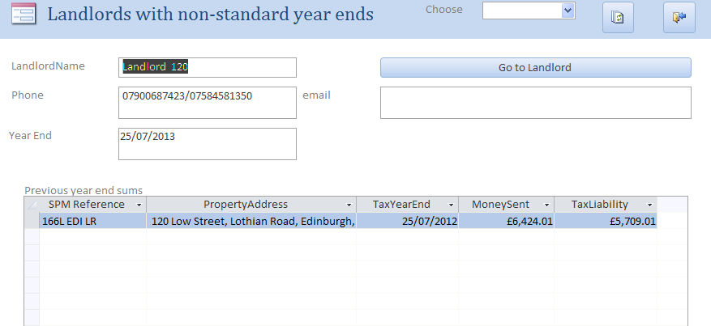

which shows the year end and previous year end sums for all properties owned by the landlord. Note that year end dates cannot be changed from here; click the Go to landlord button to open the Landlords form if a change is required.

### Important Note

The non-standard tax year end process will not automatically recalculate previous year ends if you reverse a month from the previous year. For example, with a non-standard year end of 30/6/13, May 2012 is in the previous year non-standard year, but is in the current standard year, and can therefore be reversed. The non-standard year end totals for the previous year can be recalculated by going to the Landlord screen, clearing the Non-standard tax year tick, and then resetting it to 30/6/13 again – this will recalculate the previous year total. If you then redo the MRS for May 2012, you will have to repeat this process again to recalculate the new previous year total.

The system will not calculate previous year totals for years beginning earlier than 31/3/2011, as there is insufficient detailed data held within the system from the migration.

# Lost Commission

The system creates a report of the lost commission per week on properties vacant now and or will be available in the next 10 days and calculates the lost commission that SouthSide will be incurred by their vacancy.

The calculation is

For any Property that is Vacant or will be in 10 less than 10 days

(If Property has ever been leased then take Maximum Rent.   
 else assume Rent = £500 pm) * Commission /4

The report created is given below:

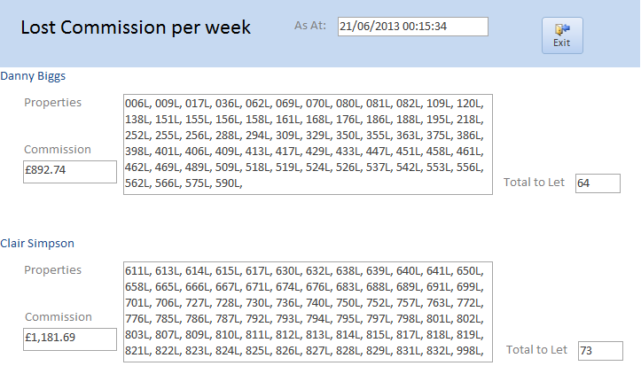

The Report is called from the Main Menu thus

Letting > Letting Opportunities > Lost Commission (Preliminary)

# Documents and Invoices

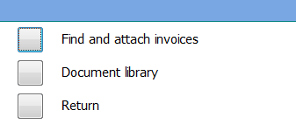

## Document Library

The Documents Register lists documents associated with a property, most commonly MRS’s, job sheets and invoices, but could be any document.

The Document screen below provides for locating these documents and loading a reference to them for a Property. References to MRS and Job Sheets are automatically written to the Document Register; other documents need to found and added to the Register. Documents can be viewed before the reference is set up – for example to ensure the correct document has been located. Each reference is set up as a hyperlink so that the documents in the reference list can be viewed through this screen.

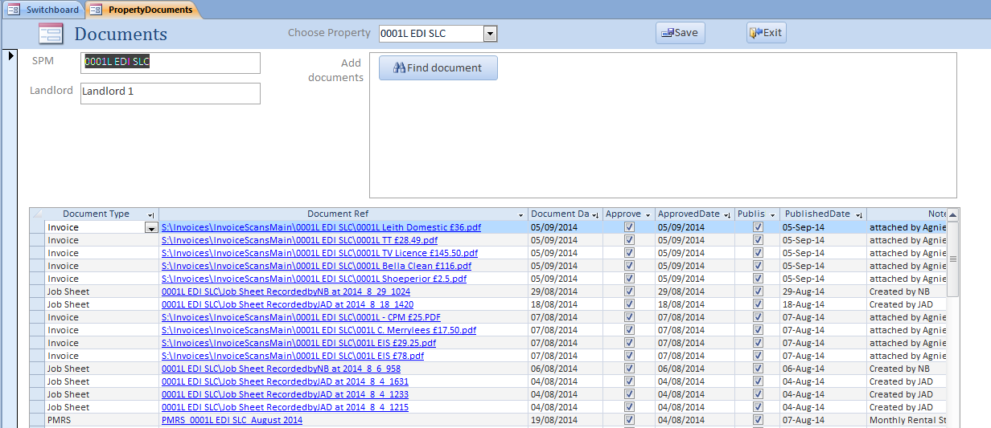

View and find Document

Hyperlink to Document

Once a reference has been created a Document Type needs to be assigned to it using the drop down Combo box. Document Types are set up as Standing Data. Approved means that the document has been approved, and Published (if it is an MRS (PMRS)) that it has been sent to the landlord.

Documents of type MRS (PMRS) and Invoice are listed in the Letting Email Selection and Mailing system – see below - for attaching to emails to sending to the Landlord of the Property concerned.

Documents of type Job Sheet are generally of no interest to a Landlord and are marked as *Published* when references to them are loaded into the register.

The documents list shows only the short file name of the document, rather than the full server\folder format.

# Attaching invoices and other documents to the Document library

### Landlord emailing

To assist accountants and property managers to emails to landlords with less manual effort, a number of changes have been made.

A simple set of folders has been provided on the Company server to file Invoices that need to be emailed to landlords as Statement ‘packages’.

The folders are:

* s:\Invoices\InvoiceScansMain for the main properties
* s:\Invoices\InvoiceScansJD for John’s properties

These folder locations are set up along with MRS and Other Documents through the SID Folder Set Up form thus:

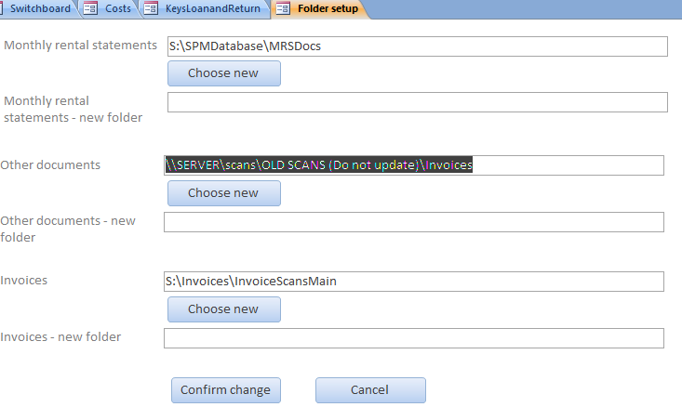

The use of the additional invoices folder location is set out below.

The database system maintains a library of documents related to properties. These include MRS’s, job sheets, and tenant documents which are automatically attached to the index of the library by the system. Documents of any kind can be attached from the Documents screen. In particular, scanned invoices should be attached because the Landlord emailing program uses this library to send monthly emails to landlords.

The attachment process has been improved to allow selection of multiple files, and to attach invoices in bulk.

### Documents screen

This screen is reached from the main switchboard via Documents and Invoices/Document library. Choose a property from the box in the header.

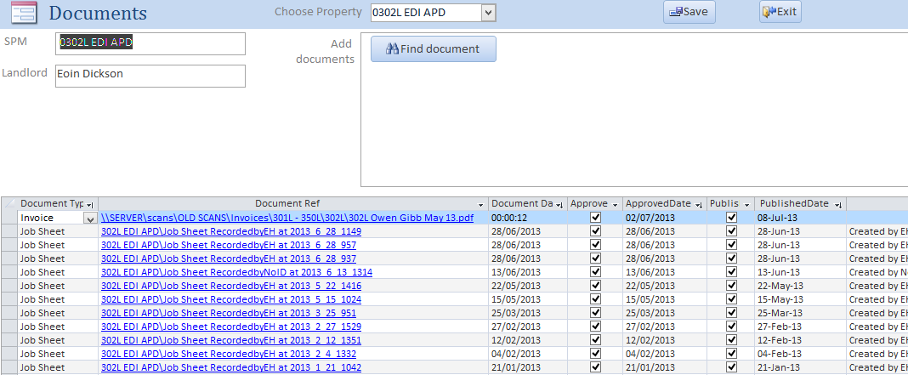

To attach document(s), click the Find document button. This will open up a file select window, defaulted to the invoices folder. Using either the CTRL key to select documents not adjacent to each other or the SHIFT key to select a block of documents, select one or more files and click OK.

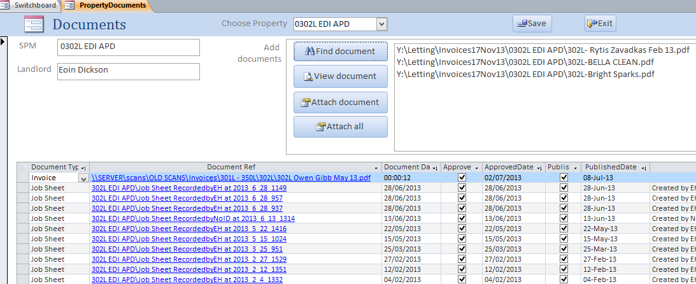

The documents selected appear in a box top right on the form, with buttons to view individual documents (select document and click View document), attach individual documents (select document and click Attach document), or attach all documents shown (click Attach all).

### Attaching invoices in bulk

#### Invoices can be attached in bulk from the Find Invoices screen, reached from the main switchboard via Documents and Invoices/Find and attach documents.

#### Note that this screen will ONLY find invoices in the invoices folder named in folder set up, in sub-folders identified by SPMRef: eg S:\Invoices\InvoicesMain\0302L EDI LR. This structure has now been set up, and should be used for all scanned invoices (InvoiceScansMain for the Main database, InvoiceScansJD for JD properties).



The Find candidate files button searches through the invoices folder for documents newer than the ‘days ago’ (top left), and not yet attached to the document library.

This is a heavyweight process, and will take some time – please be patient. It is strongly suggested that you do not put a large number in the Newer than box!

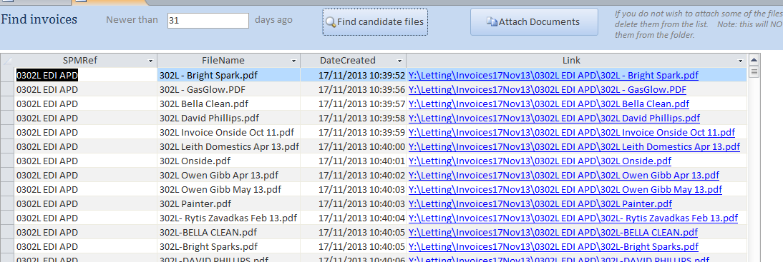

The screen will be populated with a list of candidate files for attachment. These can be viewed by clicking the blue hyperlink field, or sorted/filtered using the black arrowheads.

If there are documents in the list you do not want to attach, delete them from the list – this will not delete the document, it just means it will not be attached.

Clicking the Attach documents button will then attach all the documents in the list. Again, a heavyweight process; please be patient.

# Handling Keys

The Key Register provides a register of sets of keys by Property. It is accessed through the main menu  
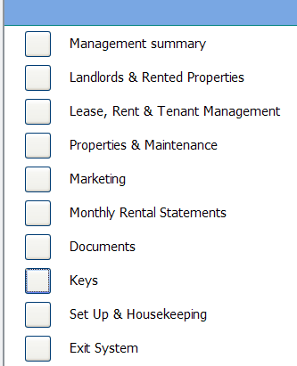

Clicking Keys gives

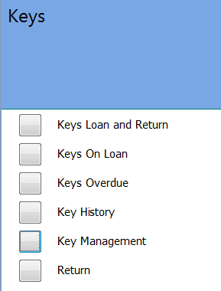

## Keys Functions

Keys for properties are allocated to users who have legitimate access to identified properties. Users are classified by Tenant, Landlord, Contractor and Other.

Lending a key may be done in two ways

1. General - lending a key using the ‘Lend Key with no job sheet’. Enter the class of user, their name and need for the key and the key to be taken out
2. A Contractor borrowing a key using ‘Lend key with job sheet’. The contractor presents a job sheet for a job of work which has already been raised in SID via the Properties and Maintenance menu.

Below is the main form for entering key set number and supporting information.

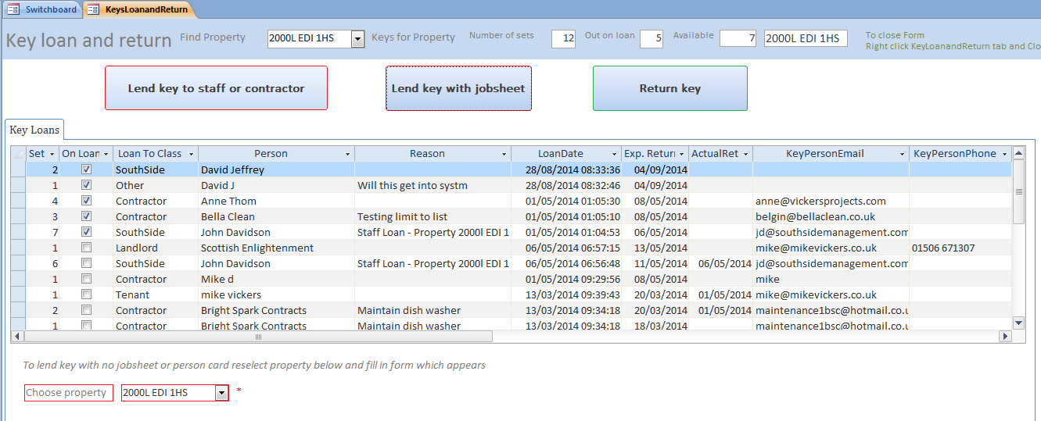

General

Contractor with job sheet

Note that when a property has been selected the number of keys in the set is displayed along with the numbers on loan and still available along the top of the form.

### General Loan

First select Property on the form for which the key is required, and then select the class for the key borrower, who they are, reason and borrower’s email and phone number.

The system assists in providing this information: for instance if the key is for the Landlord the system will default the above information to that held in the database. If the key is for a contractor the system displays a drop down list of jobs for the property where the lease is in force for the user to select, thereby minimising the information to be keyed in. Only in the class ‘Other’ does you need to enter all the data for key loan.

Enter an Expected Return date. This will default to loan date plus 5 days.

You MUST supply Key Set number: to do so click Key Set Number (above in red) and the following dialog box ‘Capture key details’ will open:

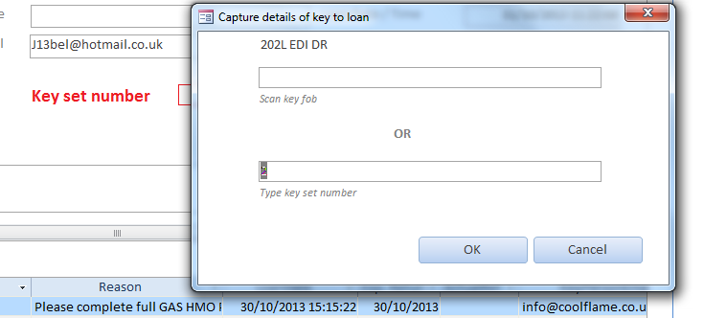

**Collect the key from the key board and scan its key fob – if key is correct for the property, the system completes the key and the collected information into a Key Register for the property; this is displayed at the bottom of the form as above.**

**You can type in the key set number if for any reason the key fob cannot be scanned correctly; in this case the system will ask the user to confirm the key set number.**

**NB**

1. **Should you wish to abandon issuing a key then click Cancel in the Dialog Box.**
2. **For the present it has been agreed that keys issued to tenants should be handled outwith the Key System.**

### Lend Key using Job Sheet

Where a contractor wishes to borrow a key and they have the job sheet that has been emailed to them, the user needs only to click on the Lend key with Job sheet tab and the following dialog box will open:

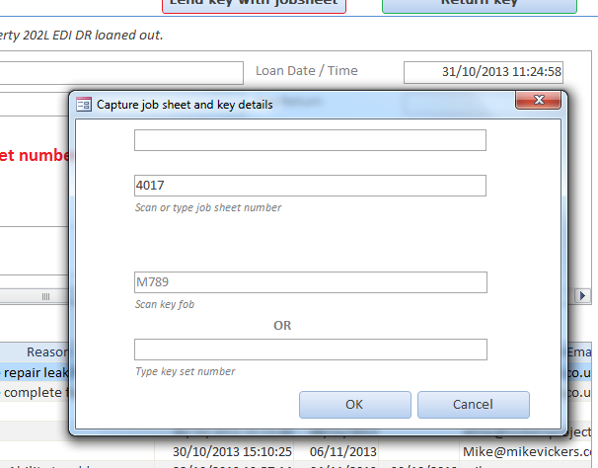

Scan the job number on the job sheet and the field Scan key fob will be filled in (Alternatively you may type in the job sheet number in the field if the job number on the job sheet is unreadable). Collect a key for the property from the Key Rack and follow the same procedure as for General Loan as above.

### Returning a key

To return a key click Return Key button in the main form and the following Dialog Box will open.

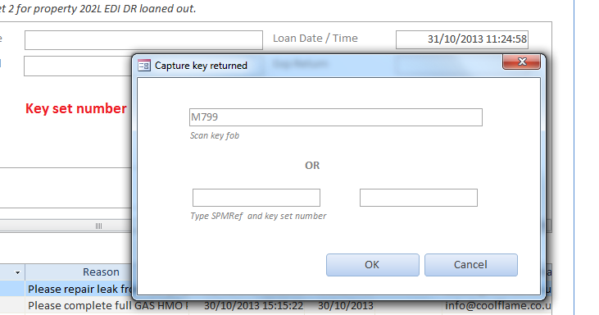

Scan the key fob of the returned key and the system will determine the property and key number from the scanned key fob and update the key register as key returned. You can confirm that this has been correctly done by inspecting Key History at the bottom of the form.

Should the key fob scan give wrong results or if the key fob is missing then you can enter the SPM Reference and key set number if you know it

You can now print all key fobs for a property

You can allocate a key to a staff member or contractor by scanning the staff or contractor card by selecting the Lend key to staff or contractor. The system will open a dialog window expecting you to scan the card and then scan the key fob – see below.

Note Staff cards are common to both the main and JD databases but Contractor cards are different for the two databases at present (because contractor are not common and have different IDs (cards start with CM or CJ)

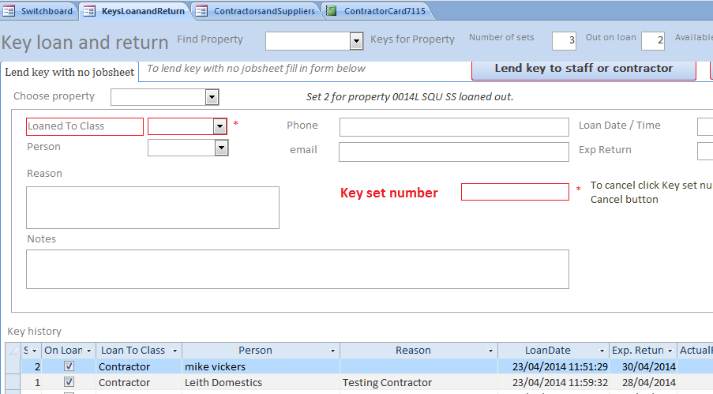

### Staff and Contractor cards

These cards may be printed through the Staff and Contractor standing data

### Loaning keys where the lender has no Key Fob

To loan a set

* Click Lend Keys and complete the next vacant line in the form.
* Enter the Loaned Class using the drop down. If Tenant is selected then the actual Tenant may be selected in the drop down under Person. If Landlord is selected then the Landlord name is selectable under Person. If Other is selected then the user is requested to enter the name of the Loaner
* If Key Sets are numbered then the number may be entered In Set. Note that in this release there is no check on the number allocated – ie there is no check that two sets don’t have the same Set number
* Loan Date is defaulted to today’s date and time and Expected return date should be entered is known.
* Clicking Save increases the number of sets Out on Loan and decreases the Available.
* Note that Location has yet to be specified

To Return a Set

* Highlight the row of the Set being returned and click Return Keys
* The number of sets Out on Loan is decreased and the number available is increased

Please do not use the Record Keys at the bottom of the window.

A simple report is provided which lists out all Keys out on loan other than to tenants:

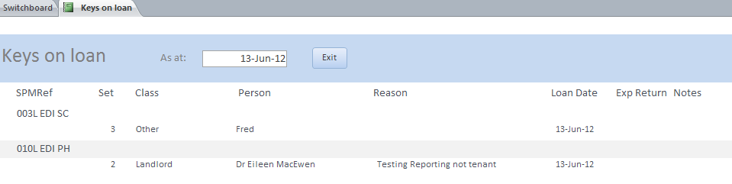

### Keys On Loan and Keys Overdue forms

The Keys on Loan form lists all keys on loan and to whom, while Keys Overdue lists only those keys whose Expected Return date is past. The Keys Overdue form has a button to click which emails all contractors who have keys overdue requesting them to return the keys. A report is available which lists any contractor who hasn’t provided an email.

Below is a sample email

________________________________________

Dear Coolflame

We believe you have keys which are overdue for return for the following properties:

Our ref: 202L EDI DR  
Address : Property 575, Edinburgh, Low 1AB  
Loaned on : 30/10/13  
Expected return date : 30/10/2013

We would be grateful for their return as soon as possible.

Kind regards,

**Natasha Bonello**

**Property Manager**

### Key History

Lists out a full history of key loans.

### Reports for Keys on Loan and Key History

You may report Keys on Loan and Key History either in total or by property. To report specific property select the property in the form using the down arrow in the property column header (equally you can select any heading eg Contractor).

### Key Management

The Key Management (called Key Details form) is provided to manage Keys and print key fobs.

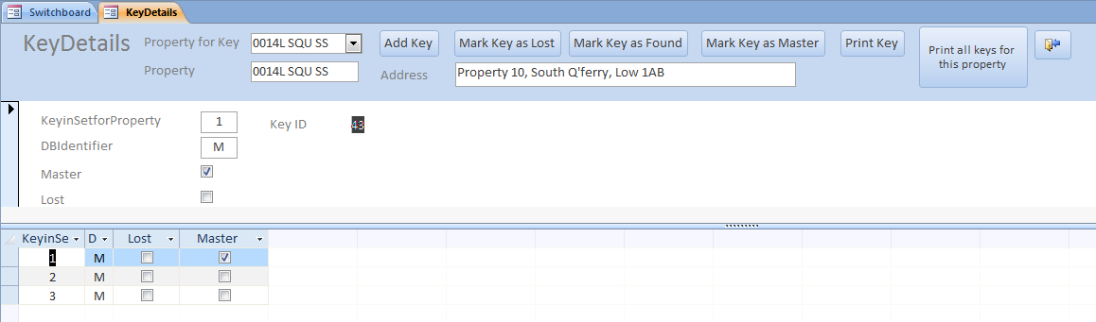

Functions provided are:

1. Add Key – adds a new key for the property to the system and increments the number of keys on the Property Details table
2. Mark Key as Lost - marks the key as lost in the system and decrements the number of keys on the Property Details table. Note key numbers are not deleted from the system.
3. Mark Key as Found – reverses 2.
4. Any key may be marked as ‘Master’ but only one can be marked as ‘Master’. A warning will be displayed if an attempt is made to lend out the master key.
5. Print Key – prints a key fob for the key selected. The SPMRef and barcode for the key are printed on the fob. Every key created is given a unique number – in the above example the key is M798. The M prefix distinguishes the key as one for the main database. The J prefix is for JD properties.

A typical key fob label will look like



# 

# SAGE transfer

### Standing data in SID and Sage

Several items of standing data MUST be set up before the Sage transfer interface is run.

**Sage Nominal code and VAT codes in SID**

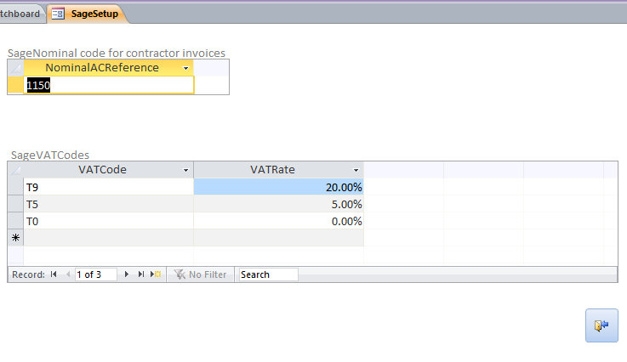Go to Standing data banks and Tax/Sage/Sage Nominal and VAT codes. In the form complete the Nominal account code against which purchase invoices will be recorded, and the VAT codes and VAT rates used by Sage.

Note that only one VAT code can be used per invoice. Invoices with items at varying VAT rates will have to be split.

**Bank Information in SID**

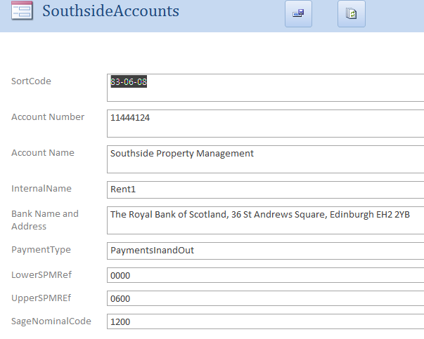Go to Setup and Housekeeping/Standing data banks and tax/Southside Accounts. Add Internal Name (eg Rent1) and Sage code (although the latter is not used at this stage). Make sure the account is PaymentsInandOut (or PaymentsOut if it is used only for paying contractors).

**Contractor Sage identifiers in SID**

For contractors whose invoices are to be loaded to Sage, you must record the contractor Sage identifier, and mark the contractor as ‘Send to Sage’. If the contractor is usually paid by BACS, tick BACS. Choose the VAT code most commonly used by the contractor. These two values will then be used by default in new invoices created for the contractor, but can be changed on an invoice by invoice basis.

Go to Setup and housekeeping/Standing Data/Contractors and Suppliers. The columns required are to the right of the screen; you will need to scroll over. UsualVATCode is a choice box; click a choice rather than typing in.

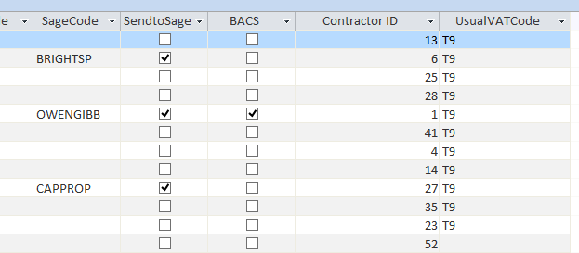

### Location of transfer files in SID

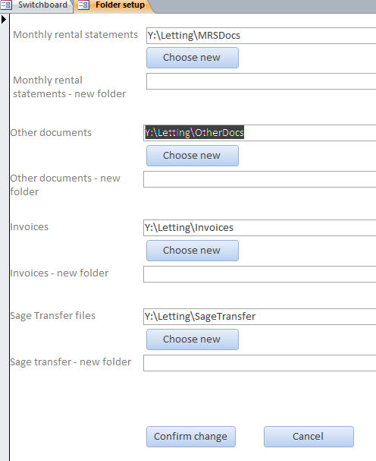This is the server folder where the system will place the csv files of transfer data. Go to Setup and Housekeeping/Database setup/Folder setup

Click Choose new, and navigate to the folder to be used. Click OK. Click Confirm change.

### Import mapping in Sage

Sage will save a mapping of fields in the transfer file to Sage fields. This is best created when importing the first file, as Sage will set up most of it automatically. Once created, sage will save the mapping and it only needs to be chosen, not re-created. This is what the mapping should look like:

|  |  |
| --- | --- |
| A | Type |
| B | Account Reference |
| C | Nominal A/C Ref |
| D | Department Code |
| E | Date |
| F | Reference |
| G | Details |
| H | Net Amount |
| I | Tax Code |
| J | Tax Amount |
|  | Exchange Rate |
| L | Extra Reference |

**Customised reports in Sage**

These depend on what you need, but will certainly include the Supplier Invoices Due report discussed previously, to sort and sub-total by bank account using ExtraRef and Department.

### Running the Sage interface

It is important to note that the Sage interface creation from SID is a simple program WHICH ASSUMES ONLY ONE PERSON IS DOING IT AT A TIME, in other words it does not place locks on data while in process.

The program reads costs and payments which have not been marked as ‘Sent to Sage’, matches the items with the contractor, and creates a proposed list of transactions for input to Sage. Once these have been reviewed and corrected as appropriate, the system will produce a file, and pause. This file should then be imported to Sage. If the import is successful, return to SID, click OK to the “Transfer file OK?” box, and SID will then mark the transactions in the file as ‘Sent to Sage’, and produce two reports: a report of all the transactions in the file, and a report of those to be paid by BACS.

#### Step by step

**Step1**: Create proposed file, review and correct input data.

Go to Properties and Maintenance/Sage transfer. The system will ask if you want to rebuild the transfer list; click yes to get the most up to date list, no to continue working on the previous list.

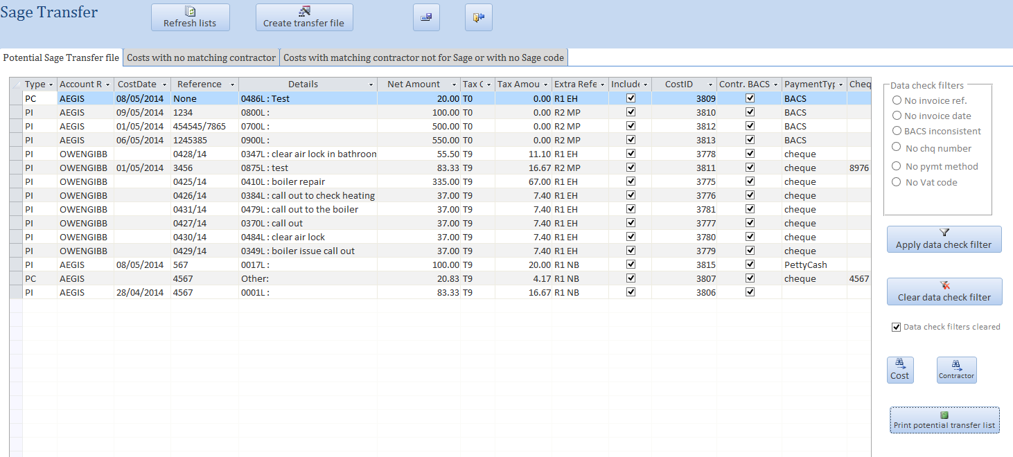

There are three tabs on the form:

* Potential Sage Transfer file: transactions where the contractor is marked for Sage
* Costs with no matching contractor: although the Supplier box on the Costs form has a drop down of contractors, there is no compulsion to use it, and the contractor name has often been typed in with variations, meaning that the system can’t identify it. A button allows for quick access to the cost to identify and/or correct the problem; Refresh Lists will then move the cost to the appropriate tab.
* Costs with matching contractor not marked for Sage or with no Sage code: in many cases this will be intentional, but this tab allows for a quick check that there are not errors in the contractor standing data.

The Potential Sage Transfer file tab also has other assistance for checking data. The Data Check filters will identify a number of likely common errors such as no invoice number or date, or cheques apparently written for a BACS contractor etc.

For example, in the test data below, Aegis and Owen Gibb have been marked as BACS contractors, but a number of invoices appear to have been paid by cheque or cash:

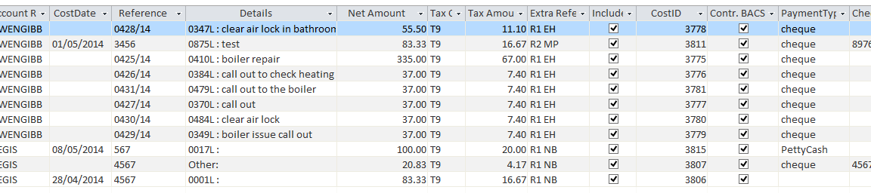

This can be corrected in the cost records, or left as is. The production of the BACS payment list will always take the conservative option of using the payment method on the cost itself.

Data check filters must be cleared before creating the file. Other filters can be created, such as only one contractor, dates before a particular date, etc.

Finally any costs can be excluded from the file by clearing the IncludeInRun check box.

**Step 2**: Create the transfer file

When you are satisfied with the proposed list, click Create Transfer File. This will produce a csv (comma separated) file in the Sage transfer files folder named Trans<dd><mm><yyyy><hh><mm><ss>.csv as below:

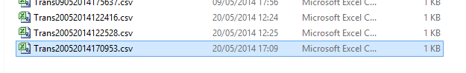

These files were created on 20th May 2014 at 12:24:16, 12:25:28, and 12:09:53.

The content looks like this:

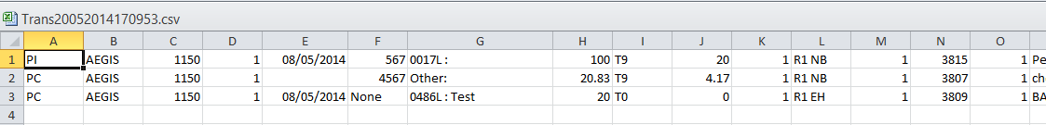

Using the map above, the first line, for example, is

|  |  |  |
| --- | --- | --- |
| A | Type | Purchase invoice (PI) |
| B | Account Reference | Contractor Sage code |
| C | Nominal A/C Ref | Nominal code for recording purchases |
| D | Department Code | As specified by yourselves, representing different bank accounts |
| E | Date | Invoice date |
| F | Reference | Invoice number |
| G | Details | Description |
| H | Net Amount | Net amount |
| I | Tax Code | VAT code |
| J | Tax Amount | VAT amount |
|  | Exchange Rate | Not used here |
| L | Extra Reference | Coding for bank account and PM, as specified by yourselves. |

The system will ask you if the transfer file is ok. Although you can open it and look at it, by far the best way to check is to try importing it into Sage; see below.  
Give SID a minute or two to complete creations of the File

**Step 3**: Import into Sage

Go to Sage, and CREATE A BACKUP!!!! Then choose File/Import to get the Sage Import screen:

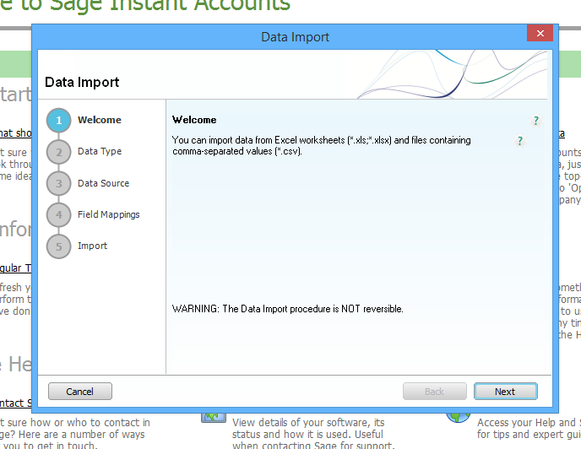

Click Next, and choose Audit Trail transactions:

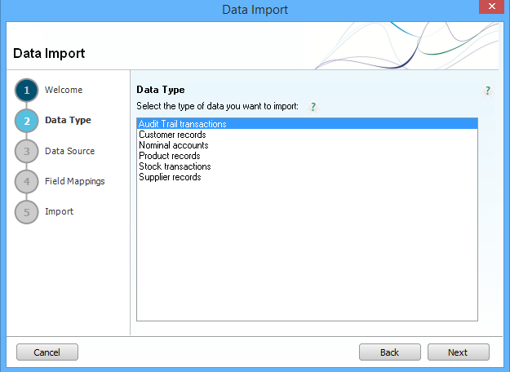

Click next and Comma Separated, and browse to the file you want to import. First row does NOT contain headings. The file itself must be closed.

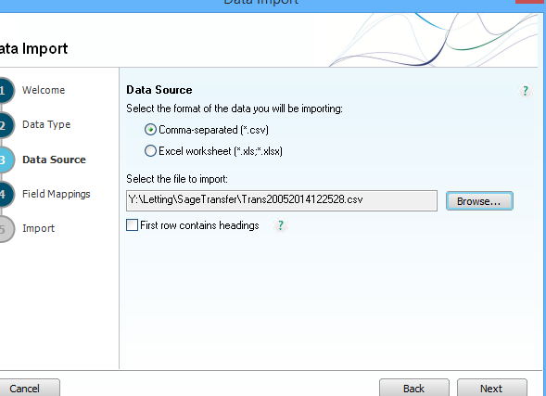

Click Next, and check by eye that Sage is using the correct mapping (it will be, since you will only have one!).

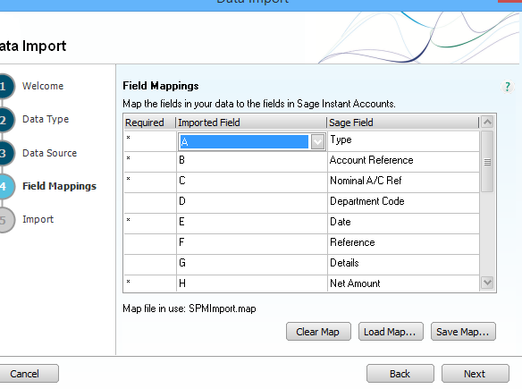

Click Next, and then Import.

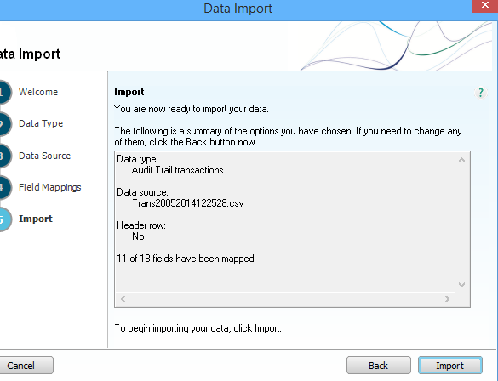

Sage will either import all the records or none if even a single error is detected. A summary will be displayed.

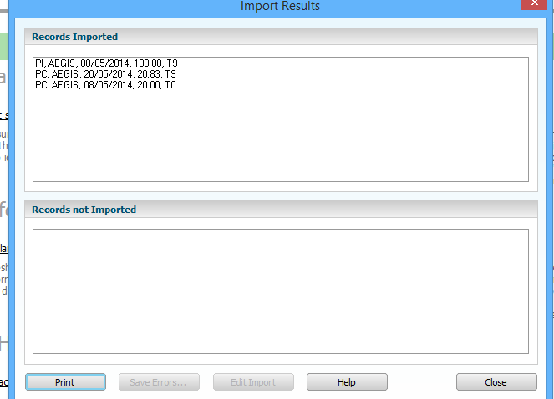

Click Close.

Now go back to your SID screen, and either click Yes or No to the “Is the transfer file ok?” question. If you click Yes, SID will update all the transactions in the file to “Sent to Sage”, and produce a list of all the transactions, and a list of BACS payments. If you click No, no such updates will be made.

The example transactions above appear in Sage as the bottom three rows below:

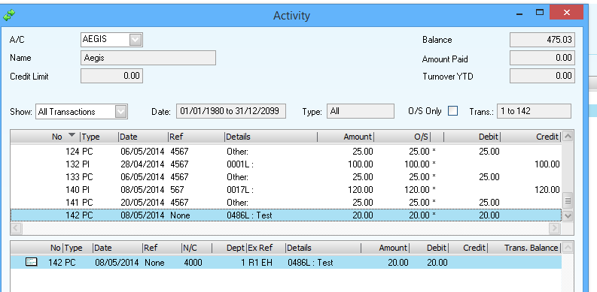

# Search by Address

The Search Address drop down throughout the system has been replaced by one that displays Street as the first sort key.

The full sort sequences is

<address less property number><address><post code><city>

In practice the Address1 field in the system assumes property number and address follow format dependinh on whether the property is flatted:

Not flatted:          <nnn> < streetname>

If flatted:               <nnn> <(n/n) <> <streetname>

where n would typically be a number but could just as well be a letter.

NB this format holds good for most Properties that have been entered into SID but some 50 do not follow this practice. It will be up to SouthSide to retype these inconsistent addresses into above format should users value the system displaying and searching Address in this way.

# Email Selection & Mailing

Email selection & Mailing is handled by a separate application from SID. The Application is called the LettingsEmail.

The system keeps a record of approved MRS files and other documents, and whether or not they have been ‘published’, ie put in a user’s Microsoft Outlook outbox or draft folder (it can’t know if they were actually then sent!). The LettingsEmail program offers a list of approved, unpublished documents for selection for emailing.

To access the program click Start / Vickers Projects / LettingsEmail. It is advisable to have Outlook open at the same time.

The program will only create an email for any particular landlord/lease if the attached documents include an MRS. Usually there would be one MRS and perhaps scanned invoices etc.

Documents to be emailed are selected by ticking the boxes at the right hand side, and clicking *Send emails*. The email will be formatted using a template if one has been selected, or with a simple sentence “Please find attached your monthly rental statement” if not.

Emails with attached documents will be placed in the Outlook Outbox or draft folder of the logged on user. It is advisable to have Outlook open before starting, and recommended that the Outlook Option ‘Send immediately’ be cleared to allow for double checking that the correct emails are to be sent out.

*Setup*: the Set database connection screen tells the program where the database is. Generally, this needs to be set only at initial installation.

Outlook templates: the Outlook templates screen allows for creation of a list of templates, one of which will be current, ie the one in use. Based on the sample template supplied, a template has been created with tags %Salutation% and %Attached% which are replaced by “Dear Ms Thom” and “Monthly rental statement for July 2011. In all cases, the subject is “MRS <property ref> < month>”.

Tick here to load selected emails in chosen Outlook folder

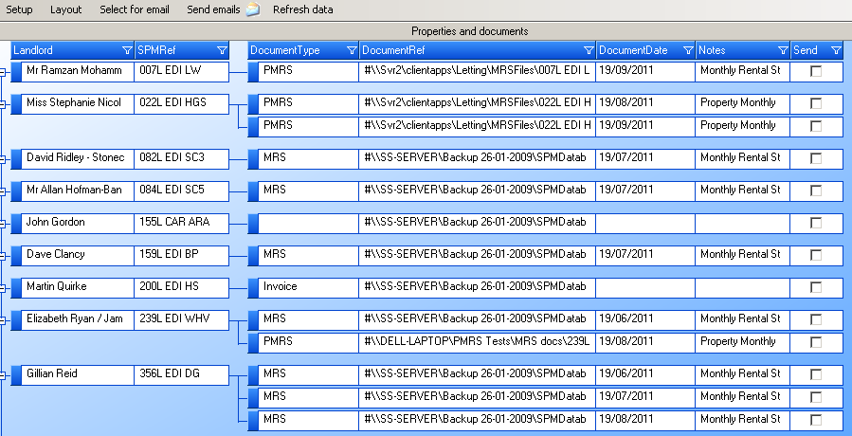

Tick here to include in send process

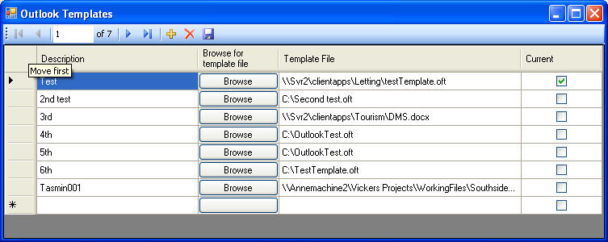

Choose outbox or drafts folder. If outbox, email can be set for delayed delivery.

Tick one template as current, or leave all blank for plain email

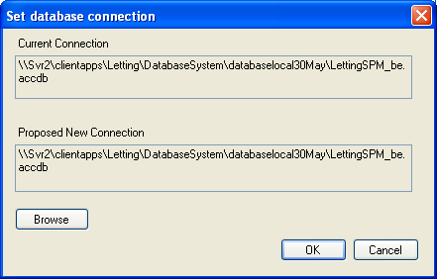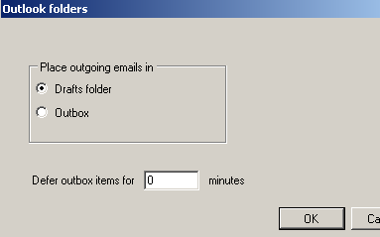

Used at setup, or if server computer is changed

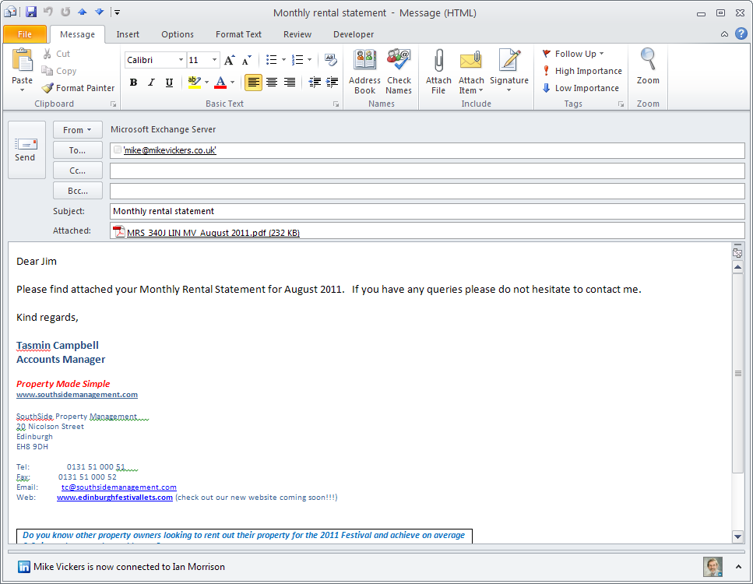

Sample email

## The emailing program

The function of this program is unchanged, but it now displays short filename in front of full file name in the list of documents ready to be emailed.

# System Set Up

The Setup and Housekeeping switchboard option leads to the Set Up switchboard.

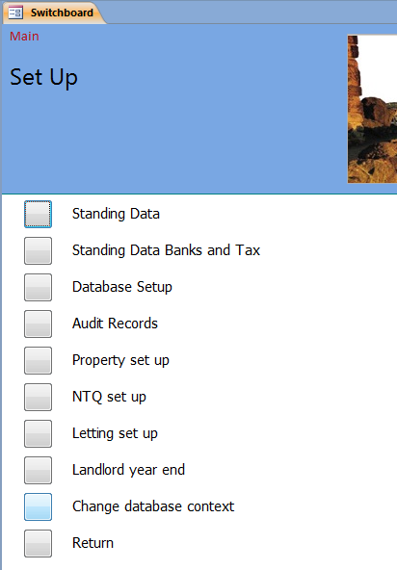

## Database choice

Both the main database and the ‘JD’ database are now reached from the same front end. On opening the system, a choice box will offer a choice of staying in the same context or choosing another:

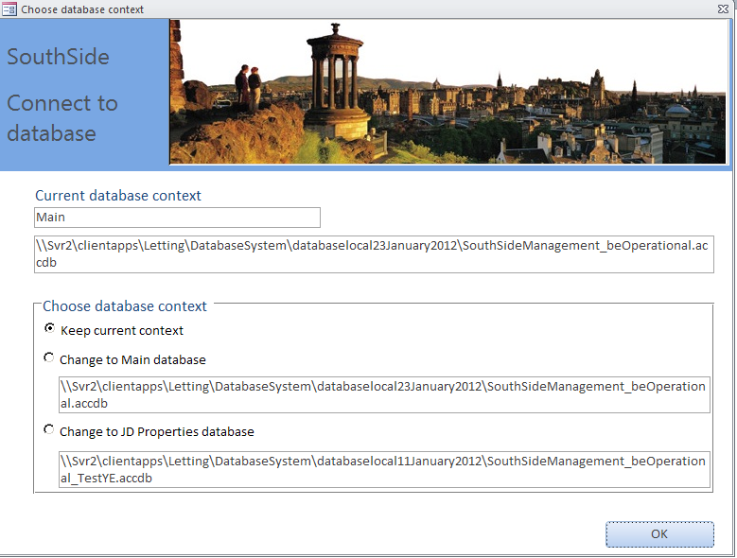

‘Context’ describes the database, either Main or JD Properties; the box below context gives the file name of the back end.

Note that this is intended simply as a switch between two current databases. When connecting to a new backend database (most likely to be after installing a new front end), use the menu Setup & housekeeping/Set up database/Database setup as before. You need to specify the database context: see form image below.

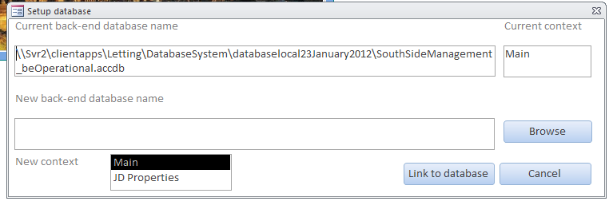

## Standing Data

The Standing data button opens another switchboard,

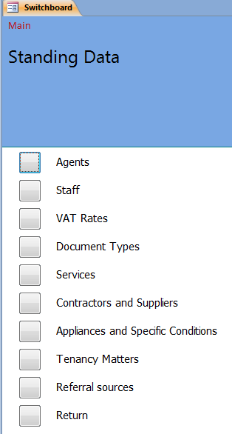

leading to forms for the maintenance of standard data used throughout the system.

The purpose of each type is as follows

1. Agents – Information including Address for SouthSide Property Management. In principle it is possible to have more than one location set up
2. Staff – members of the SouthSide Team. Where Team Members are identified in action records it is the Initials that are stored
3. VAT Rates – the VAT Rates supported by SouthSide Management
4. Document Types – a list of document types that are recognised in the Document register
5. Services > leads to submenus
   1. Maintenance / Service types that may be asigned to any job
   2. Contractors for Expiries
6. Contractors/Suppliers - Contractors ands Suppliers regularly used by SouthSide Property Management
7. Appliances and Specific Conditions – used in specifying Property Detilas
8. Tenancy Matters – Tenants preferred by Landlords, Tenancu Types, Tenant Accepability
9. Referral Sources – sources of tenants and landlords

### Maintenance / Service Types

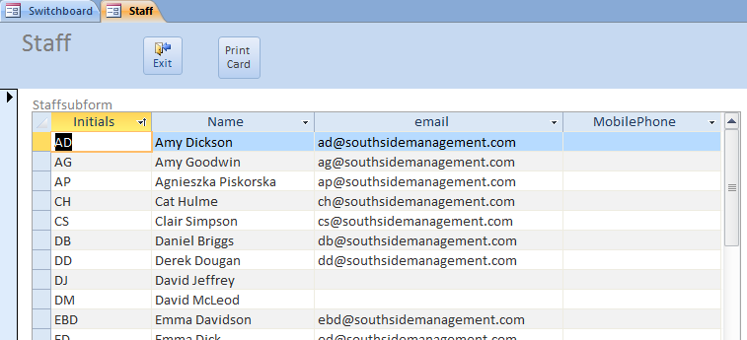

### Contractors for Expiries

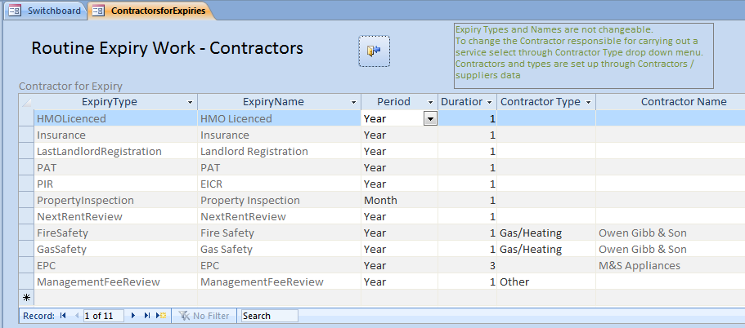

Note that Expiry Types and their Names are ‘hard coded’ and should not be changed.

### Staff Information

Email address has been added to Staff Information in the Standing Data. The email is included on Maintenance / Service emails.



Staff are the same for both the Main and JD databases.

### Example of Contractor Standing Data

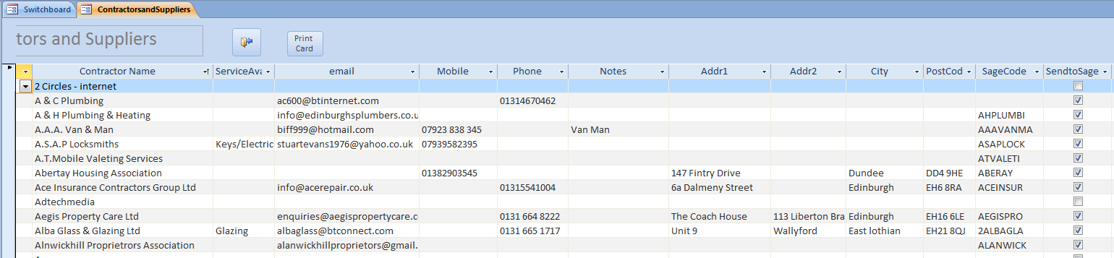

Note the Contractor Data is the same for both the Main and JD Databases and contains common Sage Codes

## Database Setup

Database setup leads to a form to tell the system where the back-end database is, and a form for set up of folders for documents (see below).

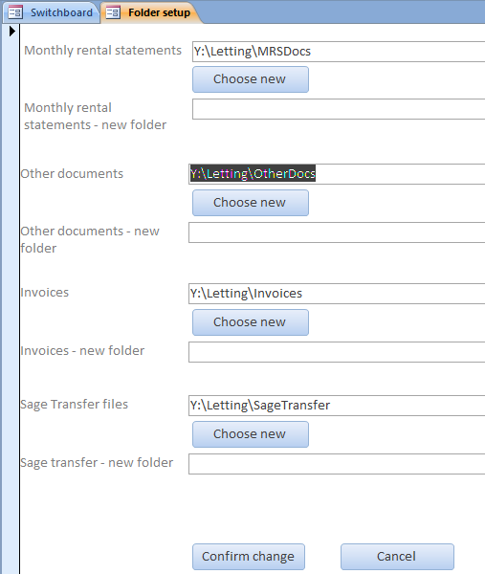

MRS (Monthly rental statement) files should be stored in a server folder with shared read/write access for all system users. Click *Choose new* to browse to a suitable folder.

Other documents should be stored in a server folder with shared read/write access for all system users. Click *Choose new* to browse to a suitable folder.

## Audit Records

Audit records are used to track imported spreadsheets, and should not be routinely needed to be changed. See Appendix V below.

## Standing Data Banks and Tax

This menu is accessed from Set up and Housekeeping

### Banks and Tax

A new switchboard ‘Standing data banks and tax’ has been introduced, with the following buttons:

|  |  |
| --- | --- |
| Southside Accounts | Table of bank account information in support of lease documents and Sage transfer.    PaymentType is PaymentsIn, PaymentsOut, or PaymentsInandOut. Lower and upper SPMrefs are used to work out which account should be used in the lease documents for rent payment, and which for invoice payment in the Sage transfer. **They must not overlap or leave any gaps!** SageNominalCode is the Sage Nominal Ledger code for the account. |
| Tax Allowance | Used to set up HMRC tax allowance categories. |
| Bank Holidays | This table of bank holidays is used to calculate working days for lease documents. It should be updated once a year, preferably by December at the latest for the next year. |

# Landlord Year End

### Purpose

The purpose of the year end process is to reset the context of the system to a new year, by

* Moving the tax year end forward by one year
* Calculating landlord totals for the year just ending, and moving the MRS year sum boxes one year to the left
* Resetting the month choice boxes forward by one year

For full details see Appendix VII.

# Distribution Lists

Distribution Lists are for providing email distribution lists for emails created within the System. These distribution lists are held in Outlook tables on the Exchange server.

Set up of Distribution Lists is through the menus Database Set Up for Maintenance email distributions, NTQ Set Up for NTQ email distribution email and Letting Set Up for Lettings email distribution.

In the table below the emailTypes are internal to SID. SID, when it creates an email for a specific notification, looks in the table below and creates an email with the email address in the email column. When the email is sent from Outlook, the Exchange server recognises the email address as an Outlook distribution list and replaces in the email address with the target recipients’ email addresses.

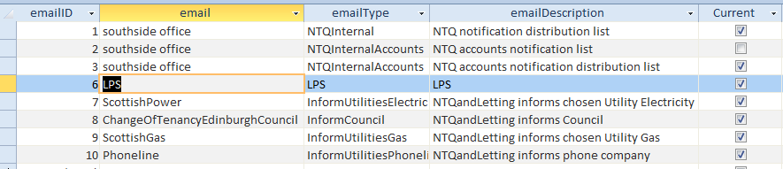

For example an email created by SID with an email address SouthSide office is recognised in Exchange as a distribution list and replaced by all staff in SouthSide who require to receive the email.

These email distribution lists need to be set in Exchange once staff have agreed who the recipients are to be; for instance the recipient of InformUtilities is likely to be defaulted to the relevant authority in Edinburgh Council.

As SID places emails in the Outlook Draft Box, staff have an opportunity to change the email address to the appropriate one if the default is the incorrect address eg a Council other than Edinburgh Council.

# Appendix I Sample MRS

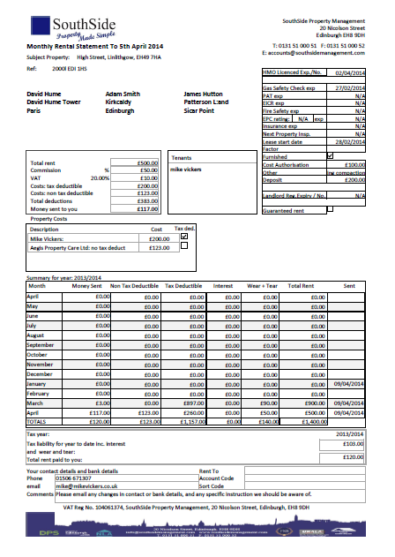

**MRS with more than 8 costs.** Seven costs are shown, and the remainder totalled under ‘Other costs’.

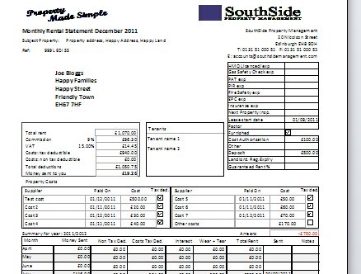

# Appendix II Database design

The structure of the database is illustrated below.

## Main and JD databases

There are two databases routinely supported. The Main database for the properties owned by Landlords other than John Davidson and partners, and the JD database for properties owned by John Davidson and partners.

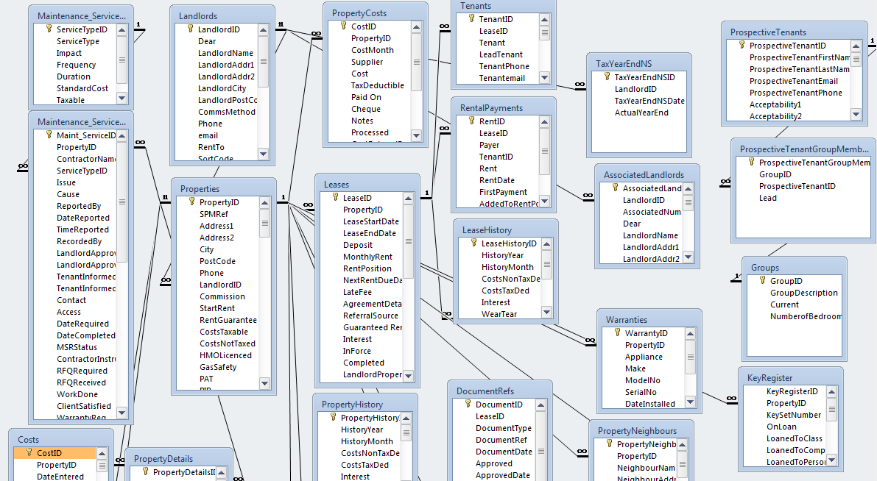

# Appendix III Common buttons and conventions

The system makes use of a number of standard controls

 Save the changes made

 Exit the form – the form will close and generally go back to a Switchboard

 Select object of interest from drop down list – the box is known as a ‘combo box’. This object, in this case Mike Vickers, is the one whose details are presented in the Detailed section of the form below.

Note that in general the detail of the form will be blank until a successful selection is made

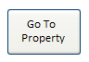Go to another form and open with same Property or Lease. Where another form is entered this way the Select Combo box does not reflect the Property or Lease displayed

In the following case

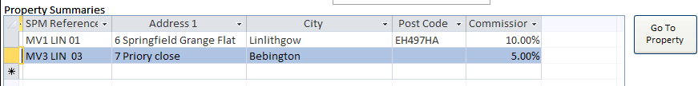the property gone to is the one highlighted

## Filtering records

You can filter or sort forms which have multiple rows. The example below uses the Unprocessed Costs form.

The form opens with all currently unprocessed costs (these figures are NOT current!):

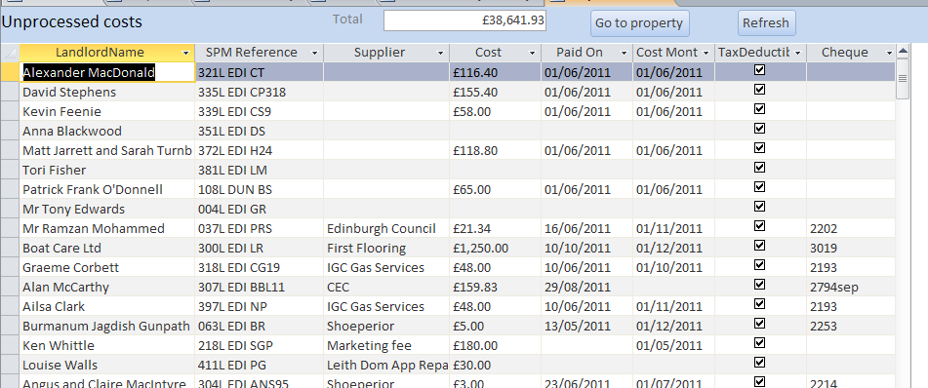

The Total box shows the total cost of the selection on the screen, depending on the filters chosen (in the case below its October costs, above its all costs):

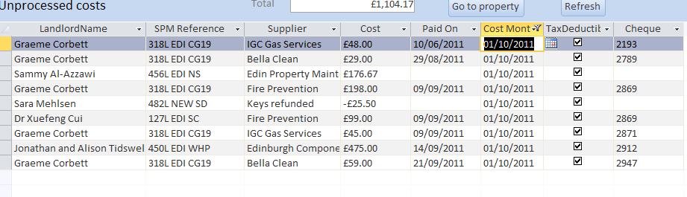

Filtering is done via the black arrowheads:

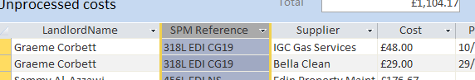

So for example, clicking the arrowhead at SPM Reference would let you order by SPM Reference, or choose a specific one. At Cost, you could order largest first, say, or find all costs greater than some amount. At CostMonth you can choose which month(s) to show. And so on. Click the filter funnel to clear a filter.

# Appendix IV Technology

The system is built using Microsoft Access 2010 and Visual Basic 2008. It is designed for shared use on a network.

Data is held in two ‘back-end’ databases

1. SouthsideManagement_be.accdb,
2. JD Properties.accdb

These should reside on a server computer. Users use the system via a front-end system, SouthSide Management, which runs on each user PC, and a Visual Basic program, LettingsEmail, installed on the PC’s of users who email MRS’s. Email client expected is Microsoft Outlook.

Access 2010 is not required to run the system, but it is recommended that at least one computer has a copy, to make use of ad-hoc querying.

MRS’s and other property documents should reside in shared folders on a server computer.

# Appendix V Audit Records

Audit Records are written for every Banking spreadsheet imported. These records can be used to check on which and when the last Banking Spreadsheet was imported providing assistance on ensuring that worksheets are neither missed and nor imported twice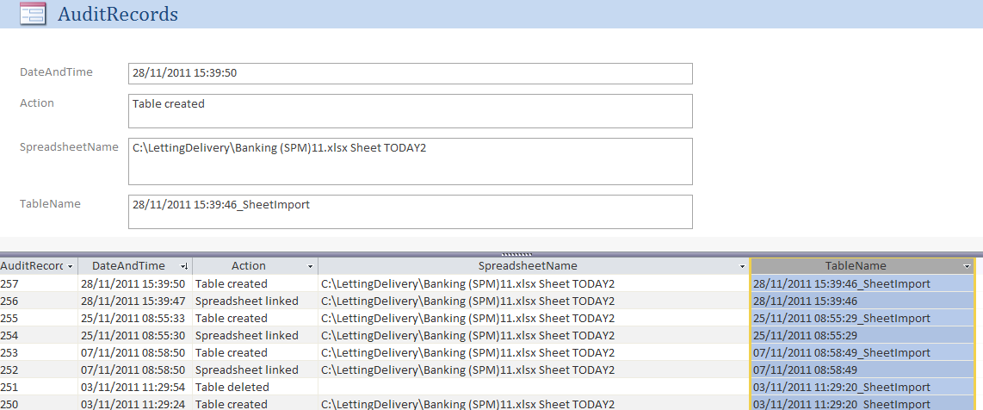

# Appendix VI Email and Letter templates

There are four groups of templates used for emailing and creating mail merge letters / documents.

## Templates

They are as follows

|  |  |  |  |
| --- | --- | --- | --- |
| Group | Template Type | Name | Purpose |
| Maintenance | email | Confirmation of maintenance item resolved.oft | Notifying Landlord of work completed and cost of work |
|  |  | JobCard.oft | Seeking Quote from Contractor or notifying him of work to be done |
|  |  | LandlordMaintenance.oft | Notifying Landlord of work instructed |
|  |  | OverdueKeys.oft | Requesting Contractor to return keys that are overdue |
|  |  | TenantMaintenance.oft | Notifying Tenant of impending work |
| Property | email | NewProperty.oft | Notifying SouthSide Staff of New property taken on |
| Letting | email | OutstandingDocuments.oft | Notifying prospective tenant that essential data is missing |
|  |  | FlatAppliedFor.oft |  |
|  |  | ProposedTenancyAgreement.oft | Seeking approval from Landlord to go ahead with Tenant Group |
|  |  | ApplicationAccepted.oft | Tenants application has been accepted – notifying SouthSide Staff and Lead Tenant |
|  |  | InitialRentReminder.oft | Reminding Tenants that initial rent is due |
|  |  | CouncilIncoming.oft | Informing Council of Incoming Tenants |
|  |  | UtilitiesIncoming.oft | Informing Utilities of Incoming Tenants and providing initial meter readings |
|  | Letter | GF Guarantor Form.dotm | Form to be completed by Guarantor |
|  |  | AT5 Form.dotm | Statutory Statement of Terms of Tenancy |
|  |  | DOCUMENT 2 - Prior Notification of Grounds.dotm | Grounds for Landlord seeking recovery of the property |
|  |  | DOCUMENT 3 - Lease - 001L to 600L templ.dotm | Conditions of Tenancy |
|  |  | Tenant Information Pack.pdf | Statutory Pack provided by Scottish Government |
|  |  | Tenant Information Pack.dotm | Specific pages of pack which contain details of Landlord and Tenants |
|  |  | Repairing Standard.pdf |  |
|  |  | LPS Information Template.dotm | Notification to LPS of deposit provided by Tenants |
|  |  | LSR.xltx | Lease Signing Report |
| NTQ | email | NTQ.oft | Notice to quit –Informing SouthSide staff of Notice to Quit |
|  |  | Advise landlord of Tenant NTQ.oft | Advice Landlord of Tenants intention to leave Property |
|  |  | ToLandlordreNTQ.oft |  |
|  |  | CouncilOutgoing.oft | Notifying Council of Tenants departure |
|  |  | UtilitiesOutgoing.oft | Notifying Utilities of departing Tenants with meter readings |
|  |  | OnsideCheckOutEmail .oft | Notifying Onsite of Tenants vacating Property |
|  |  | SPMCheckOutEmail .oft | Informing SouthSide Staff of departure |
|  |  | ETSLPS.oft | Providing LPS of Deposit position from SouthSide view point |
|  |  | ETSTenant.oft | Informing Tenants of the Deposit to be returned |
|  |  | CoveringEmail.oft | Covering email where Documents emailed to departing Tenants |
|  | Letter | TT NTQ letter and deposit return checklist_4.dotm | Acknowledging Tenants’ intent to leave premises |
|  |  | DOC 1 - Notice to Quit.dotm | Formal Notice to Quit issued by Landlord /Agent |
|  |  | DOC 2 - AT6 Form.dotm | AT6 |
|  |  | DOC 3 - Section 33 Form.dotm | Notice of repossession |
|  |  | Tenant Leaving Form.dotm | Responsibilities placed on Tenant on leaving to secure Deposit |

## Data Items Used in Emails and Mail Merges

Data items available for incorporation in the emails currently are:

|  |  |
| --- | --- |
| *Item* | *Expected Usage* |
| Salutation | Name of person to be emailed |
| Property | SPM Reference |
| Issue | The work reported as needed to be done |
| Cost Estimate | Cost estimated by SouthSide / Contractor |
| Approval | Details of who bears the cost |
| Date Instructed | Date that Southside has given instructions to the Contractor |
| Maintenance | Type of work to be carried out |
| Contractor | The name of the Contractor, phone and mobile numbers |
| Contact | Contact provided by the person who has requested that there is an Issue |
| Access | Method of access to the property proposed by the SouthSide Property manager |
| arrMergeParameters | A string matrix used to hold text strings used within the body of the email |



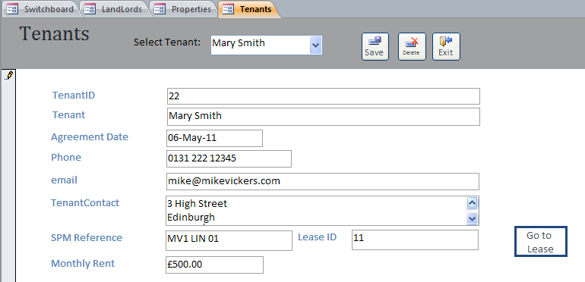

Note: this form is for updating Tenant information and for finding which Lease the Tenant relates to.   
If a Tenant moves from one Property to another they are considered as two separate tenants and will appear twice in the list.

# Annendix VII - Landlord tax year end processing

### Purpose

The purpose of the year end process is to reset the context of the system to a new year, by

* Moving the tax year end forward by one year
* Calculating landlord totals for the year just ending, and moving the MRS year sum boxes one year to the left
* Resetting the month choice boxes forward by one year

### Environment

The nature of this process requires that a number of types of outstanding item be processed in advance, and that the actual year end change is made from one computer with no-one else logged on to the system. It must be run *after* all MRS’s have been produced for month 13 of the year ending (ie the short month to 5th April), and *before* any MRS’s have been produced for month 1 of the new year (ie the month from 6th April).

### The process

When opening the Year End form, the system will ask if you have made a backup copy of your data, and create a time-stamped one if you say no.

#### Work to do in advance

1. Review all unprocessed property costs

This is advisory, as a ‘review and tidying’ opportunity. Costs will however still be able to be re-scheduled to dates in the future.

This can be done from the Monthly Summary screen, or the Landlord year end screen.

1. Review all unprocessed rents

This is advisory, as a ‘review and tidying’ opportunity. Rents will however still be able to be re-scheduled to dates in the future.

This can be done from the Monthly Summary screen, or the Landlord year end screen.

1. Complete all bank statement uploads

This is mandatory. All remaining bank statement uploads must be completed. (The Year End check will delete any imports with no remaining entries.) Once the year end has been run, only dates in the New Year will be selectable for allocating rents.

This should be done from the Load Rents from Bank Statement screen.

1. Create all outstanding MRS’s

Outstanding in this context means an MRS for a property with at least one non-completed lease which has not yet been approved for a month later than the lease start date in the year to be closed. (Note: leases should have a start date, otherwise they will be omitted from this check and ‘stranded’.)

The review can be done from the Landlord Year End screen.

Begin by reviewing all non-completed leases via the Non-completed Leases report. This report lists all leases which are not completed, grouping those which are not In Force at the top. Next update any which are in fact complete but have not yet been marked as such, from the Property screen in the standard way.

Re-run the Missing MRS report as a guide, and then approve all outstanding MRS’s in the standard way.

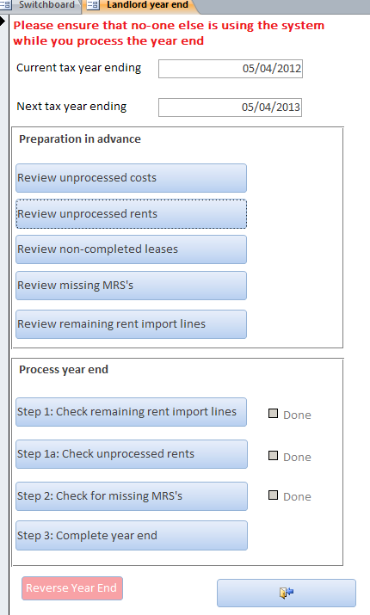

#### Processing year end

The steps must be done in the order on the form, as above. Mandatory steps which are not complete (ie steps 1 and 2) will not allow the process to complete. Step 1a will issue a warning, but will allow the process to continue.

The year end process will increase the year end date by one year, and modify the month choice boxes on the Monthly Review and Load Rents from Bank Statement forms. New sets of property history records will be created for each property, and Tax liability and Total rent calculated for the previous year. MRS’s produced thereafter will have totals boxes moved one to the left.

#### Reversing the year end

The year end can be wound back one year using the Reverse Year End button. Be very careful to check that you are reversing the year you intend.

# Annenx VIII - Installing Front End Application on PCs

* 1. Where PC does not have Full Access 2014
     1. First uninstall the existing version. To do so go to Programs in the Control Panel > Uninstall a program
        1. Search for SouthSide Management – the version should be 1.0.71 or earlier – if it’s 1.0.73 then the latest version has already been installed
     2. Find the new version at SPMDatabase\R26Installation\Packages\Packages
        1. Either Full or RunTime
        2. Install as appropriate – you can determine whether Access is present on the PC you want to install by going to Start>All Programs and opening Microsoft Office – it will include Access or not
     3. Install by clicking setup.exe
  2. Linkage as usual to the following files
     1. Main – SPMDatabase - file Southsidemanagement_be.accdb
     2. JD – SPMDatabase\JDProperties – file SouthSideManagementJDProps_be.accdb
  3. Installing on PCs with Access 2014. Just copy or overwrite if already present into folder to C:\SouthsideManagement from
     + 1. SPMDatabase\R26Installation\SouthsideManagement.accdb
       2. NB this copy must be done while logged into standard user of the PC otherwise they won’t see it when they log on

1. To ensure fast switching between the two sets of properties two icons are provided on a number of Desk top , one for Main and one for JD properties